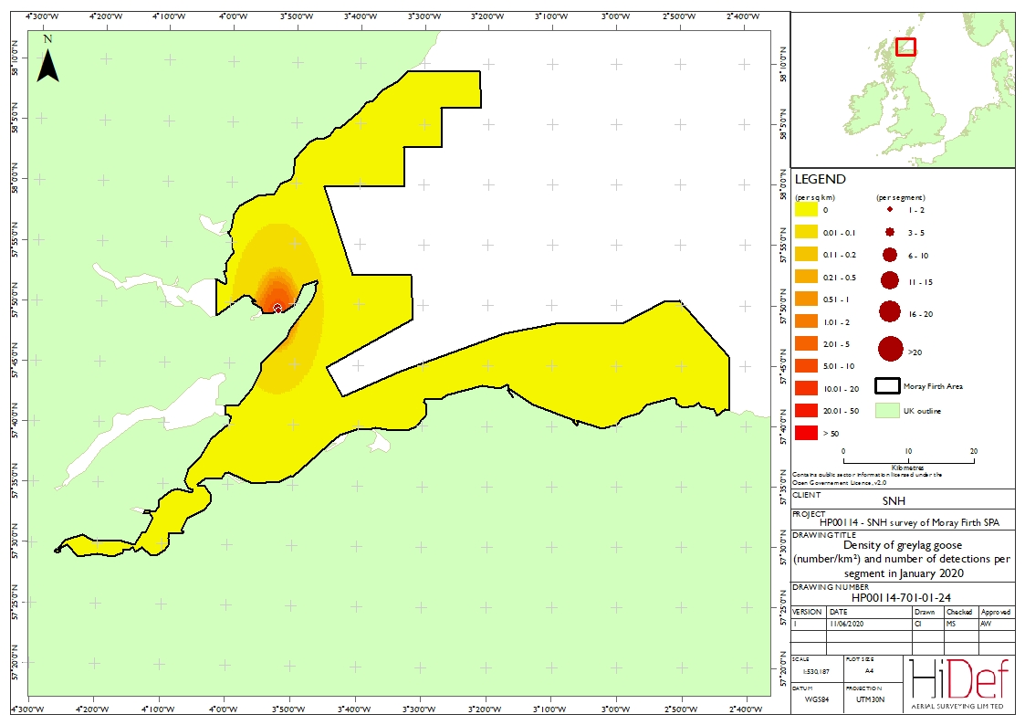

Figure A4.1 Densities of greylag goose (number/km²) and number of detections per segment during Survey 1 on 19 January 2020. : Map of Moray Firth SPA showing greylag goose densities. Contains public sector information under the Open Government Licence v 2.0.
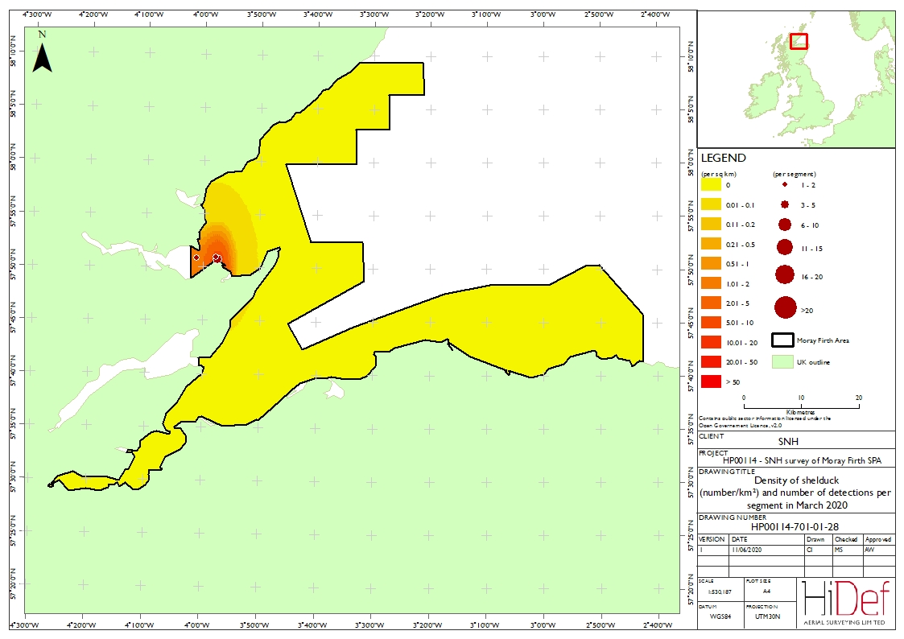
Figure A4.2 Densities of shelduck (number/km²) and number of detections per segment during Survey 2 on 8 March 2020. Map of Moray Firth SPA showing shelduck densities. Contains public sector information under the Open Government Licence v 2.0.

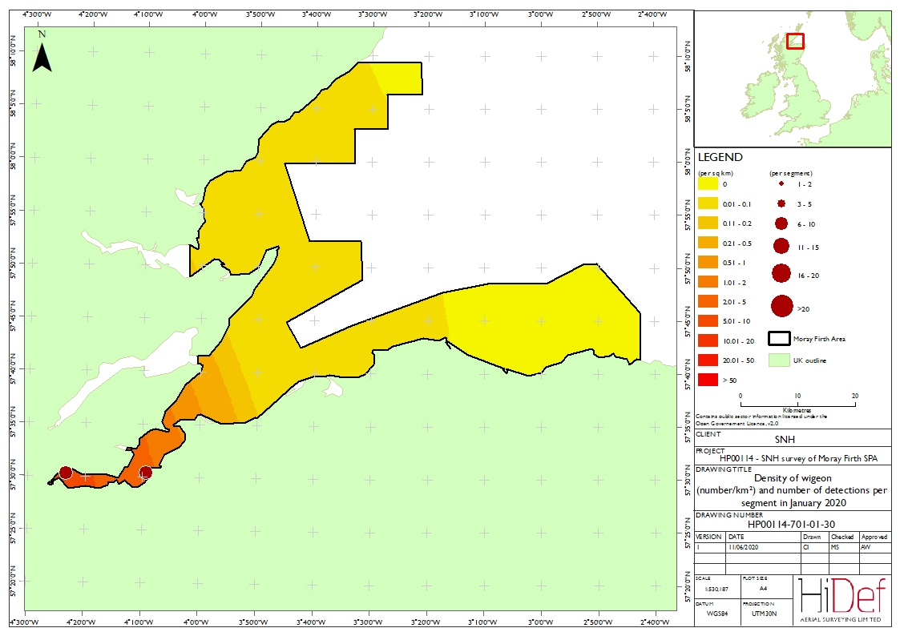

Figure A4.3 Densities of wigeon (number/km²) and number of detections per segment during Survey 1 on 19 January 2020. Map of Moray Firth SPA showing wigeon densities. Contains public sector information under the Open Government Licence v 2.0.

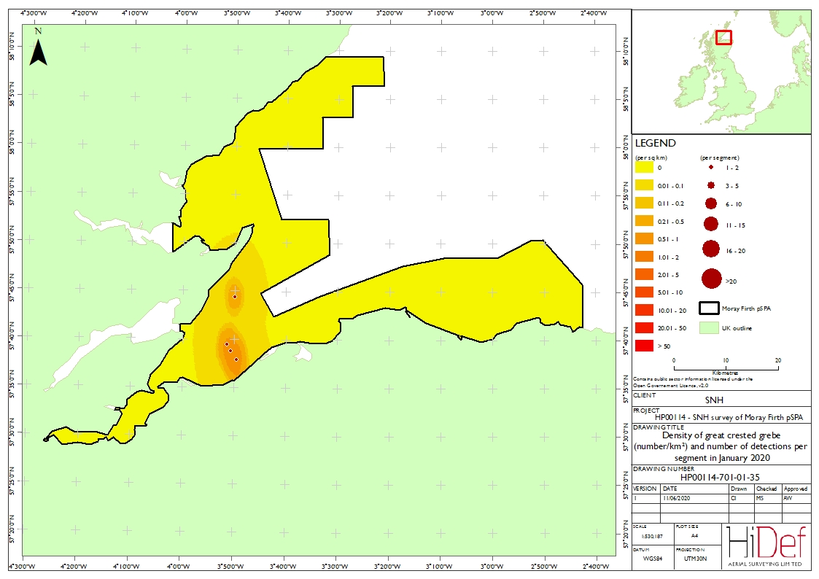

Figure A4. 4 Densities of great-crested grebe (number/km²) and number of detections per segment during Survey 1 on 19 January 2020. Map of Moray Firth SPA showing great crested grebe densities. Contains public sector information under the Open Government Licence v 2.0.

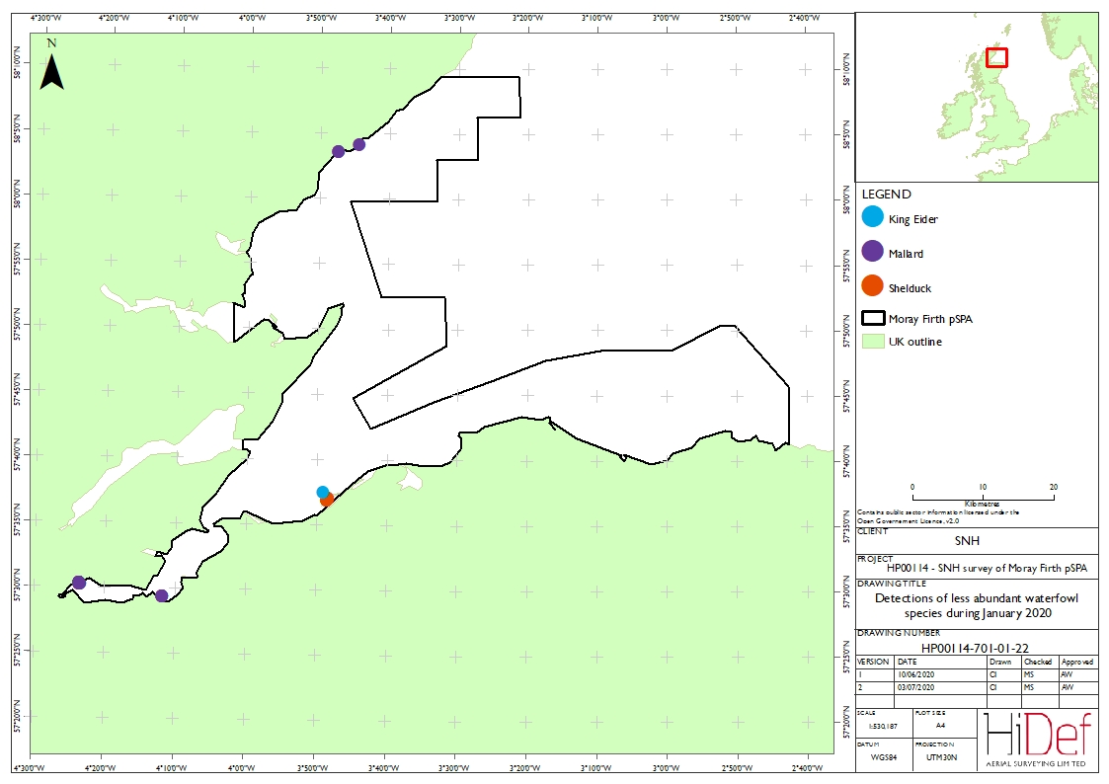

Figure A4.5 Detections of less abundant waterfowl species (number/km²) during Survey 1 on 19 January 2020. : Map of the Moray Firth SPA showing the locations where king eider, shelduck and mallard were detected. Contains public sector information under the Open Government Licence v 2.0.

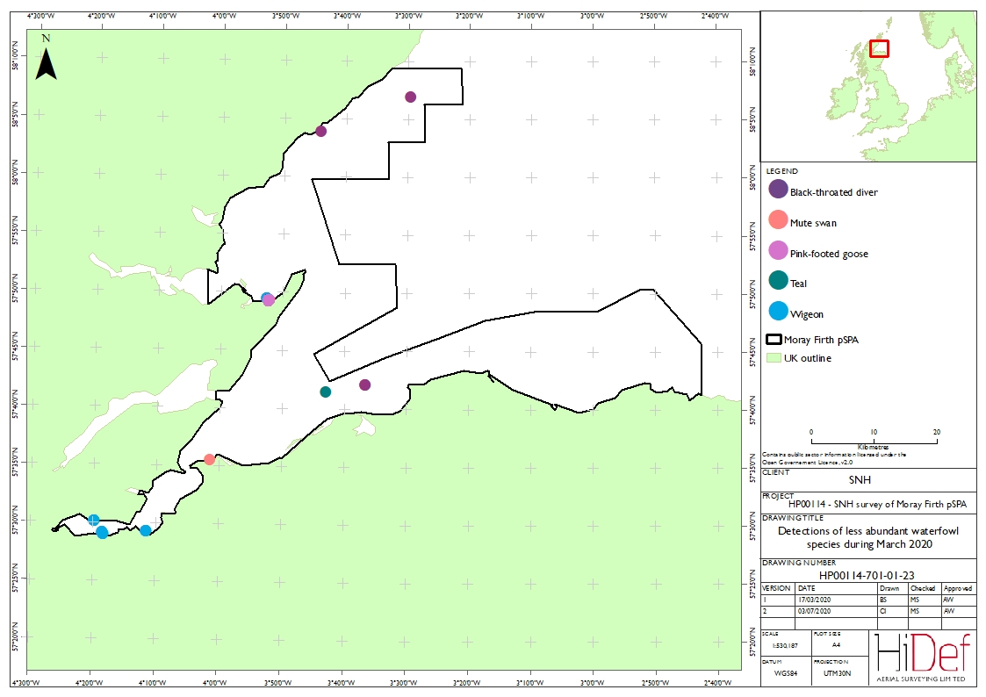

Figure A4.6 Detections of less abundant waterfowl species (number/km²) during Survey 2 on 8 March 2020. Map of the Moray Firth SPA showing the locations where black-throated diver, mute swan, pink-footed goose, teal and wigeon were detected.
Contains public sector information under Open Government Licence v 2.

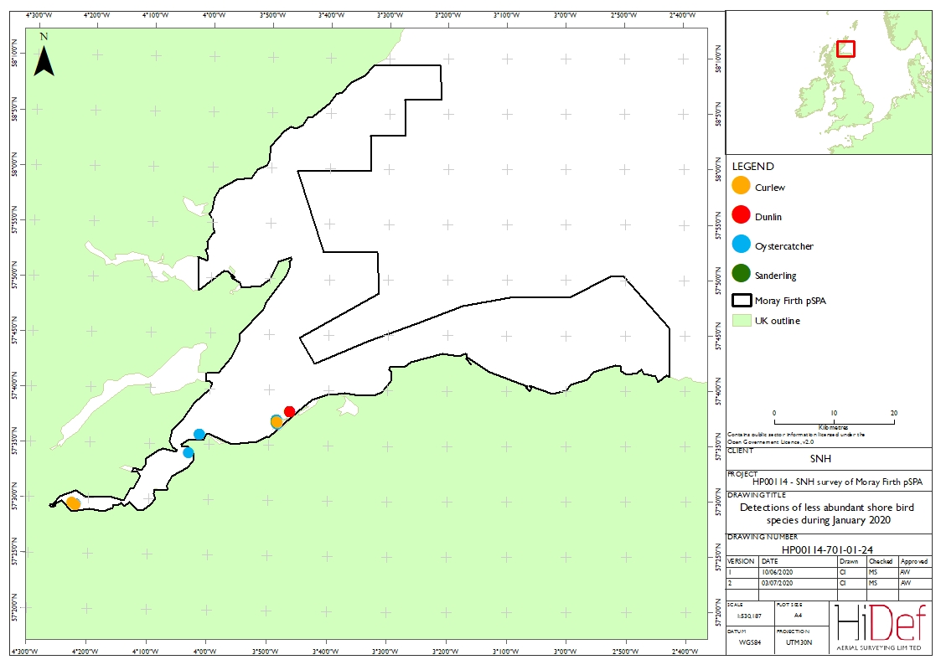
Figure A4.7 Detections of shore bird species (number/km²) during Survey 1 on 19 January 2020. : Map of the Moray Firth SPA showing the locations where curlew, dunlin, oystercatcher and sanderling were detected. Contains public sector information under Open Government Licence v 2.0.

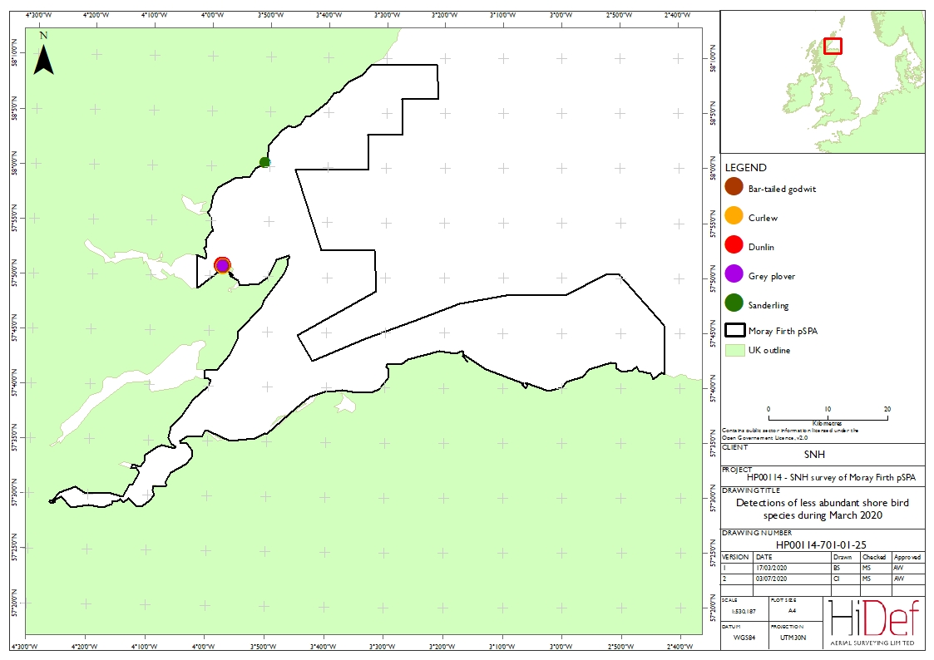
Figure A4.8 Detections of shore bird species (number/km²) during Survey 2 on 8 March 2020. Map of the Moray Firth SPA showing the locations where bar-tailed godwit, curlew, dunlin, grey plover and sanderling were detected. Contains public sector information under the Open Government Licence v 2.0.

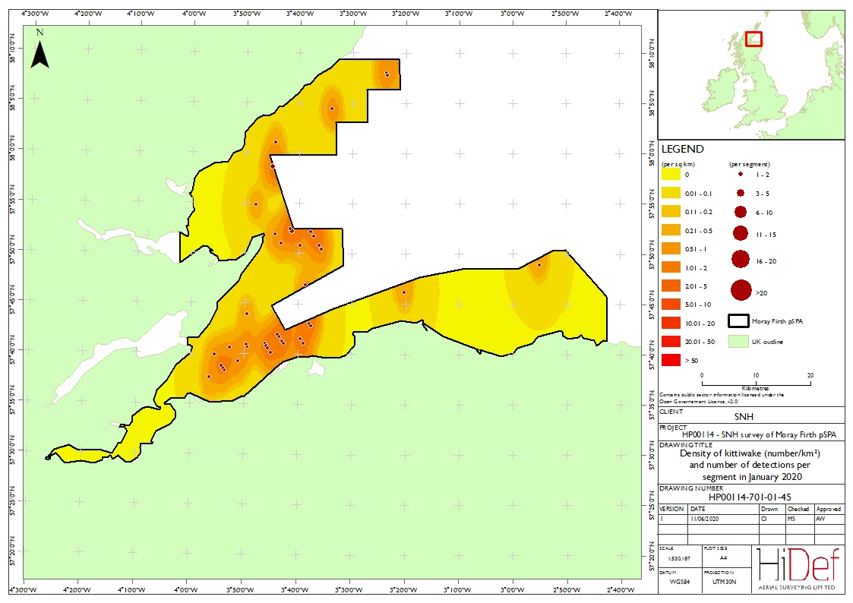
Figure A4.9 Densities of kittiwake (number/km²) and number of detections per segment during Survey 1 on 19 January 2020. Map of Moray Firth SPA showing kittiwake densities. Contains public sector information under the Open Government Licence v 2.0.

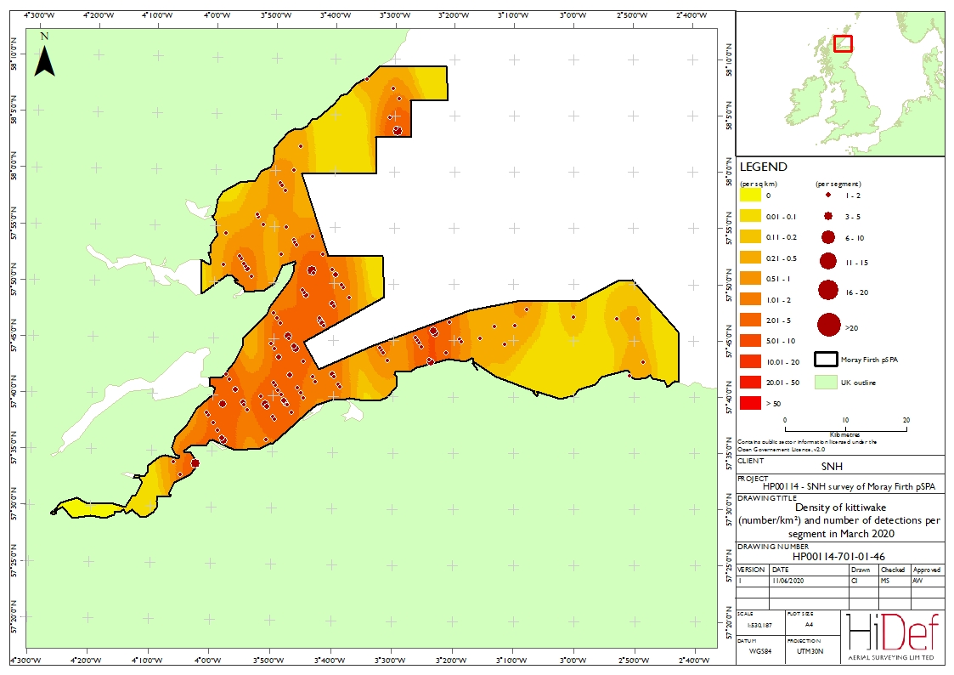

Figure A4.10 Densities of kittiwake (number/km²) and number of detections per segment during Survey 2 on 8 March 2020. Map of Moray Firth SPA showing kittiwake densities. Contains public sector information under the Open Government Licence v 2.0.

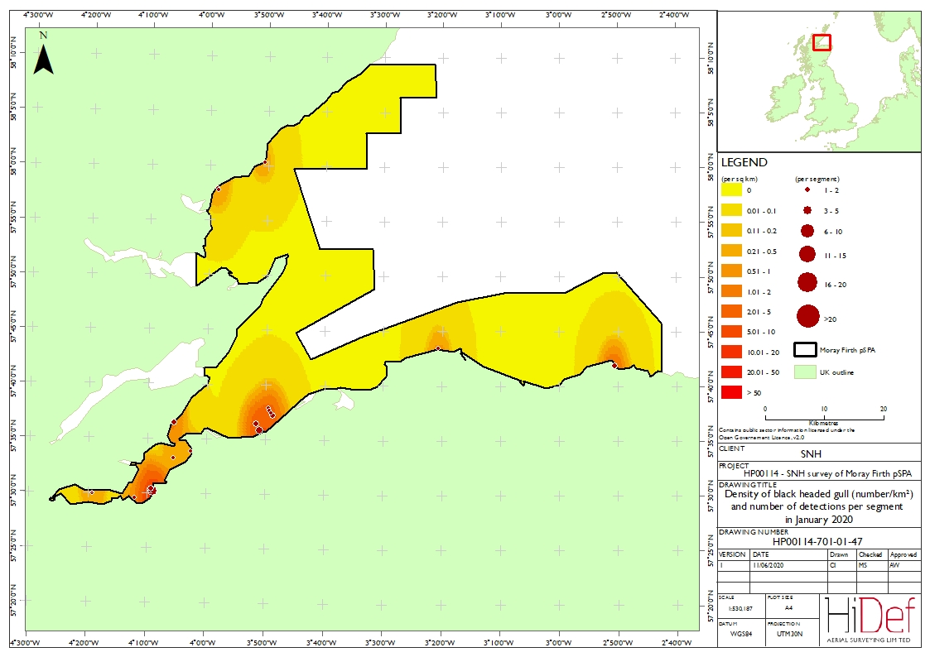

Figure A4.11 Densities of black-headed gull (number/km²) and number of detections per segment during Survey 1 on 19 January 2020. Map of Moray Firth SPA showing black-headed gull densities. Contains public sector information under the Open Government Licence v 2.0.

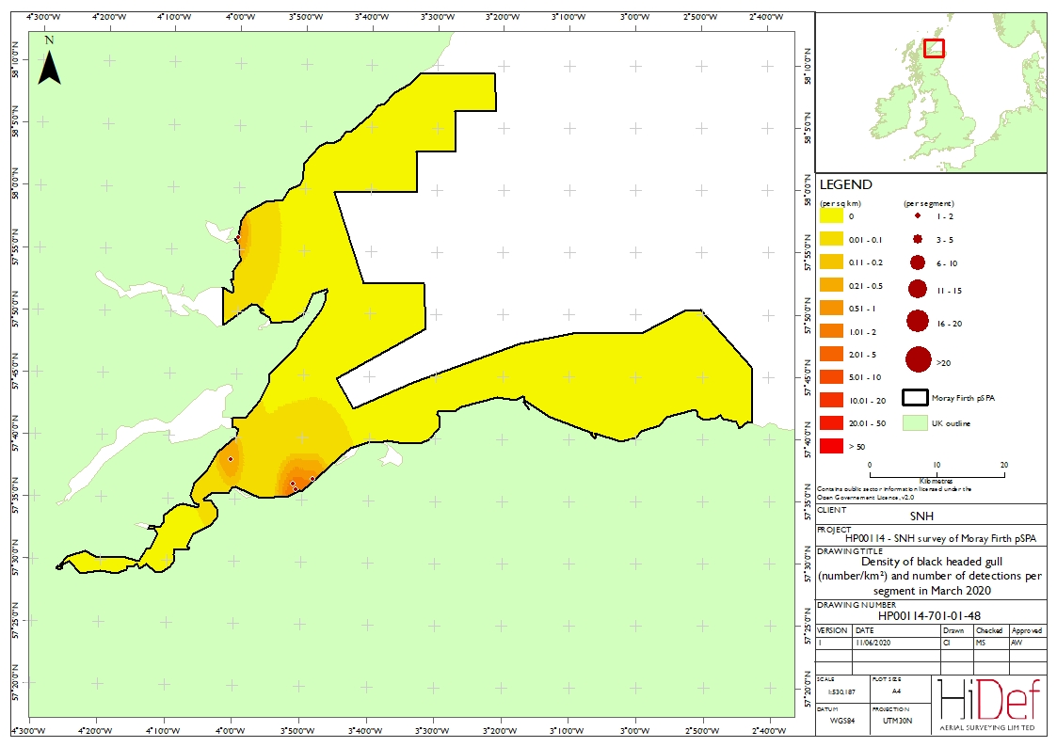

Figure A4.12 Densities of black-headed gull (number/km²) and number of detections per segment during Survey 2 on 8 March 2020. Map of Moray Firth SPA showing black-headed gull densities. Contains public sector information under the Open Government Licence v 2.0.

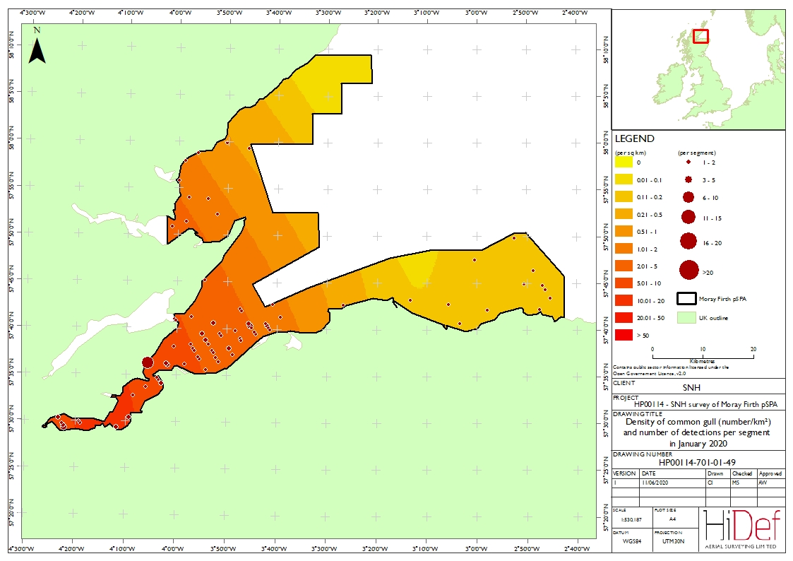

Figure A4.13 Densities of common gull (number/km²) and number of detections per segment during Survey 1 on 19 January 2020. : Map of Moray Firth SPA showing common gull densities. Contains public sector information under the Open Government Licence v 2.0.

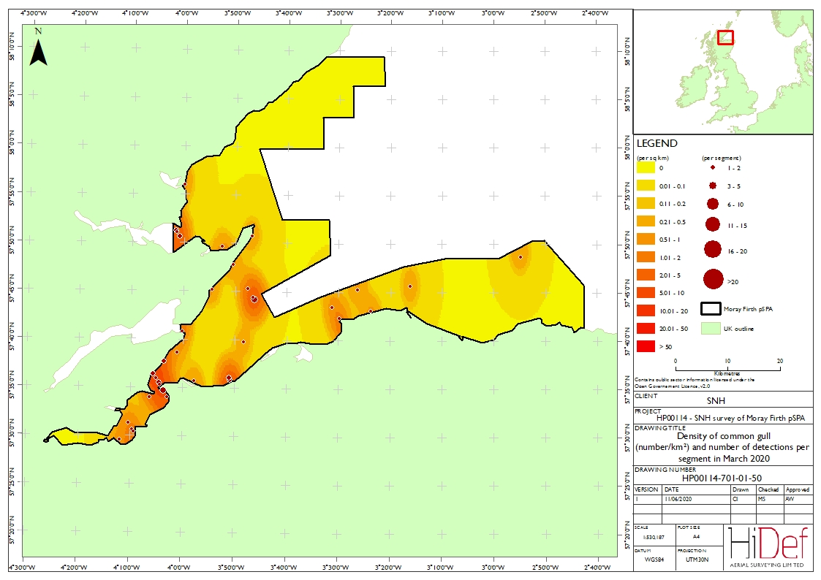
Figure A4.14 Densities of common gull (number/km²) and number of detections per segment during Survey 2 on 8 March 2020. Map of Moray Firth SPA showing common gull densities. Contains public sector information under the Open Government Licence v 2.0.

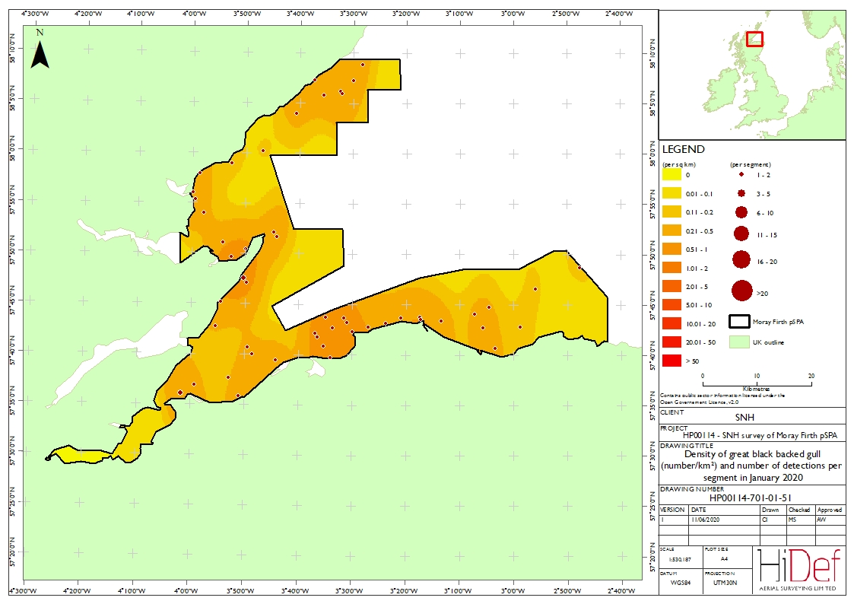

Figure A4.15 Densities of great black-backed gull (number/km²) and number of detections per segment during Survey 1 on 19 January 2020. : Map of Moray Firth SPA showing great black-backed gull densities. Contains public sector information under the Open Government Licence v 2.0.

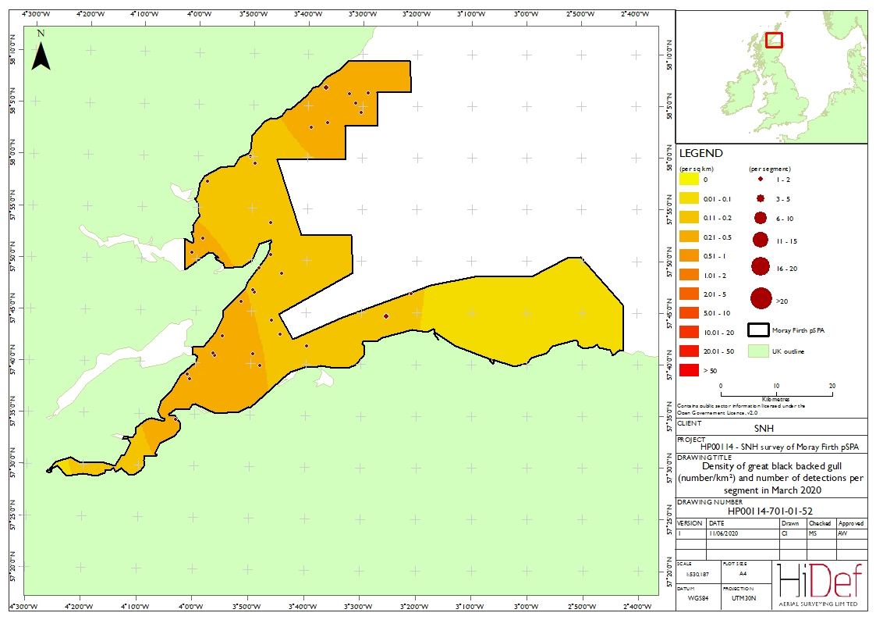
Figure A4.16 Densities of great black-backed gull (number/km²) and number of detections per segment during Survey 2 on 8 March 2020. Map of Moray Firth SPA showing great black-backed gull densities. Contains public sector information under the Open Government Licence v 2.0.

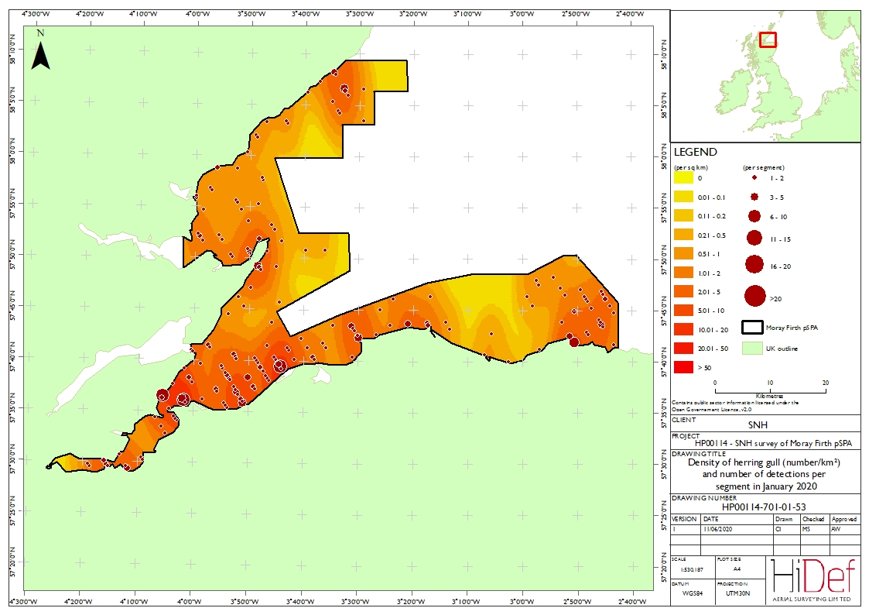

Figure A4.17 Densities of herring gull (number/km²) and number of detections per segment during Survey 1 on 19 January 2020. Map of Moray Firth SPA showing herring gull densities. Contains public sector information under the Open Government Licence v 2.0.

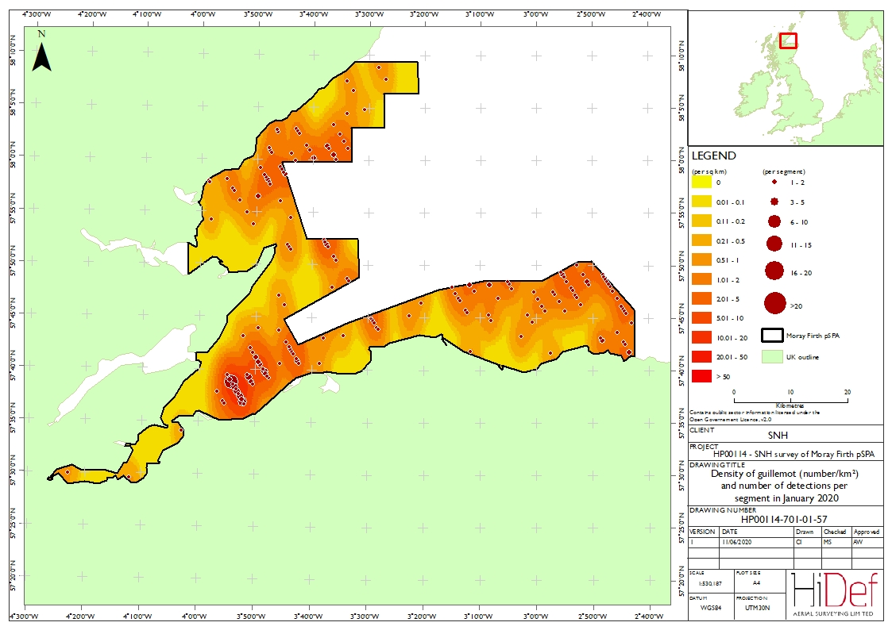
Figure A4.18 Densities of guillemot (number/km²) and number of detections per segment during Survey 1 on 19 January 2020. Map of Moray Firth SPA showing guillemot densities. Contains public sector information under the Open Government Licence v 2.0.

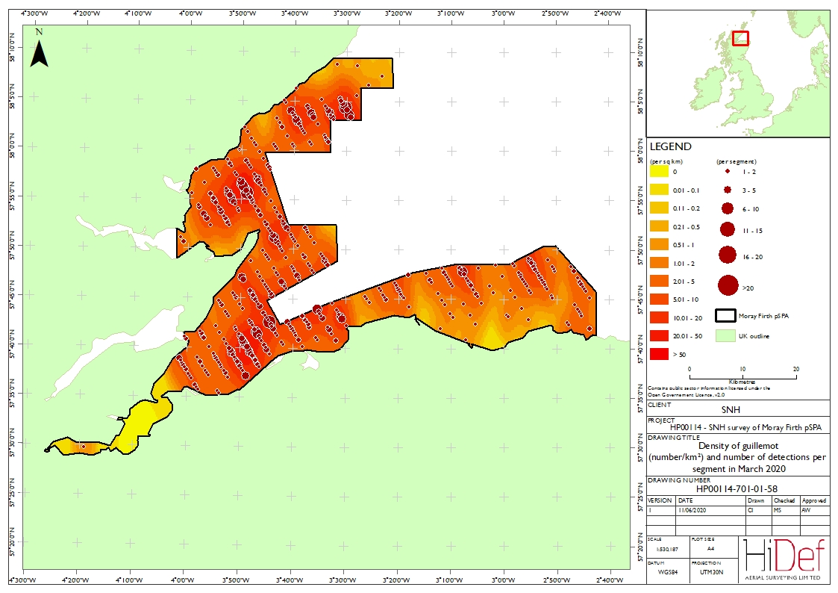
Figure A4.19 Densities of guillemot (number/km²) and number of detections per segment during Survey 2 on 8 March 2020. Map of Moray Firth SPA showing guillemot densities. Contains public sector information under the Open Government Licence v 2.0.

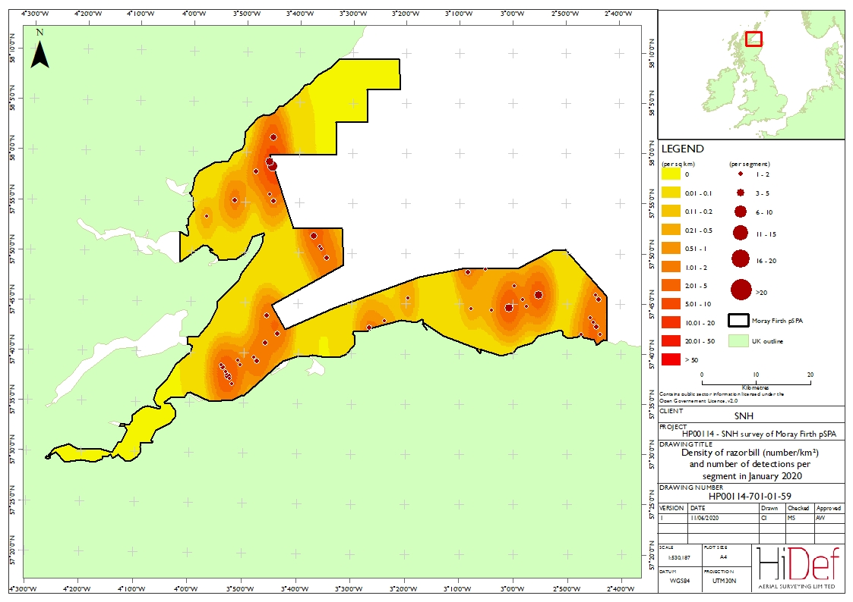

Figure A4.20 Densities of razorbill (number/km²) and number of detections per segment during Survey 1 on 19 January 2020. Map of Moray Firth SPA showing razorbill densities. Contains public sector information under the Open Government Licence v 2.0.

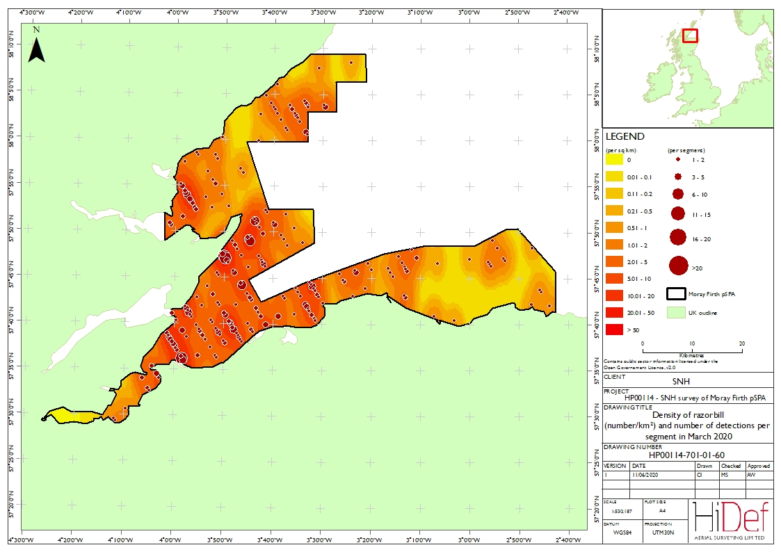
Figure A4.21 Densities of razorbill (number/km²) and number of detections per segment during Survey 2 on 8 March 2020. Map of Moray Firth SPA showing razorbill densities. Contains public sector information under the Open Government Licence v 2.0.

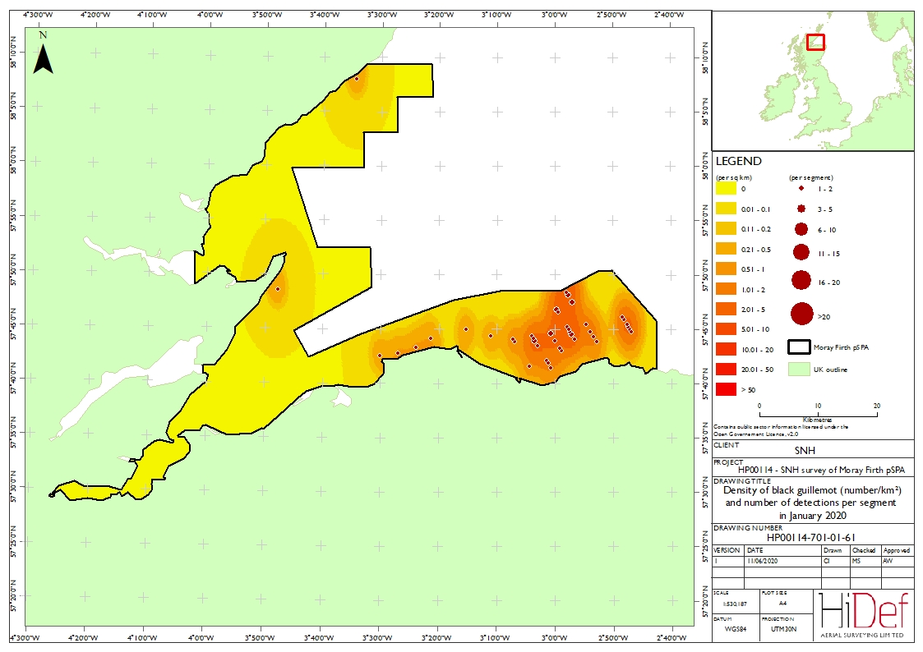

Figure A4.22 Densities of black guillemot (number/km²) and number of detections per segment during Survey 1 on 19 January 2020. Map of Moray Firth SPA showing black guillemot densities. Contains public sector information under the Open Government Licence v 2.0.

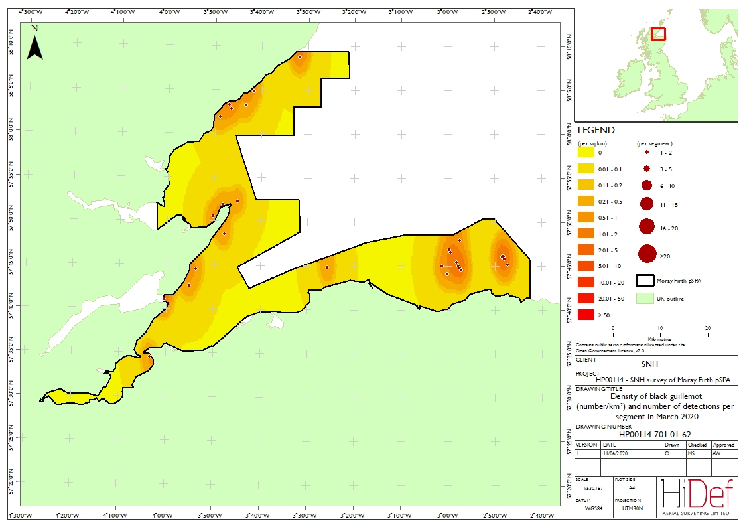
Figure A4.23 Densities of black guillemot (number/km²) and number of detections per segment during Survey 2 on 8 March 2020. Map of Moray Firth SPA showing black guillemot densities. Contains public sector information under the Open Government Licence v 2.0.

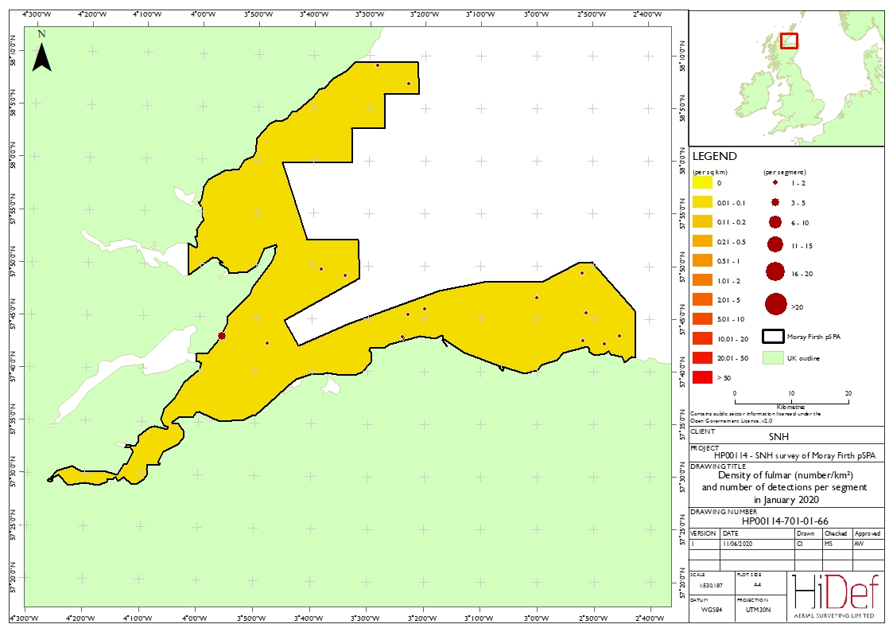
Figure A4.24 Densities of fulmar (number/km²) and number of detections per segment during Survey 1 on 19 January 2020. : Map of Moray Firth SPA showing fulmar densities. Contains public sector information under the Open Government Licence v 2.0.

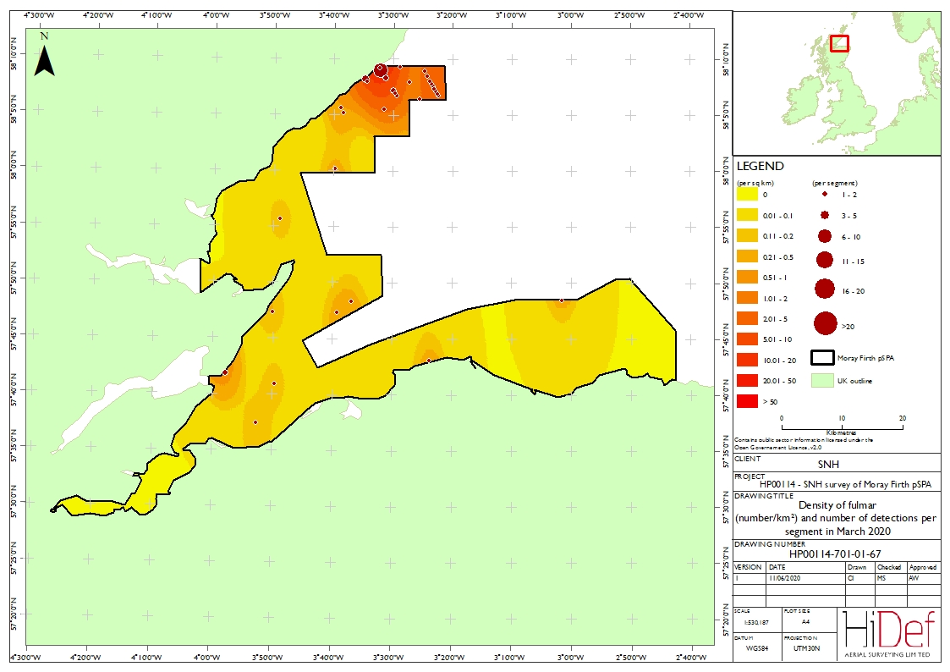
Figure A4.25 Densities of fulmar (number/km²) and number of detections per segment during Survey 2 on 8 March 2020. Map of Moray Firth SPA showing fulmar densities. Contains public sector information under the Open Government Licence v 2.0.

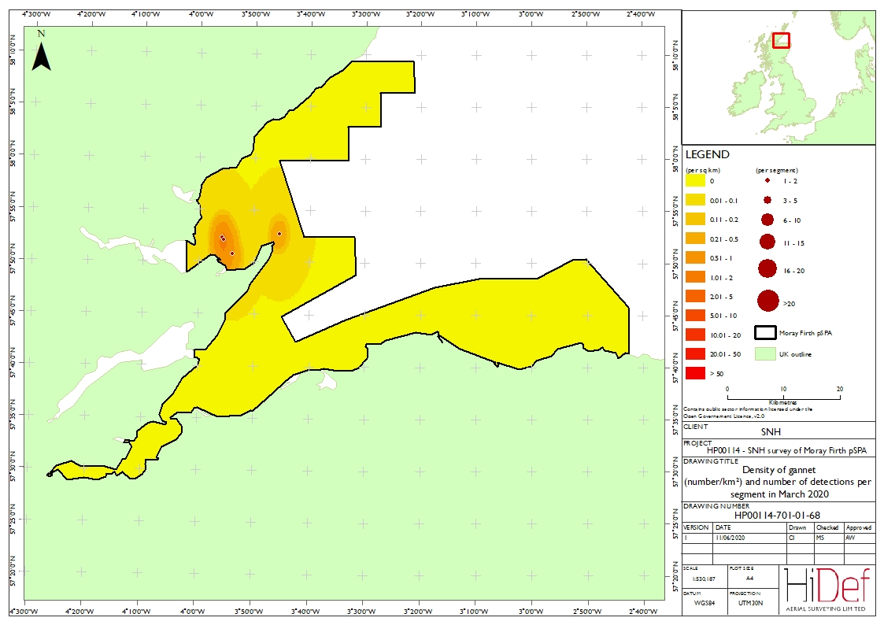

Figure A4.26 Densities of gannet (number/km²) and number of detections per segment during Survey 2 on 8 March 2020. Map of Moray Firth SPA showing gannet densities. Contains public sector information under the Open Government Licence v 2.0.

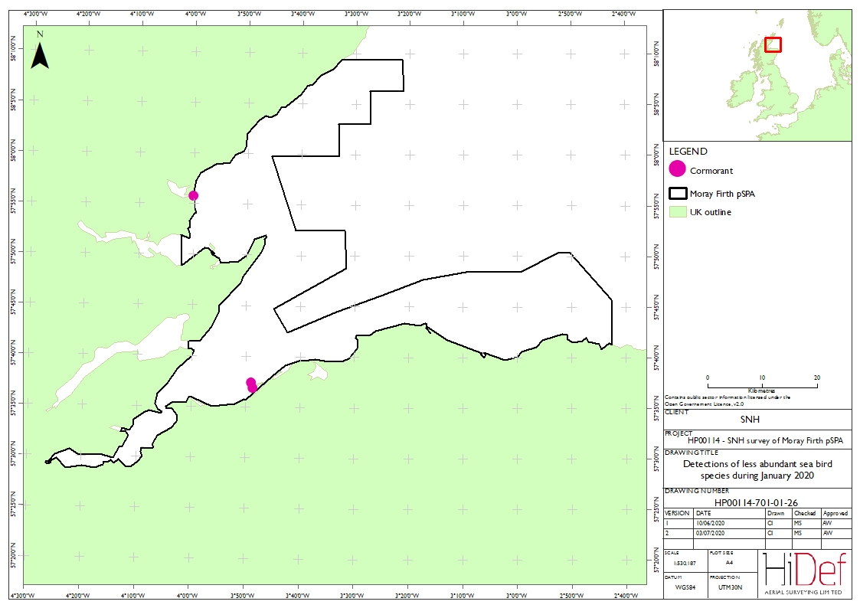
Figure A4.27 Detections of less abundant seabird species (number/km²) during Survey 1 on 19 January 2020. Map of the Moray Firth SPA showing the locations where cormorants were detected. Contains public sector information under the Open Government Licence v 2.0.

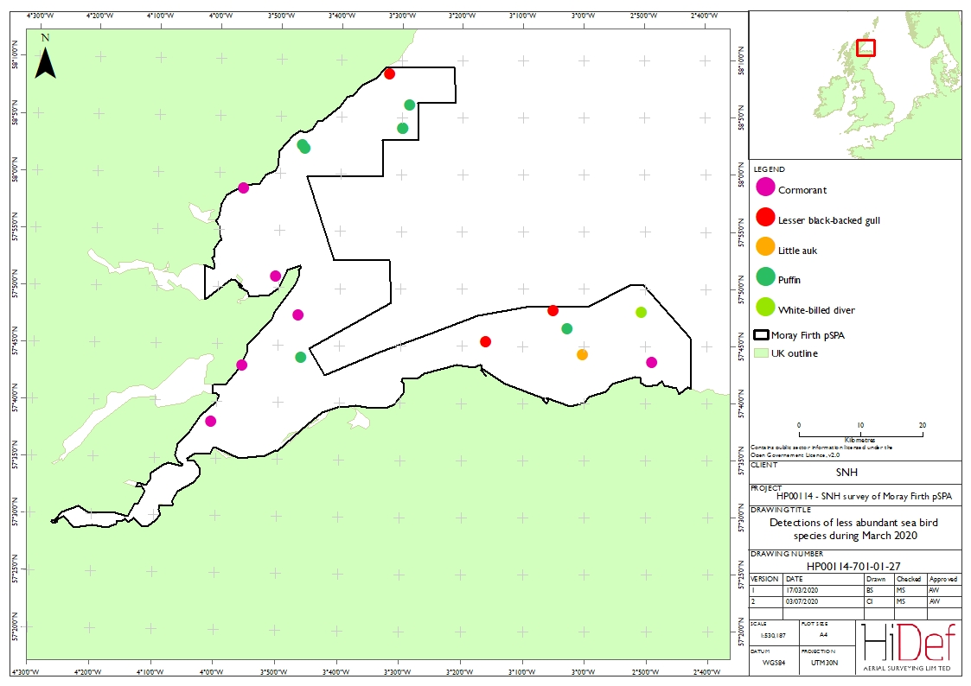
Figure A4.28 Detections of less abundant sea bird species (number/km²) during Survey 2 on 8 March 2020. Map of the Moray Firth SPA showing the locations where cormorant, lesser black-backed gull, little auk, puffin and white-billed diver were detected.
Contains public sector information under the Open Government Licence v 2.0.

