Future Routes Fund 2024

Idea Submission Form

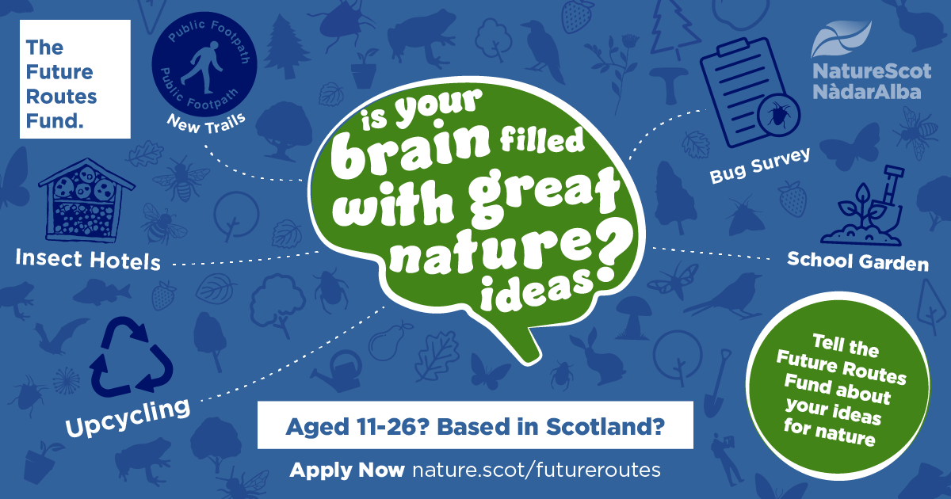
  - Future Routes Fund – 2024

Before completing this form, please read the Future Routes Guidance.

Please complete this idea submission form with as much information as possible to help us understand your idea. If you aren’t sure how to make your idea work or what it would involve, you should still submit your idea with as much detail as possible. We can support you to develop your ideas, so write down any thoughts or ideas you have even if you are not sure!

If you need help or have any questions, you can contact us on the contact details at the bottom of this page.

We are happy for you to submit this form in a different format, for example as a video or audio recording. Please ensure you answer every question fully if you decide to do this.

  - Part One: About Your Team
Please provide details about your team. If you are submitting your idea as an individual, please put your details in the ‘Team Leader’ box. If you have more than five team members, please add rows in order to list everyone!

What is your Team or Project name?
Click or tap here to enter text.

Team Leader’s Details

Name | Age |  | Postcode (eg. EH12 5EZ)
Click or tap here to enter text. | Choose an item. |  | Click or tap here to enter text.
Please provide the Team Leader’s contact details so that we can contact them about this submission.

Mobile number |  | Email address (that is regularly checked)
Click or tap here to enter text. |  | Click or tap here to enter text.

Team Member’s Details
Name | Date of Birth | Postcode (eg. EH12 5EZ)
Click or tap here to enter text. | Choose an item. | Click or tap here to enter text.
Click or tap here to enter text. | Choose an item. | Click or tap here to enter text.
Click or tap here to enter text. | Choose an item. | Click or tap here to enter text.
Click or tap here to enter text. | Choose an item. | Click or tap here to enter text.
Click or tap here to enter text. | Choose an item. | Click or tap here to enter text.

Tell us a bit about yourself or your team – for example what your interests are, how you met, what you do together, are any of you involved with nature (volunteering, hobbies etc.) You can include photos, videos, links, or any other documents. (Max 100 words).
Click or tap here to enter text.

  - Part Two: About Your Idea

Is your idea completely new, or will the Future Routes Fund money be used for an existing project that is already running?
New Project | ☐
Existing Project | ☐

Please tell us about your idea.
You should describe what your idea will achieve, how you will carry it out, and what you will spend the money on. Please provide as much details as possible to help us understand our idea. (Maximum 400 words)
Click or tap here to enter text.

Why is your idea important and how would your idea connect young people with nature and make a positive impact on the environment? (Maximum 200 words)
Click or tap here to enter text.

Which of these outcomes would your idea help to achieve?
(Remember, ideas must meet at least two of the outcomes of the fund).
☐ | Young people can improve their local environment
☐ | Young people can be engaged in their community through nature
☐ | Young people can increase their knowledge and understanding of Scottish nature
☐ | Young people have more opportunities to connect to nature and take action for nature and climate

How many young people do you hope to engage through your idea?
(If you aren’t sure, you can write your best guess).
Click or tap here to enter text.

How long will your idea take to complete?
(for example, a one-off event, 2 months, 6 months?)
Click or tap here to enter text.

Please list any other organisations/networks/clubs/communities that you could/ want to work with to make your idea happen.
Click or tap here to enter text.

What challenges do you think you might have to overcome to make sure your idea is a success?
Click or tap here to enter text.

How will you make your idea accessible to all young people (consider reasons why young people might find it difficult to get involved such as a disability, language barriers or additional support)?
Click or tap here to enter text.

  - Part Three: Your Project Support

Please provide the details of your Project Support. For more information about the Project Support please see the Guidance.

Project Support’s Name | How do you know them? |  | What is their job/role/position?
Click or tap here to enter text. | Choose an item. |  | Click or tap here to enter text.
Please provide the Project Support’s contact details in case we need to contact them about this submission.

Mobile number |  | Email address (that is regularly checked)
Click or tap here to enter text. |  | Click or tap here to enter text.
  - Part Four: Budget

Please use the table below to list all the costs involved with your idea.
It is important to research how much everything will cost so that you can ask for the right amount of money. If you don’t know exactly how much something will cost, put down your best guess – we can support you to develop your budget if your idea is successful. Remember to consider things like insurance if needed for your idea.
Please provide as much information as possible to show you have thought through what costs are involved in the project.
Item | How much will it cost? | Can this item be donated or given ‘in kind’?
Click or tap here to enter text. | Click or tap here to enter text. | Click or tap here to enter text.
Click or tap here to enter text. | Click or tap here to enter text. | Click or tap here to enter text.
Click or tap here to enter text. | Click or tap here to enter text. | Click or tap here to enter text.
Click or tap here to enter text. | Click or tap here to enter text. | Click or tap here to enter text.
Click or tap here to enter text. | Click or tap here to enter text. | Click or tap here to enter text.
Click or tap here to enter text. | Click or tap here to enter text. | Click or tap here to enter text.
Click or tap here to enter text. | Click or tap here to enter text. | Click or tap here to enter text.
Click or tap here to enter text. | Click or tap here to enter text. | Click or tap here to enter text.
Click or tap here to enter text. | Click or tap here to enter text. | Click or tap here to enter text.
Click or tap here to enter text. | Click or tap here to enter text. | Click or tap here to enter text.
TOTAL COST OF IDEA: | 0
‘In-kind’ describes a donation of a product or service made by an organisation, instead of a cash donation.

If you have any equipment/supplies left over, how will this be used?
Click or tap here to enter text.

Will your project be funded by any other individuals or organisations? If yes, who will fund your project and what is the amount of funding they will provide you?

Click or tap here to enter text.

What is the total amount of funding you require from NatureScot?
Click or tap here to enter text.

  - Part Four: Additional Information

Is there anything else you’d like to tell us about your idea that may help your submission?
Click or tap here to enter text.

  - Part Five: Signatures & Submitting Your Idea
All data provided will be protected in accordance with the General Data Protection Regulations (GDPR - the laws that protect your data). Your personal information can be removed from our system at any time if you no longer want to be part of this project.
☐ Please tick here to consent to NatureScot holding your personal details for the purposes of this project. We will use your contact details to contact you about anything related to the Future Routes Fund.
If completing this form digitally, typing your name below acts as a signature.

Team Leader’s Name: Click or tap here to enter text.

Team Leader’s Signature: Click or tap here to enter text. Date: Click or tap here to enter text.

Once you have completed every part of this form, you are ready to submit your idea! Make sure everyone in your team has read the submission and is happy to submit it! Remember to tweet #FutureRoutesFund to tell us you are getting involved!

Please send your completed Idea Submission Form to us by email or post

Post | Email
NatureScot  Meadowbank House  6th Floor South  153 London Road  Edinburgh  EH8 7AU | Futureroutesfund@nature.scot

The deadline to submit your ideas is 19 June 2024
You will hear back about your idea by 10 July 2024

We will ensure that successful applications cover a wide range of activity across Scotland so unfortunately not all applications will be successful.

  - Background Information

Who is NatureScot?
NatureScot is the government funded body that looks after all of Scotland’s nature. For more information visit www.nature.scot

Who is Young Scot?
Young Scot is Scotland’s national youth information and citizenship charity for young people aged 11-26 in Scotland. For more information visit www.youngscot.net

Who is ReRoute?
ReRoute is a group of young people who worked with NatureScot and Young Scot to engage young people in Scotland’s amazing nature and Scotland’s Biodiversity Strategy. ReRoute set up the Future Routes Fund to empower young people to take action for nature. To find out more on ReRoute visit www.young.scot/reroute.

