Habitats Regulations Appraisal (HRA) on the Firth of Forth
A Guide for developers and regulators

Contents

Section 1 Introduction

Introduction

Habitats Regulations Appraisal

Impact Pathways

Climate Change

Ecosystem Services

Section 2 Habitats Regulations Appraisal (HRA)
European Sites
The HRA procedure
Figure how to Consider plans and Projects that could affect European Sites (SPAs and SACs)
HRA in the Firth of Forth area
The information required
Determining that there are no adverse effects on site integrity
Exceptional Circumstances

Section 3 Potential Pathways of Impact
Construction Pressures
Operation Pressures
Table 1 Generic impact pathways and mitigation to consider

Section 4 Ecological Principles
Estuarine habitats and physical processes
Sediment Transport
Tidal Cycle
Species migration
Section 5 Human pressures effecting change to the environment
Pressures resulting from land-claim and physical change to the intertidal
Dredging and disposal pressures
Disturbance and displacement pressures and ecological consequences
Types of disturbance and displacement
Disturbance whilst foraging
Disturbance at roosting and resting sites
Sensitivity and habituation

Section 6 Species Accounts for Qualifying Features 17
Birds – an explanation of the account sections 17
Conservation Status 17
Origin 18
Behaviour 18
Diet 18
Habitat 18
Distribution 18
Seasonality 18
Pressures 18
Population trends 19
Marine Mammals and Fish 19
Pink footed goose 20
Shelduck 21
Wigeon 22
Mallard 23
Scaup 24
Eider 25
Long-tailed duck 26
Common scoter 27
Velvet scoter 28
Goldeneye 29
Red-breasted merganser 30
Red-throated diver 31
Fulmar 32
Manx shearwater 33
Gannet 34
Great cormorant 35
Shag 36
Great crested grebe 37
Slavonian grebe 38
Oystercatcher 39
Golden plover 40
Grey plover 41
Lapwing 42
Ringed plover 43
Curlew 44
Bar-tailed godwit 45
Turnstone 46
Knot 47
Dunlin 48
Redshank 49
Puffin 50
Razorbill 51
Guillemot 52
Sandwich tern 53
Common tern 54
Roseate tern 55
Arctic tern 56
Kittiwake 57
Black-headed gull 58
Little gull 59
Common gull 60
Lesser black-backed gull 61
Herring gull 62
Bottlenose dolphin 63
Harbour seal 64
Grey seal 65
Atlantic salmon 66
Sea lamprey 67
River lamprey 68
Further Reading 70

Annex 1: Glossary 72

Introduction
The purpose of this guide is to help developers and regulators meet the requirements of the Habitats Regulations on the Firth of Forth when first considering proposals. It does this by presenting the multiple protected areas present in the Firth of Forth and explaining the habitats regulations appraisal process. Then presenting information on qualifying features, explaining basic principles of ecology, and the most important impact pathways, while identifying key activities and pressures considered capable of affecting qualifying features.
It considers the activities involved in carrying out projects on the Firth of Forth that affect qualifying features of its associated European sites. We hope it will help in making decisions about projects, including how to avoid or mitigate impacts on European sites before proposals become so defined that solving problems is more expensive and difficult, by introducing broad principles to consider. Links to formal guidance are provided throughout this document and these should be used when carrying out Habitats Regulation Appraisal (HRA).
The Firth of Forth area contains several European sites, including:
- Firth of Forth SPA,
- Forth Islands SPA,
- Imperial Dock Lock, Leith SPA,
- Isle of May SAC
- Outer Firth of Forth and St Andrew’s Bay Complex SPA.
Nearby or adjacent European sites that may also lead to a requirement for HRA of proposals in the Firth of Forth include:
- River Teith SAC,
- Firth of Tay & Eden Estuary SAC
- Moray Firth SAC,
- Berwickshire and North Northumberland Coast SAC
- St. Abb’s Head to Fast Castle SPA.
Although these sites are all out-with the Firth of Forth, they are designated for mobile species such as fish, dolphins, seals and birds which may also use the Firth of Forth for foraging, resting, roosting, breeding.
Habitats Regulation Appraisal
Under the Habitats Regulations, decision makers (known as competent authorities in the legislation), can only agree to development proposals which are unconnected with the nature conservation management of the site, after having confirmed that they will not affect the integrity of the European site. The process of coming to this judgement is commonly referred to as Habitats Regulations Appraisal (HRA). If this is not the case and there are no alternative solutions, the proposal can only be allowed to proceed if there are imperative reasons of over-riding public interest (IROPI)
Development in and around the Firth of Forth often has potential to affect European qualifying features and therefore requires HRA. The size and diversity of the European sites which could be affected by development on or around the Firth of Forth means that assessment of potential impacts can seem complex and daunting. This guide will make HRA simpler by presenting common themes and issues which can help to focus thinking when considering impacts. Recent EC guidance has highlighted that many of the delays and problems encountered in HRAs, and Appropriate Assessments are caused by incomplete or deficient information gathering and provision, meaning competent authorities cannot confirm that there are no adverse effects on site integrity. The following are EU guidance on Article 6 (of the Habitats Directive) on the protection and management of European sites, and guidance for a range of sectors:
- Managing Natura 2000 sites, The provisions of Article 6 of the ‘Habitats’ Directive 92/43/EEC (EU 2019 43)
- Guidance document on wind energy developments and EU nature legislation (EU 2021 74)
This guidance document is intended to help with the collating of information to support HRAs in the area of the Firth of Forth.
There are some key things to consider at the earliest opportunity.
- What is the development in its entirety?
- Could works, through activities and related pressures, involve impact pathways to the qualifying features of European sites?
- If so, can they be modified in location, scale, nature or timing to avoid the impact pathway entirely?
To consider these issues, it is helpful to have a basic understanding of the qualifying species’ ecological requirements and how they might be affected by development. By ecology we mean breeding, lifecycles, diet and habitat. We hope that the species accounts in this document will help provide guidance on both the ecology and sensitivities of these qualifying features.
Impact Pathways
With such a large site, there are many types of possible impact pathways which can occur through human-related activities and their related pressures. For example:
- industry including harbours, offshore energy, oil rig repair and decommissioning sites, and their pressures including disturbance, displacement, collision, loss or damage to habitats and prey supporting habitats
- dredging and disposal and their pressures including damage of supporting habitat, smothering of prey supporting habitat, water clarity changes
- exploitation of natural resources and reclamation for industrial uses and their pressures including colonisation by non-native invasive species, habitat loss or deterioration, and reductions in prey abundance.
- leisure activities (onshore and offshore) and their pressures including disturbance, vehicle tracking and trampling
Climate change
Where we understand effects of climate change are likely to affect European site features, this must be borne in mind and considered when carrying out an HRA. The Scottish coast is exposed to climate change pressures due to effects of rising sea level, rising land and sea temperatures, increasing storms and waves, and rainfall changes on land affecting freshwater input and salinity in coastal areas These climate changes will place additional pressures on qualifying species and supporting habitats of European sites in the Firth of Forth area. For example, seabird and marine mammal foraging success and behaviour could be affected by geographic shifts in the presence of prey fish species in Scottish waters. In addition, loss of supporting habitat, such as ground vegetation, due to rising land temperatures could affect the breeding success of some wader species.
See the latest NatureScot advice on climate change impacts on species and habitats https://www.nature.scot/climate-change/climate-change-impacts-scotland ; the coast https://www.nature.scot/climate-change/climate-change-impacts-scotland/impacts-coast; present and future sea-levels https://www.nature.scot/landforms-and-geology/scotlands-rocks-landforms-and-soils/landforms/coasts/present-and-future-sea-levels and coastal adaptation guidance https://www.dynamiccoast.com/
Ecosystem Services
The Forth is the most substantial estuary on the east coast of Scotland. It stretches around 55 miles between the flood plain around Stirling and Kincardine to the open sea and cliffs characteristic of the mouth of the Firth, with Fife Ness in the north and North Berwick to the south. In addition to its marine waters, the Firth of Forth also includes a mosaic of coastal habitats and settlements that support a wide range of species. The Firth of Forth and its qualifying features provide ecosystem services, which provide benefits for both people and nature. For example, the diverse mud, sand and gravel marine habitats of the Firth of Forth support provisioning services of fish and shell-fish, and maintaining services of carbon storage. The large numbers of inshore wintering waterfowl, and both breeding and non-breeding seabirds within the Outer Firth of Forth and St Andrews Bay Complex SPA provide supporting services of nutrient cycling and biomass production. The Atlantic salmon of the River Teith SAC provide cultural services through tourism, recreation, and opportunities for connection with nature.
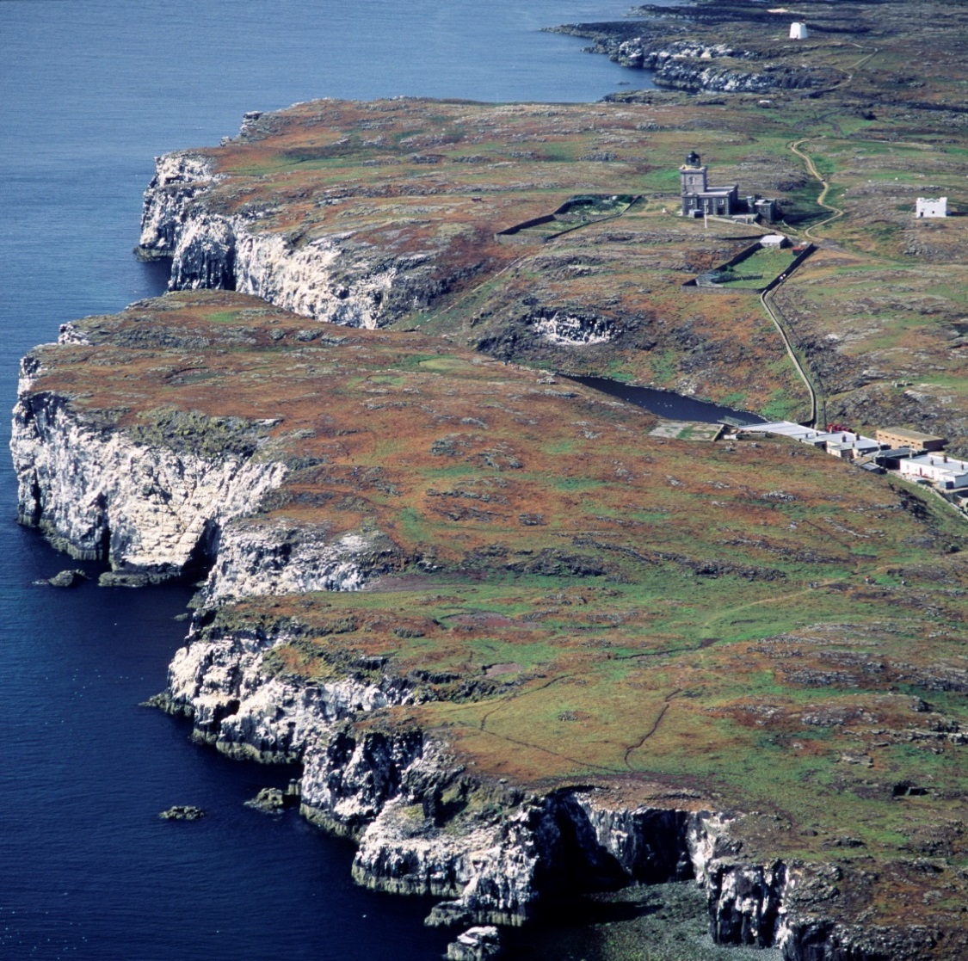

Habitats Regulations Appraisal (HRA)
European Sites
European Sites encompass the network of areas (Special Protection Areas and Special Areas of Conservation) originally set up to conserve key natural habitats and species which are rare, endangered, or vulnerable in the European Community. Following EU exit the network continues in the UK as the ‘National Site Network of European Sites’. Due to their international importance, European sites receive protection from development and other regulated activities (including general permitted development rights) in Scotland through both the Conservation (Natural Habitats, &c.) Regulations 1994, known as the ‘Habitats Regulations’ and policy. The network is not, however, a series of strict nature reserves where all human activities are excluded; instead the emphasis is on ensuring that the management of European sites is sustainable while maintaining or securing the restoration of the conservation status of qualifying species and habitats.
The HRA procedure
Habitats Regulations Appraisal is a precautionary and rigorous procedure required by the ‘Habitats Regulations’ when consenting a plan, project or proposal, e.g. under the Planning Acts. The HRA procedure must be applied to any plan or project that might affect the qualifying features of any European site; this includes plans and projects outside a European site. It provides an opportunity to consider appropriate mitigation that can reduce impacts, avoid adverse effects, and permit plans or projects to proceed having taken full account of the protected features of a European site. The HRA comprises a series of stages, and is explained in full in our Habitats Regulations Appraisal Guidance. The HRA stages (1-6) look to assess 3 key tests:
- Is the plan or project directly connected with or necessary to site management for nature conservation?
- Is the plan or project likely to have significant effect on the site?
- Can it be ascertained that the proposal will not adversely affect the integrity of the site?
Insert diagram same as within HRA guidance How to Consider plans and Projects that could affect European Sites (SPAs and SACs)
In stage 3 of the HRA process the Competent Authorities (i.e. the body responsible for consenting the proposal in question) are required to make a judgement if the plan or project is likely to have a significant effect (LSE) on a European site, either alone or in-combination with other plans and projects (Stage 3). The test for likely significant effect acts as a simple but very precautionary filter to exclude from further assessment, any plans or projects which are not capable of having a significant effect. To help clarify this the Waddenzee Judgement (para 45 p19/20) says there is a Likely Significant Effect, “…if it cannot be excluded, on the basis of objective information, that it will have a significant effect on that site”, and as such there is a high likelihood that many projects are likely to have significant effects which require further consideration. European case law states that mitigation cannot be considered at this stage, although we recognise that some measures that avoid a significant effect will be intrinsic to some projects. For more information see the handling of mitigation in Habitats Regulations Appraisal following the People over Wind CJEU judgement.
If the answer is yes, the plan or project is likely to have a significant effect on the site, they need to carry out an appropriate assessment (AA) of a plan or project, this is stage 4. European guidance states that Competent Authorities must judge proposals on a case-by-case basis because it should be recognised that what may be significant in relation to one site may not be in relation to another.
In stage 5 of the HRA the Competent Authority must come to a conclusion as to whether there are no adverse effects on the integrity of the European site. This conclusion must be reached in view of the conservation objectives of each of the sites’ qualifying features. The conservation objectives (COs) can be thought of as ecological yardsticks against which to assess the effects of proposals and apply to each qualifying species or habitat of a European site. The COs can be found on Sitelink. On Sitelink qualifying feature conservation objectives are provided within Conservation and Management Advice (CMA) documents for marine SACs, Conservation Advice Packages (CAP) for coastal and river SACs, and Conservation Objectives or CMA documents for SPAs.
The Competent Authority must consult NatureScot over their appropriate assessment and have regards to our comments. Further help and advice on HRA including links to useful guidance, court cases, legislation, and other websites can be found on the HRA page
HRA in the Firth of Forth area
The Firth of Forth area contains several European sites, including:
- Firth of Forth SPA,
- Forth Islands SPA,
- Imperial Dock Lock, Leith SPA,
- Isle of May SAC
- Outer Firth of Forth and Tay Bay Complex SPA.
Between them they contain dozens of qualifying features, mainly bird species, but also mammal and habitat features.
Nearby or adjacent European sites that may also lead to a requirement for HRA of proposals in the Firth of Forth include:
- River Teith SAC,
- Firth of Tay & Eden Estuary SAC
- Moray Firth SAC,
- Berwickshire and North Northumberland Coast SAC
- St. Abb’s Head to Fast Castle SPA.
Although these sites are all out-with the Firth of Forth, they are designated for mobile species such as fish, dolphins, seals, and birds which may also use the Firth of Forth for foraging, resting, roosting, breeding.
The information required
The breadth, content, and level of information required for an HRA depends upon the individual circumstances of each case. There can be a perception that the HRA process is complicated; however, the level of detail should reflect the complexity of the case and be sufficient to allow the Competent Authority to determine beyond reasonable scientific doubt that there are no adverse effects on site integrity. This could include mitigation within plans and proposals with the aim to reduce the level of impacts on European sites. A HRA need not therefore be a difficult or lengthy process when the issues involved are straightforward. It is the proposer of the plan or project who must supply the relevant information to the Competent Authority to carry out the HRA.
Determining that there are no adverse effects on site integrity
At stage 5 of the HRA, for a plan or project to be consented, the appropriate assessment must ascertain that the plan or project will not adversely affect the integrity of a European site. It is important to remember that the test is whether the plan or project will not adversely affect the integrity of a European site, not whether it will. Conclusions must be made on the basis of there being no reasonable scientific doubt as to the absence of adverse effects. Each case will be judged on its own merits.
The integrity of the European site only applies to the qualifying features and is directly linked to the conservation objectives for each feature. Depending on the ‘condition status’ of a feature, (that is whether the condition status is favourable or unfavourable), this will have a bearing on that feature’s Conservation Objectives If a plan or project does not undermine the conservation objectives, then the integrity of the site should be maintained or, where relevant, have the ability to be restored. Conversely, if any of the conservation objectives could be undermined, it would not normally be possible to ascertain that the integrity of the site would not be adversely affected.
If it can be concluded that the proposal will not adversely affect the integrity of a European site, permission may be granted. If not, or there is uncertainty, permission must be refused (subject to exceptions, see HRA guidance stages 6-9). A competent authority may add legally enforceable conditions to a consent to ensure no adverse effect on the integrity of a European site.

Exceptional Circumstances
Stages 6-9 are only considered in exceptional circumstances where it cannot be ascertained that the plan or project will not adversely affect the integrity of a European site. These exceptions are set out in regulation 49 of the Habitats Regulations. The regulation provides some scope to approve a plan or project even when it cannot be ascertained that there is no adverse effect on European site integrity. For a proposal to proceed there must be no alternative solutions and there must be imperative reasons of overriding public interest (IROPI). It needs to be considered whether a priority habitat or species would be adversely affected, see full list of SAC priority habitats, (there are no priority species in Scotland’s SACs). This decision requires notification to Scottish Ministers.
Potential Pathways of Impact
Here are some examples of common ways in which a proposal can have an effect on the qualifying features in the SAC and SPA European sites associated with the Firth of Forth:
Pressure examples
- Permanent or temporary habitat loss/deterioration.
- Disturbance and/or displacement (e.g. noise and visual)
- Introduction of lighting or shading
- Underwater noise and vibration impacts from piling and construction, and traffic movements (including shipping) during construction.
- Reduced water quality (including increased suspended solids, reduced dissolved oxygen and release of contaminants) from deposition of polluting materials and dredging.
- Changes to coastal processes, e.g. hydrology and sedimentation.
- Introduction or spread of invasive non-native species
- Barrier to species movement and collision risk

In many cases the pressures exerted by activities do not work independently and the way they interact needs to be considered. For example, land-claim and dredging may lead to changes in coastal processes, sediment deposition and water flows. Some may be temporary. Other pathways may be a risk to European features throughout the life of a development from construction onward, such as the risk of introducing damaging invasive non-native species (INNS).

Planning and development guidance on minimising impacts on habitats and species is available on the NatureScot website pages https://www.nature.scot/professional-advice/planning-and-development/planning-and-development-advice and marine planning advice https://www.nature.scot/professional-advice/planning-and-development/marine-planning. Also see FeAST a web-based application which allows users to investigate the sensitivity of marine features to pressures arising from human activities.

The table below identifies generic actions that have the potential to mitigate or avoid some of the commonly occurring potential activities which could exert pressures on the qualifying features in the SAC and SPA European sites associated with the Firth of Forth. This generic mitigation may not be applicable in all cases but will provide a starting point for consideration.

Table 1 Generic impact pathways pressures and mitigation to consider

Impact pathways | Potential Generic Mitigation
Damage or deterioration to intertidal habitat through run-off or pollution and reduced water quality. | - SNH advice, Scottish Government & SEPA guidance such as SEPA pollution prevention guidance  or Scottish Government "Scotland's environment" estuaries PDF.
Direct loss of intertidal and subtidal habitats and supporting qualifying features. | - No generic mitigation.  Avoid if at all possible or accept that it is difficult to mitigate without creating alternative compensatory habitat and failing the initial HRA tests
Abrasion and siltation effects on subtidal habitats | - See FeAST a web-based application which allows users to investigate the sensitivity of marine features to pressures arising from human activities.
Indirect loss of intertidal habitat within the European site and supporting qualifying features (for example as a consequence of changed coastal processes). | - Where a proposal would affect coastal processes. Modelling of the coastal processes should be used to design solution which avoid the impact, such as modifying structure locations or dredge proposals.
Temporary (construction) disturbance. | - Time construction to avoid peak times that qualifying features are present.  - Provide screening between construction site and coastal area.  - Use “soft start” techniques to avoid sudden unexpected disturbance.
Permanent disturbance e.g. from lighting, noise, human activity, etc. on development sites adjacent to areas of use by qualifying species. | - Developments can be designed to minimise these impacts – depends on the type of development, e.g. birds may habituate more to background industrial noise and vehicles than they will to people walking about, particularly with the unpredictable activity of dogs. Also depends on the sensitivity of the site.
Permanent disturbance from recreational activity in the intertidal area, i.e. people walking on the beach. | - Where planned development is close to the coast developers should plan alternative recreational provision to take pressure off the coastal site, e.g. links into core path networks away from the coast, good greenspace provision within the development. Specific access management may be required for some sites. Large scale development at particularly sensitive sites may not be suitable for this reason.  - Developers and regulators may also have to consider mitigating effects from an increase in disturbance facilitated by house building more widely in the Firth’s hinterland. Consider strategic mitigation such as ensuring increased provision of alternative recreational facilities, e.g. core path networks, country parks, ranger-managed coastal honey pot sites, good greenspace provision in developments, etc.
Temporary (construction) disturbance/damage to intertidal habitat. | - Time construction to avoid peak times that qualifying features are present.  - Carefully defined working corridors to minimise damage.  - Habitat restoration may be required.
Collision risk / barriers to flight lines (from wind turbines or tall buildings on or very close to the intertidal area) or migratory passage through water for fish and marine mammals. | - No generic mitigation - siting and design of buildings would need to be assessed.
Loss of feeding or roosting sites for birds closely associated with the SPA and on greenfield sites out with the SPA, e.g. agricultural land, parks, sports fields, etc. | - Displacement of birds by small scale development can sometimes be mitigated by careful siting and design.

Ecological Principles
Estuarine habitat and physical processes
Animals require energy to survive and to breed which they obtain from their food. Different species are adapted to feed on different resources and therefore favour different habitats. Even within the same habitat, different species may exploit different food resources. For example, through variation in bill length and shape, birds are adapted to feed on different prey species. Many waders and other long-billed birds such as curlew have touch-sensitive bill tips and typically forage by touch or a combination of sight and touch, whereas the short-billed plovers forage mainly by sight.
Minor changes to processes such as sediment deposition, water flows, availability of food resources and predator/prey relationships constantly occur. Their impact can be extremely complicated, and, in some cases, small incremental changes may lead to a substantial overall effect. Apparently minor changes to the environment therefore need to be assessed carefully when considering factors that could cause declines in bird numbers.
There are a number of characteristics of estuarine habitat. For birds the following are especially important either for their own survival or that of their preferred food source:
- Water depth and the extent of the intertidal area
- Sediment particle size and the substrate character of the intertidal area
- Nutrient levels
- Salinity
- Disturbance – area around them clearly visible and the ability to detect trouble coming
- Light

Sediment Transport
Sediment transport is natural process where estuarine habitat is strongly influenced by sediment transport processes, a supporting benefit of their ecosystem services. Sediment particle size varies throughout an estuary, determined by topography, currents, tides and weather and creates different substrates from coarse sand to fine muds. Whether a substrate is rocky, shingle, sand or mud is a key determinant of which animals and food-plants are abundant in which parts of an estuary, and hence the food available to the various species of estuarine bird. This variability of habitat in the Firth is key and also influences the abundance of prey items in the water column for seabirds and marine mammals.
Tidal Cycle
In the estuarine environment, the tidal cycle influences habitat availability and has a strong effect on the behaviour on all species present. This is compounded by limited daylight hours in winter. Estuarine birds may need to feed at night. Tactile feeders are adapted better for this than visual feeders (e.g. plovers) though the latter often have large eyes which enable them to feed at night, at least on moonlit nights. Movement of fish species and their associated marine mammal predators can be influenced by the tidal cycle allowing free migration upriver.
Habitats are important for purposes other than foraging. At high tide or when intertidal habitats and their associated food resources are unavailable waders and wildfowl often move to a safe place where they roost and wait for the tide to turn. Some may seek alternative feeding sites such as coastal fields or lagoons adjacent to the estuary. Birds, especially when migrating or over-wintering, must conserve energy and minimise unnecessary and wasteful energy expenditure. Consequently, roosting sites need to be undisturbed, by predators and human activity. Birds may use natural habitats, for example a saltmarsh or an island or mudflat, or man-made sites such as concrete islands and jetties.
Species migration
Many species use different habitats in different seasons or different stages of their life. This is particularly pronounced in fish species such as lamprey and salmon where different stages of the life cycle move between the sea and freshwater. It is also true of many bird species that migrate between breeding sites and non-breeding areas. For some species, including oystercatcher, curlew, and redshank a proportion of birds remain within Britain but many of them move inland to breed and only small numbers breed within the Firth of Forth and its immediate vicinity.
Human pressures effecting changes to the environment
Pressures resulting from land-claim and physical change to the intertidal
Land-claim (also referred to as “reclamation’) involves converting marine or intertidal habitat to dry land, often by constructing a barrier such as a seawall to prevent the tide from reaching that area. Parts of the Forth estuary have been claimed and converted for use as industrial sites (e.g. the Grangemouth industrial complex, Rosyth port complex). Other areas have been used for dumping mining waste, ash from coal-fired power stations and general waste (e.g. at Bo’ness, Longannet and Kinneil) with most such habitat losses occurring in the 20th century. In addition, there has been longer term and progressive loss for agriculture. As much as 50% of the historic intertidal of the Firth of Forth has been lost for a variety of reasons including agriculture, harbours and industrial development. The most obvious impact of land-claim on birds is the loss of natural marine and intertidal habitats. However, change is not always entirely negative. In time, some of the areas claimed from the estuary develop into different habitats, some of which become valued as wildlife habitats and local nature reserves (e.g. the old bing at Bo’ness and Kinneil lagoon. Musselburgh lagoons are another example and are an important area of the Firth of Forth SPA for birds). Even where development has minimal or no physical impact on intertidal habitat, birds may still be affected. Some developments adjacent to the estuary may not directly affect estuarine habitats but result in loss of inland habitat used by estuarine birds that can be particularly important at certain times (e.g. feeding areas for pink-footed geese, wigeon, lapwing, golden plover, curlew and roost sites for a variety of species).
Birds that previously used claimed areas must find new habitat. Their ability to do so will depend on whether these sites have any capacity to support extra birds. A study of birds displaced by the construction of Cardiff Bay barrage highlighted that displaced birds will not necessarily be able to find suitable alternative long-term habitat elsewhere. The study also demonstrated that the displaced birds were significantly lighter than those which had previously been using the site and suffered significantly higher winter mortality.
Land-claim may also have indirect effects. Altered topography may cause changes to currents and tidal flows, affecting sediment deposition and erosion and potentially affecting the extent and type of intertidal habitat available to birds. Such effects may extend well beyond the immediate vicinity of the development. For example, the creation of jetties may cause additional accretion to occur one side of the jetty and reduced accretion or scour on the other. Land-claim also has the potential to create narrower estuaries and ‘coastal squeeze’, making habitats more vulnerable to future sea-level rise.
Land-claim and development projects may often be small but the cumulative effect of many small-scale developments causing minor loss of habitat may be significant.
Dredging and disposal pressures
The act of dredging has consequences beyond the area dredged and the immediately adjacent seabed. It alters the sediment equilibrium leading to redistribution over a much wider area. Many living organisms are removed and habitats for others are destroyed or redistributed.
Maintenance dredging is an ongoing process and there may be insufficient time for ‘recovery’. Therefore, changes in sediment structure and invertebrate communities may be more permanent and the bird assemblages associated with such continuously dredged areas could potentially achieve a new stable equilibrium. Capital dredging is likely to have a greater impact on established use of an area by birds.
Dredging may also increase the levels of metals and organic pollutants in the estuary, by releasing contaminants that have been trapped within the sediments. In some cases, it has also been suggested that nutrients have also been released during dredging operations.
Dredging can also change the level of mudflats and sandflats so that less area is exposed at certain states of the tide, reducing areas available for foraging birds.
The impact of dredging can differ markedly between sites and therefore potential changes to the water and sediment flows of an estuary should be carefully assessed and tested through models specific to that site. Modelling is most often carried out at the project stage. Strategic planning should therefore consider whether dredging associated with proposals is possible in principle and should ensure adequate policy safeguards are in place in addition to ensure no adverse effect on site integrity.

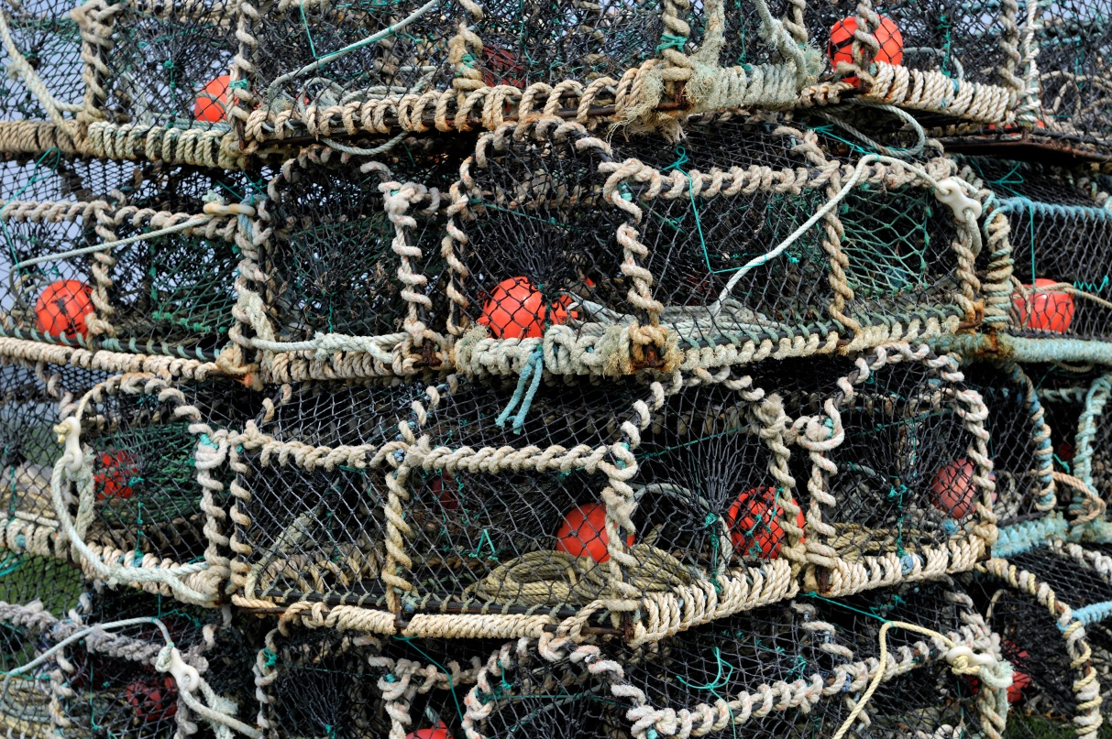

Disturbance and displacement pressures and ecological consequences
Types of disturbance and displacement
Disturbance is defined as the result of direct or indirect interaction with people that changes the behaviour of any animal or changes the environment, which in turn affects the well-being or survival of an animal in the short, medium, or long-term. Disturbance can occur naturally, for example when predators approach potential prey. However, this section focuses on anthropogenic disturbance pressures. The effects of disturbance depend on magnitude, frequency, predictability, extent, and duration. Nature can also experience ‘displacement’ effects without ‘disturbance’. For example, due to the sustained presence of new objects and/or infrastructure, which denies or limits the use of an area by particular species.
Whilst it is clear and obvious that species may be disturbed to some extent by human activity, it is more difficult to assess the actual impact that disturbance, and displacement, may have on individuals or at a site or population level. Feeding and resting activity of birds and mammals may be disturbed by both the presence of people and noise associated with particular activities. In the environment of an open estuary, views are very long, and sound carries well, especially over water. Thus, disturbance on estuaries can have exceptionally long reach.
Activities causing disturbance and displacement pressures include:

Construction work
Construction work on or adjacent to an estuary may cause noise and visual disturbance. Major construction work can reduce densities, or exclude birds from some intertidal areas, during the construction phase (and sometimes after construction)

Noise
Birds often respond to loud noise by flying away but few studies have looked at the effect of noise on foraging and roosting birds. Most studies have found that irregular and/or louder noises cause more disturbance than quiet and/or regular noises. Noise impacts through the water can be particularly disturbing to some marine mammals and fish and can even cause physical damage. Sound propagation in marine environments is affected by four main factors: the frequency of the sound, water depth, and density differences within the water column, which vary with temperature and pressure.

Artificial lighting
Artificial lighting has been found to affect the movements of migratory birds by attracting them, sometimes causing mortality, Artificial lighting can make it easier for visual feeders to find and capture prey but also make birds more vulnerable to predators.

Aircraft
Aircraft may have particularly strong effects on waterfowl, but as with other influences this depends on volume, height, frequency of flights and other factors

Walking and dog-walking
Walking (including birdwatching) and dog-walking are among the most common and widespread activities carried out on British estuaries. Individual instances of disturbance from these activities may be relatively minor, but cumulatively the effects may be considerable. For example, a stretch of shore used by many people for recreation may become unusable for birds.

Water-based recreation
Water-based recreational activities include sailing, water-skiing, jet-skis, motorboats, kayaking windsurfing, and paddleboarding. Water-based activities may affect species that normally forage at sea and are less used to disturbance than birds using other habitats.

Disturbance whilst foraging

The actual impact of disturbance to feeding animals depends on the effects of disturbance on energy intake and expenditure. This will be determined by:

- how much foraging time is lost
- how much extra energy expenditure occurs because of disturbance, and
whether individuals can compensate
Animals may be able to compensate by a variety of means:
- using alternative habitat, if available
- increasing food intake rates when they resume feeding and/or
- extending the length of time that they feed
Minor levels of disturbance may therefore have little long-term effect. However, the ability to compensate may be limited. Wading birds can feed on mudflats only during low tide when they are uncovered, and areas will be variable in their foraging quality. This limiting factor becomes more important in cold weather when birds need to feed for longer to meet their energy requirements. Some species need to feed for longer than others and so are more susceptible to the effects of disturbance during cold weather. Sustained or repeated disturbance may result in an area becoming unusable and effectively the long-term loss of an area of feeding habitat. Such disturbance may therefore cause a reduction in the number of birds that a site can support, known as the 'carrying capacity' of a site.

Disturbance at roosting and resting sites

Birds
Disturbing activities can occur at or close to the high-tide mark, where roosting birds are often more vulnerable to disturbance pressures, as they gather in large flocks. Foraging birds are generally spread out over a wide area of mudflat, and often further away from most human activities. Many subtidal species, such as the seaducks, roost during the night, irrespective of tidal cycles. Some seaducks may also have ‘retreat zones’ which they may use if they are disturbed. Therefore, considering which species are susceptible to disturbance, for any given proposal, will be important, and may have a bearing on potential impacts.

Seals
Seals (grey and harbour) are vulnerable to disturbance and displacement at their haul out sites. People getting too close, especially with dogs are a particular problem. Seals are especially vulnerable to disturbance during the breeding season and, during their moult.
Mothers recognise their pups from their calls and smell. The bond formation between mother and pup can be interrupted by excessive or persistent disturbance, particularly during the first few days after birth. If a mother fails to recognise her pup and abandons it, the pup is likely to starve and die. Females pupping for their first time are often more susceptible to disturbance. During their moult, seals prefer to spend longer out of the water than at other times of the year. This is because they are growing new hair. At this time their peripheral blood supply is open, providing the cells that make the new hair with the necessary nutrients. If they are forced to enter the water the blood system closes down, and they have to restart this system when they next haul out. This is a drain on their energy reserves.
Bottlenose Dolphin
It is difficult to determine specific resting or breeding sites for dolphin, but we do know that certain areas are particularly important for them. Dolphins are present in the Firth of Forth all year round, and, while they range widely, they appear to favour particular areas. They may range further afield and occur regularly in the Firths of Tay, Forth and St Andrews Bay.
Sensitivity and habituation

The impact of disturbance may be lower if it occurs regularly and is predictable (e.g. walkers staying on footpaths), especially if the intensity of the disturbing feature is not severe. In such cases, birds may show habituation to disturbance and allow a closer approach than birds which are not habituated. This does not mean that it is safe to assume that birds will habituate to any disturbance.

Measures to prevent disturbance in late winter may be particularly important as this will be when many species are likely to be most at risk and less able to compensate for the effects of disturbance; declining temperatures and food quality combine to make survival more difficult in late winter. This is especially true during periods of severe weather, when birds may be at risk of starvation even without the added impact of disturbance. A formal statutory process and set of criteria already exists in the UK to suspend shooting of wildfowl on the foreshore in severe weather.
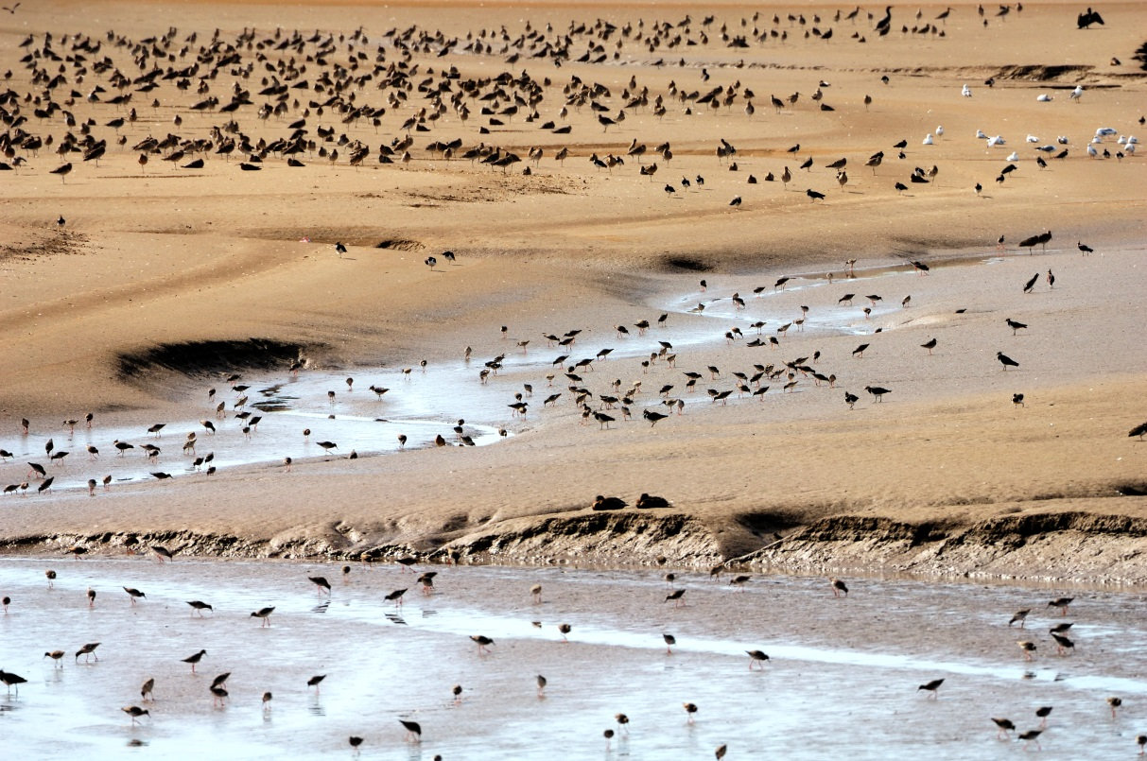

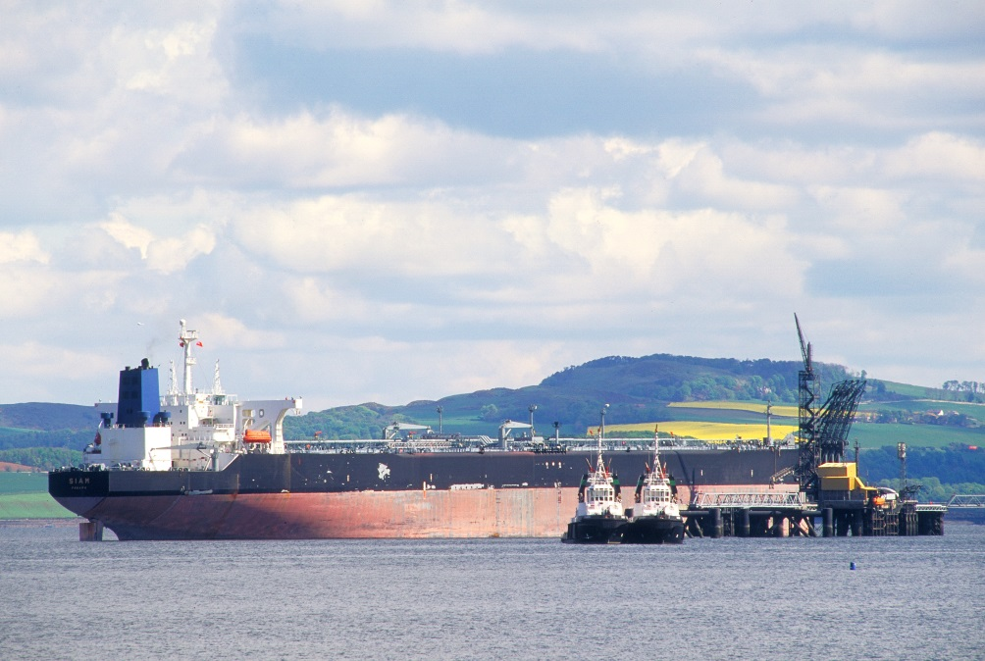

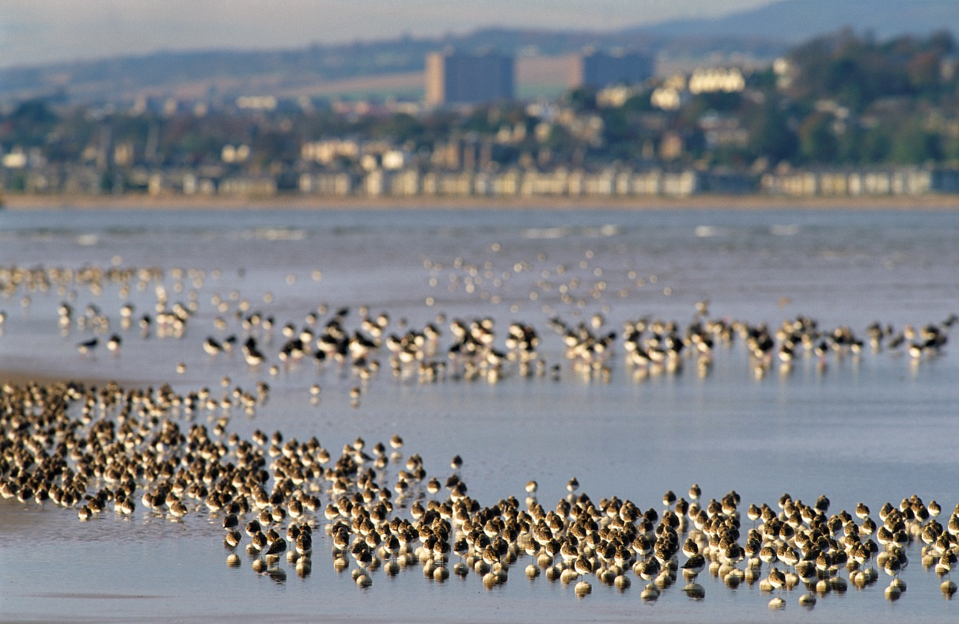

Species Accounts for Qualifying Features
This section contains brief species descriptions for all the qualifying features of European sites which are likely to require consideration for projects occurring on the Firth of Forth. Not all developments will have the potential to affect all features. The accounts are not arranged by Natura site. The species can be clearly referenced to the relevant European site by checking the citation. Information on all European sites and their qualifying features is available on Naturescot Sitelink page. This includes interactive maps of the sites.
Birds - an explanation of the account sections
The bird species accounts apply to the European sites to which they relate, and identify their populations at classification, origin, behaviour, habitat, diet, seasonality, pressures, and population trends. Reference sources are included from which the information required to complete the various aspects of each species’ account was obtained.

Condition Status
SPA & SAC features may, or may not, be in ‘favourable condition’. Please check Sitelink to see the most up to date ‘condition status’ for each European feature. The condition of a feature can be important to take into consideration when undertaking an HRA. For example, if a feature is ‘unfavourable-declining/no change’ it means that the potential for that feature to accept further and/or ongoing pressures is going to be low, thus it’s resilience to deal with ongoing impacts could potentially affect its recovery. Therefore, ‘condition status’ has relevance for including within HRAs.
Origin
This section describes whether the species is a resident within the Firth of Forth area covered by this review, or migratory. For non-resident species, it describes briefly where they spend the rest of the year.
Behaviour
Key information on each species’ feeding, roosting, and breeding behaviour when they are present within the Firth of Forth area.
Diet
Key information on the diet of each species when they are present within the Firth of Forth area.
Habitat
This section summarises information on the principal habitats that species use within the Firth of Forth area. Habitat use is described for both high and low tides as some species’ presence in a particular habitat can be dependent on the state of the tide.
Distribution
This section summarises the occurrence and abundance of the species within: (a) the ‘Inner Forth’, defined as the largely estuarine area upriver from the Queensferry Bridges; and (b) the ‘Outer Forth’ that includes the Firth of Forth below the Queensferry Bridges, the Forth Islands and outer Tay areas. Within each area, the distribution and abundance of species are described using the terms:
- Widespread – species found in most areas of suitable habitat within the site.
- Local – species found in a few (often specific) areas of the site.
- Absent, rare, scarce, uncommon, common, numerous – six subjective categories are used to indicate relative in increasing order of magnitude. These categories are based on data from the Wetland Bird Survey (WeBS), the Seabird Monitoring Programme, local bird reports and BTO expertise. Numerical data for each species are presented in the population trends section.

Seasonality
Periods of presence and relative abundance are presented graphically using data from the WeBS where applicable or are otherwise summarised by brief text. Where presented, the figures show mean monthly counts for five recent years.
Pressures
This section provides a short summary of some pressures and issues most relevant to each species, both within the SPAs and elsewhere in the Firth of Forth. Some pressures apply to all species (for example pollution or recreational disturbance) and to prevent repetition, these are largely excluded from the species accounts but are noted in the discussion on impacts earlier in this document. A more detailed discussion is available at
SNH Commissioned Report 804: A review of literature on the qualifying interest species of Special Protection Areas (SPAs) in the Firth of Forth and development related influences upon which this guidance is based.
In some instances, there is a lack of published evidence that specific pressures identified for one species may also influence other species, even though this seems likely. An example that is especially relevant to the Firth of Forth is the interaction between scaup, molluscs and water quality - reduced sewage outputs leading to reduced mollusc abundance which supported fewer scaup. Although it is likely that other sea duck will have similar interactions, their accounts may not include this pressure because a link has not been investigated or the details remain unpublished. Therefore, the list of pressures should not be considered comprehensive but rather an indication of current knowledge about them, and new issues may arise in future which plans and projects need to consider.
Highly Pathogenic Avian Influenza or HPAI is affecting seabirds, for most recent guidance see here
Population Trends
Where data are available, this section details whether the Firth of Forth area population for each species has increased, declined or remained stable, and makes comparisons with the wider Scottish trend. The comparisons are made to illustrate that a decline or increase within the Forth area does not always indicate a change in the conditions of that area. In some cases, a change in the Forth may simply reflect wider scale changes occurring in Scotland and further afield. The accounts use data from the Wetland Bird Survey (WeBS), and the Seabird Monitoring Programme.
Note that population trends are determined from data that are not necessarily restricted to the SPA. This will lead to some apparent discrepancy from baseline population estimates given under the ’Conservation Status’ heading; however, the trends should be representative of patterns of change within the SPAs.
Figures derived from WeBS show relative changes in peak counts over the period covered (generally over three decades) with the baseline year (index = 100) taken as the 2010/11 winter. The figures illustrate both the raw maximum indices (joined by a dotted line) and also the smoothed trend (shown by a solid line) derived from those counts.
Population changes for pink-footed goose are based on winter roost counts. Population changes for breeding seabirds are based on counts of apparently occupied nest sites. Breeding seabird trends are shown for years when most (and a constant sample of) island colonies have been counted. Longer runs of seabird data than presented are available from single colonies, notably for the Isle of May.

Pink-footed goose
Anser brachyrhynchus

For the most up to date information on site conservation status and population trends go to Sitelink:

Firth of Forth SPA
Sitelink provides feature condition assessment details, with feature conservation objectives provided in either a Conservation Advice Package (CAP), Conservation and Management Advice (CMA) or generic Conservation Objectives
SPA Population at Classification: 10,852

Origin – Winter visitors to Scotland, breed in Iceland and eastern Greenland. Many birds that winter in England stage in Scotland in the spring and autumn.

Behaviour – Highly gregarious, roosting and feeding in large flocks. Persistent use of favoured feeding sites within and between winters, especially when little disturbed.

Diet – Herbivorous. Outside the breeding season feeds on improved grasslands, cereal stubbles and vegetables (e.g. potatoes, sugar beet, carrots).

Habitat – Feeds on farmland and usually roosts on estuaries at night. Foraging areas are normally within 20 km of roost sites.

 | Low tide | High tide
Open water
Intertidal mud |  | -
Saltmarsh
Rocky shore | - | -
Coastal fields
Inland fields

Distribution
Inner Forth | Locally numerous
Outer areas | Locally numerous

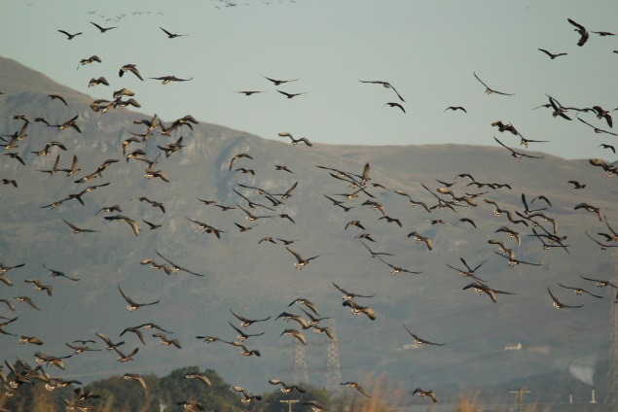
Anne Cotton

Seasonality – Mainly a passage migrant with more modest numbers through the winter.

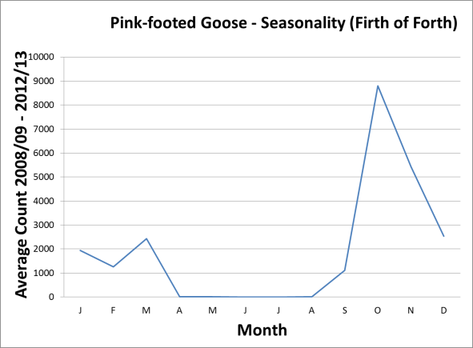

Pressures – Conflict with farmers may grow especially if numbers continue to increase. Changes in agricultural practice could affect food availability. Disturbance to roosts and feeding areas. A major quarry species for hunters.

Population trends – Winter numbers in (and around) the Firth of Forth have increased in line with national trends.

Shelduck
Tadorna tadorna

For the most up to date information on site conservation status and population trends go to Sitelink:

Firth of Forth SPA

Sitelink provides feature condition assessment details, with feature conservation objectives provided in either a Conservation Advice Package (CAP), Conservation and Management Advice (CMA) or generic Conservation Objectives.

SPA Population at Classification: 4,509

Origin – Undertakes short migrations to moulting sites in late summer when most adults leave the UK for a month or two. Small number of birds moult in British estuaries, notably including the Forth.

Behaviour – Feeds by digging and dabbling in intertidal areas, feeding during both day and night according to the tide. The late summer moulting flock around Grangemouth is one of the three largest in Britain.

Diet – Various tiny invertebrates, with small molluscs predominant in northern and western Europe, especially Hydrobia snails.

Habitat – Prefers saline habitats including muddy and sandy estuaries.

 | Low tide | High tide
Open water
Intertidal mud |  | -
Saltmarsh
Rocky shore | - | -
Coastal fields
Inland fields

Distribution
Inner Forth | Widespread, numerous
Outer areas | Locally common

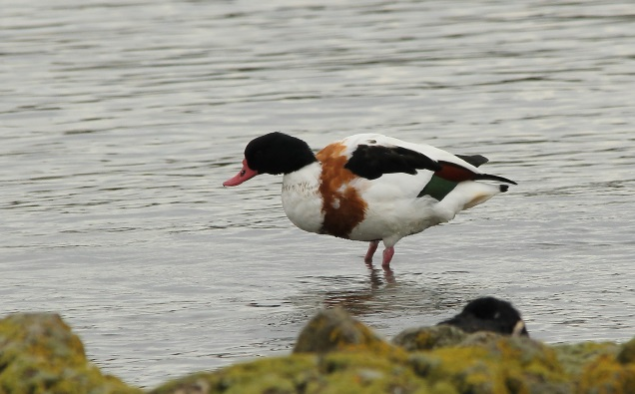
Anne Cotton

Seasonality – Mainly an autumn/winter visitor, with peak numbers occuring during the autumn moult in August/September. The breeding population on low ground around the estuary is important in a Scottish context.

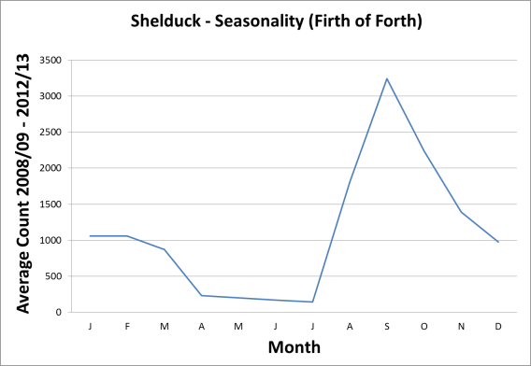

Pressures – Disturbance to potentially flightless moulting birds. Across UK estuary sites counts were significantly lower in areas close to footpaths. The abundance of Hydrobia water snails (a major food source for the species) is influenced by water quality and may affect the numbers of shelduck and their duration of stay.

Population trends – Numbers reasonably stable in recent years.

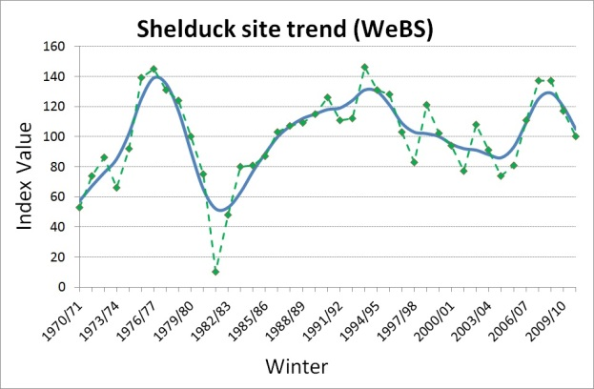

Wigeon
Anas penelope
For the most up to date information on site conservation status and population trends go to Sitelink:

Firth of Forth SPA

Sitelink provides feature condition assessment details, with feature conservation objectives provided in either a Conservation Advice Package (CAP), Conservation and Management Advice (CMA) or generic Conservation Objectives.

SPA Population at Classification: 2,139

Origin – Birds wintering in UK breed mainly in northern Russia, though some Icelandic-bred birds also occur in Scotland.

Behaviour – Gregarious, forming large flocks, often grazing in grassy fields. Can feed at night, especially in marine habitats.

Diet – Plant material from both above and below surface level.

Habitat – Salt marshes, lagoons, estuaries, intertidal mudflats, sheltered marine habitats and nearby grassy fields.

 | Low tide | High tide
Open Water
Intertidal mud |  | -
Saltmarsh
Rocky shore | - | -
Coastal fields
Inland fields

Distribution
Inner Forth | Widespread, common
Outer areas | Locally common

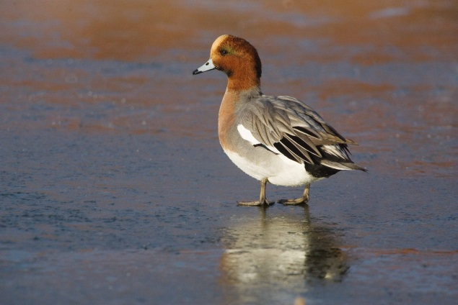
Edmund Fellowes

Seasonality – Winter visitor, from September to March.

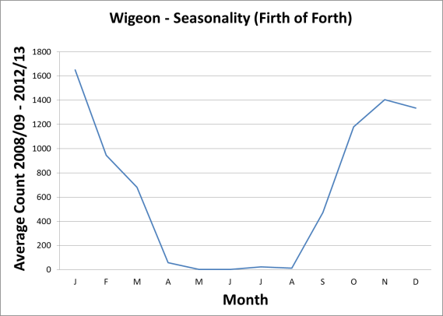

Pressures – Wigeon flocks feed close to the water’s edge. When disturbed, flocks fly to the safety of open water and take a while to come back to feed affecting their ability to forage if ongoing disturbance occurs.

Population trends – The Forth trend is tracking the Scottish trend, and the proportion of Scottish wintering birds using the site is stable. This suggests the site remains relatively favourable to this species.

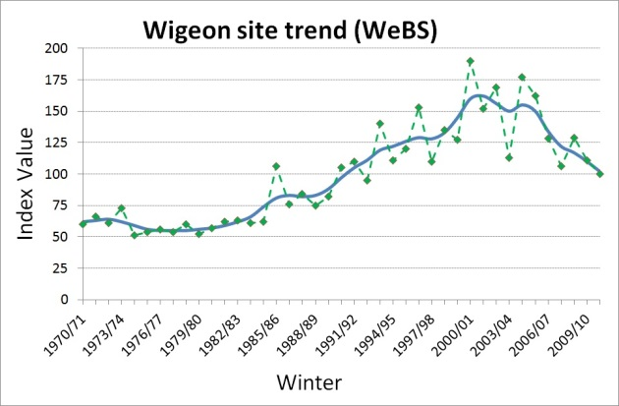

Mallard
Anas platyrhynchos
For the most up to date information on site conservation status and population trends go to Sitelink:

Firth of Forth SPA

Sitelink provides feature condition assessment details, with feature conservation objectives provided in either a Conservation Advice Package (CAP), Conservation and Management Advice (CMA) or generic Conservation Objectives.
SPA Population at Classification: 2,564
Origin – Many are local but up to three-quarters of the birds wintering in the UK may be winter visitors from northwest Europe.

Behaviour – Feeds predominantly by dabbling in shallows or upending in slightly deeper water. Birds may occasionally graze ashore. May feed at night. Often tolerant of humans, especially in urban areas.

Diet –Will eat both plant and animal matter.

Habitat – All wetland types, though prefers sites with shallow water and cover. Will feed and roost on the sea and in brackish waters.

 | Low tide | High tide
Open water
Intertidal mud |  | -
Saltmarsh
Rocky shore | - | -
Coastal fields
Inland fields

Distribution
Inner Forth | Widespread, common
Outer areas | Widespread, common

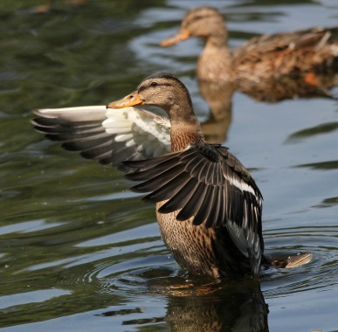
Anne Cotton

Seasonality – Mainly a winter visitor but with substantial numbers resident and breeding.

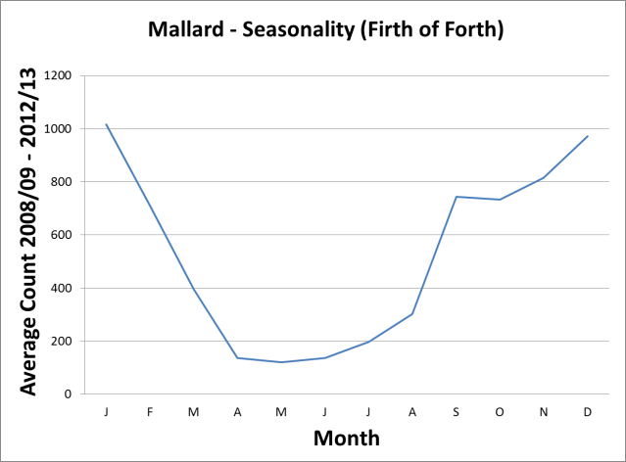

Pressures – Localised disturbance.

Population trends – The decline in the wintering population in the UK is thought to be caused by a reduction in long-distance movement by European mallards, perhaps because of milder winters in mainland Europe. The Forth trend is tracking the Scottish trend and the proportion of Scottish wintering birds using the site is stable. This suggests conditions on the site remain favourable for this particular species.

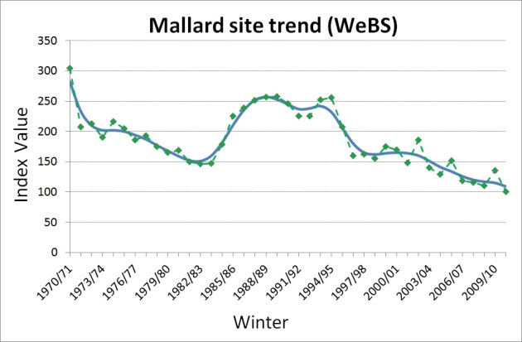
Scaup
Aythya marila
For the most up to date information on site conservation status and population trends go to Sitelink:

Firth of Forth SPA
Sitelink provides feature condition assessment details, with feature conservation objectives provided in either a Conservation Advice Package (CAP), Conservation and Management Advice (CMA) or generic Conservation Objectives.

SPA Population at Classification: 437

Origin – Birds wintering in Britain & Ireland come from Iceland, the Baltic, Scandinavia and Russia.

Behaviour – Gregarious outside breeding season, feeding by diving in shallow waters.

Diet – Omnivorous, but mostly molluscs in winter, especially mussels Mytilus species. Also cockles Cardium species and clams Macoma species in estuaries and Hydrobia species in brackish waters.

Habitat – Winters in sheltered coastal waters e.g. estuaries.

 | Low tide | High tide
Open water
Intertidal mud | -
Saltmarsh | - | -
Rocky shore | - | -
Coastal fields | - | -
Inland fields | - | -

Distribution
Inner Forth | Scarce
Outer areas | Scarce

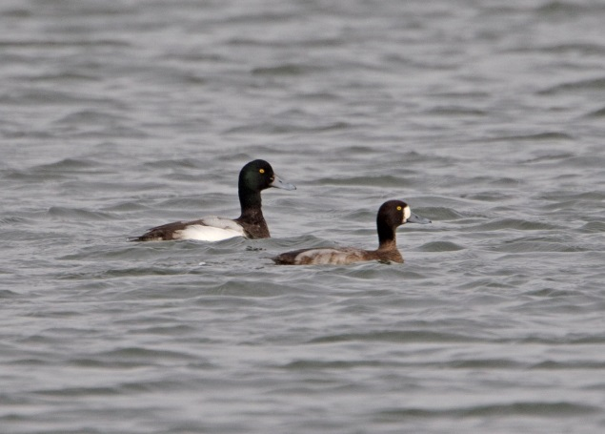
Graham Catley

Seasonality – Winter visitor, mainly October to March.

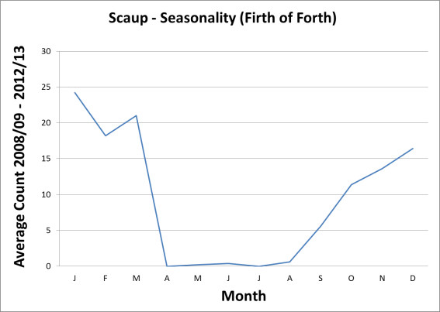

Pressures – Improving water quality may have a negative effect on abundance of some food sources, such as molluscs.

Population trends – Numbers using the site declined sharply, from >60% of Scottish wintering birds in the late 1970s to less than 5% in recent years. Declines linked to reduction in sewage inputs.

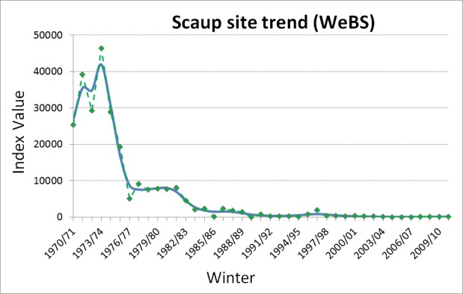
Eider
Somateria mollissima
For the most up to date information on site conservation status and population trends go to Sitelink:

Firth of Forth SPA
Outer Firth of Forth and Tay Bay Complex SPA.

Sitelink provides feature condition assessment details, with feature conservation objectives provided in either a Conservation Advice Package (CAP), Conservation and Management Advice (CMA) or generic Conservation Objectives.

SPA Population at Classification: 2,400 pairs

Origin – In Scotland mainly a resident species with only a few birds making short-distance movements.

Behaviour – Eider feed either by diving in deeper water or upending in shallow water. Frequent flights are made between roost and feeding sites. Eider form large flocks during July and August when birds moult and are flightless for several weeks. After hatching, young will join together to form large creches which can disperse several km (e.g. from islands to mainland coast).

Diet – Molluscs and crustaceans, blue mussels Mytilus edulis are the main prey species .

Habitat – Eiders are a marine species concentrated in sheltered waters. Eider nest on the ground mainly on mammal-free offshore islands and on quieter areas of mainland coast.

 | Low tide | High tide
Open water
Intertidal mud | -
Saltmarsh | - | -
Rocky shore
Coastal fields | - | -
Inland fields | - | -

Distribution
Inner Forth | Uncommon
Outer areas | Common

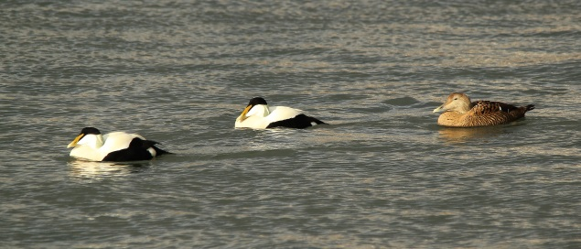
Anne Cotton

Seasonality – Present year-round in the Firth of Forth with a peak in late summer /early autumn as numbers are supplemented by young birds.

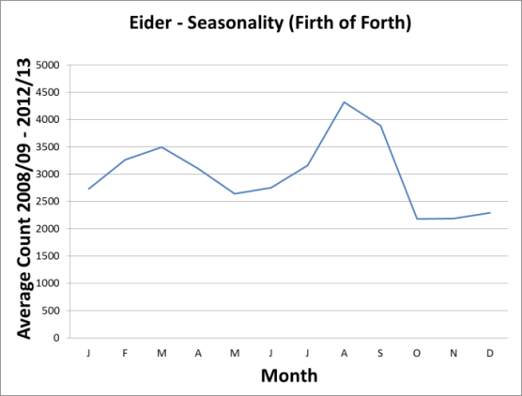

Pressures and population trends can be found for Outer Firth of Forth and St Andrews Bay Complex SPA in the Conservation and Management advice (CMA) document within site 'documents and links' section on Sitelink.

Long-tailed duck
Clangula hyemalis
For the most up to date information on site conservation status and population trends go to Sitelink:

Firth of Forth SPA
Outer Firth of Forth and Tay Bay Complex SPA.
Sitelink provides feature condition assessment details, with feature conservation objectives provided in either a Conservation Advice Package (CAP), Conservation and Management Advice (CMA) or generic Conservation Objectives.

SPA Population at Classification: 1,045

Origin – Breeds around Arctic Circle. Those wintering in Britain may originate from Fennoscandinavia and northwest Russia.

Behaviour – Highly gregarious outside the breeding season, roosting and feeding in inshore and offshore waters. Feed during day by diving, regularly to depths of 3–10m, but to maximum depth of 50–60m.

Diet – Predominantly animal matter, including crustaceans, molluscs, other marine invertebrates and fish.

Habitat – At sea, often far offshore, but also in estuarine waters.

 | Low tide | High tide
Open water
Intertidal mud | -
Saltmarsh | - | -
Rocky shore | - | -
Coastal fields | - | -
Inland fields | - | -

Distribution
Inner Forth | Rare
Outer areas | Locally uncommon

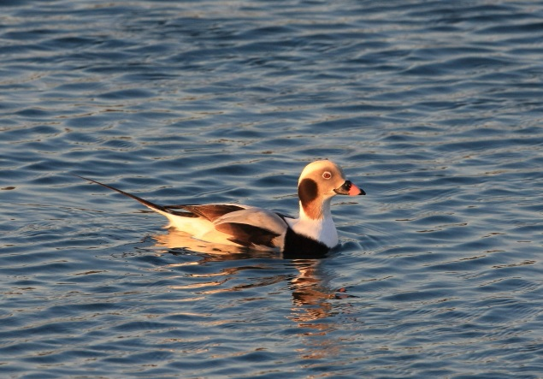
Dave King

Seasonality – Winter visitor, mainly November to April, peaking in February.

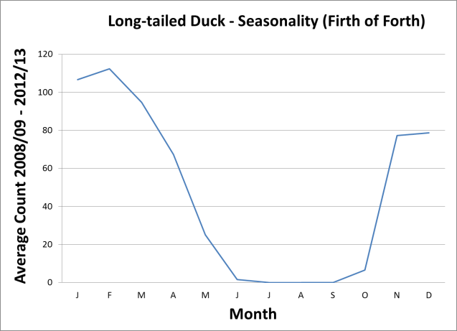

Pressures and population trends can be found for Outer Firth of Forth and St Andrews Bay Complex SPA in the Conservation and Management advice (CMA) document within site 'documents and links' section on Sitelink.

Common scoter
Melanitta nigra
For the most up to date information on site conservation status and population trends go to Sitelink:

Firth of Forth SPA
Outer Firth of Forth and Tay Bay Complex SPA.
Sitelink provides feature condition assessment details, with feature conservation objectives provided in either a Conservation Advice Package (CAP), Conservation and Management Advice (CMA) or generic Conservation Objectives.

SPA Population at Classification: 2,125 individuals

Origin – Mostly a winter visitor from Iceland and Fennoscandinavia, although small numbers of non-breeding birds are present in the Firth of Forth throughout the year.

Behaviour – Feeds and roosts in flocks sometimes quite far offshore. Frequently fly between favoured feeding areas.

Diet – A range of mollusc species caught by diving and foraging mostly over sandy substrates.

Habitat – Away from their breeding grounds common scoter spend most of their time on the sea. They forage for food by diving in inshore waters that are up to 20 m deep.

 | Low tide | High tide
Open water
Intertidal mud | -
Saltmarsh | - | -
Rocky shore | - | -
Coastal fields | - | -
Inland fields | - | -

Distribution
Inner Forth | Rare
Outer areas | Locally common

Large flocks found between Musselburgh and North Berwick on the south side of the Forth, in Largo Bay and St Andrews Bay in Fife.

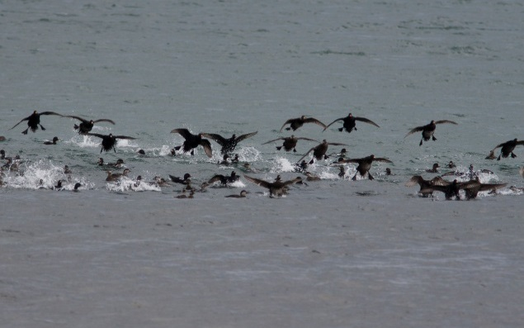
Graham Catley

Seasonality – Numbers are highest in November and during April to June.

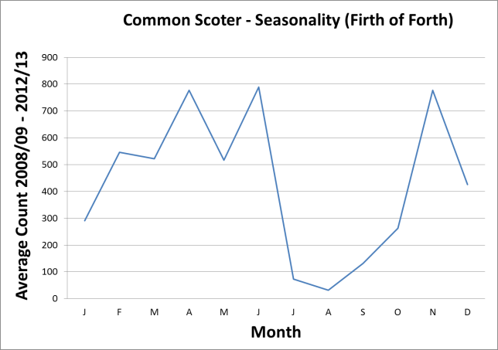

Pressures and population trends can be found for Outer Firth of Forth and St Andrews Bay Complex SPA in the Conservation and Management advice (CMA) document within site 'documents and links' section on Sitelink
Velvet scoter
Melanitta fusca
For the most up to date information on site conservation status and population trends go to Sitelink:

Firth of Forth SPA
Outer Firth of Forth and Tay Bay Complex SPA.
Sitelink provides feature condition assessment details, with feature conservation objectives provided in either a Conservation Advice Package (CAP), Conservation and Management Advice (CMA) or generic Conservation Objectives.

SPA Population at Classification: 612

Origin – A winter visitor from Fennoscandinavia and Russia, although small numbers of non-breeding birds are present in the Forth through the year.

Behaviour – Feeds and roosts in flocks, often mixed with common scoter, although velvet scoter often forage closer to shore. Frequently fly between favoured feeding areas.

Diet – A high proportion of velvet scoter diet consists of molluscs, caught by diving underwater and foraging in mostly sandy substrates.

Habitat – Away from their breeding grounds, velvet scoter spend most of their time on the sea. They forage for food by diving in inshore waters that are up to 20 m deep.

 | Low tide | High tide
Open water
Intertidal mud | -
Saltmarsh | - | -
Rocky shore | - | -
Coastal fields | - | -
Inland fields | - | -

DISTRIBUTION
Inner Forth | Rare
Outer areas | Locally common

Large flocks found between Musselburgh and Gullane on the south side of the Forth, and in Largo Bay and St Andrews Bay in Fife.

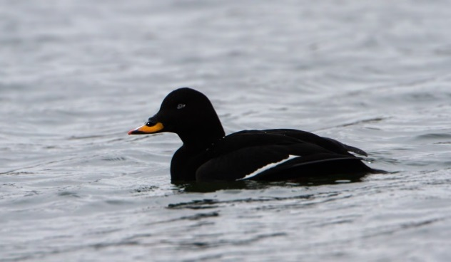
Peter Walkden

Seasonality – Numbers increase from late summer with a peak in late winter.

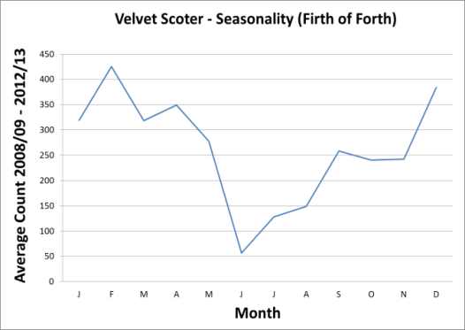

Pressures and population trends can be found for Outer Firth of Forth and St Andrews Bay Complex SPA in the Conservation and Management advice (CMA) document within site 'documents and links' section on Sitelink.

Goldeneye
Bucephala clangula
For the most up to date information on site conservation status and population trends go to Sitelink:

Firth of Forth SPA
Outer Firth of Forth and Tay Bay Complex SPA.

Sitelink provides feature condition assessment details, with feature conservation objectives provided in either a Conservation Advice Package (CAP), Conservation and Management Advice (CMA) or generic Conservation Objectives.

SPA Population at Classification: 2,465

Origin – A small number of birds nest in the north of the UK but most wintering birds in Scotland are thought to be from Norway and northern Sweden.

Behaviour – Principally a daytime feeder. Feeds by diving.

Diet – Mostly aquatic insects, molluscs and crustaceans and occasionally fish. Plant material generally less than 25% of diet.

Habitat – Mainly shallow estuaries, bays and harbours; also, larger lakes and rivers and in the vicinity of sewage outfalls.

 | Low tide | High tide
Open water
Intertidal mud | -
Saltmarsh | - | -
Rocky shore | - | -
Coastal fields | - | -
Inland fields | - | -

Distribution
INNER FORTH | Widespread, uncommon
OUTER AREAS | Widespread, uncommon

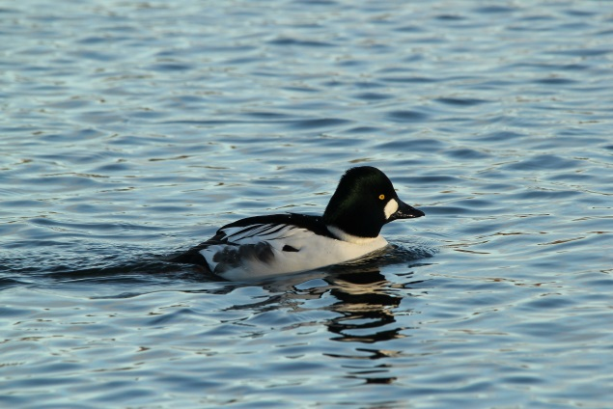
Anne Cotton

Seasonality – Winter visitor (mainly November to March).

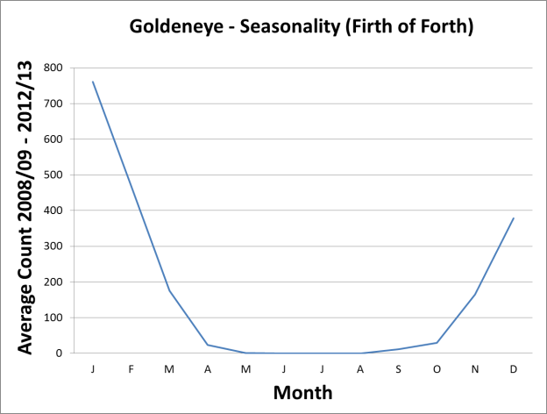

Pressures and population trends can be found for Outer Firth of Forth and St Andrews Bay Complex SPA in the Conservation and Management advice (CMA) document within site 'documents and links' section on Sitelink.

Red-breasted merganser
Mergus serrator
For the most up to date information on site conservation status and population trends go to Sitelink:

Firth of Forth SPA
Outer Firth of Forth and Tay Bay Complex SPA.
Sitelink provides feature condition assessment details, with feature conservation objectives provided in either a Conservation Advice Package (CAP), Conservation and Management Advice (CMA) or generic Conservation Objectives.
SPA Population at Classification: 670

Origin – Wintering birds include some local breeders and probably some from central Europe, but most are from Iceland and possibly eastern Greenland.

Behaviour – Gregarious during winter. Feeds by diving.

Diet – Mainly fish and crustaceans; also worms, insects and amphibians.

Habitat – Winters mainly at sea on secluded bays or estuaries. Shows a preference for clear, shallow waters not affected by heavy wave action.

 | Low tide | High tide
Open water
Intertidal mud | -
Saltmarsh | - | -
Rocky shore | - | -
Coastal fields | - | -
Inland fields | - | -

Distribution
INNER FORTH | Widespread, uncommon
OUTER AREAS | Widespread, uncommon

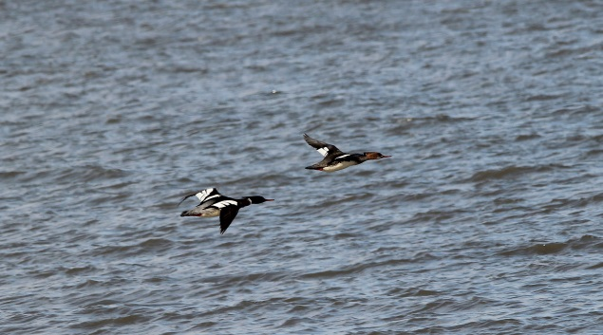
Anne Cotton

Seasonality – Mainly a winter visitor, but birds start returning in late summer to moult in the Firth of Forth.

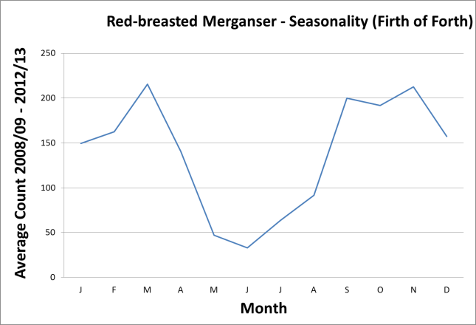

Pressures and population trends can be found for Outer Firth of Forth and St Andrews Bay Complex SPA in the Conservation and Management advice (CMA) document within site 'documents and links' section on Sitelink.

Red-throated diver
Gavia stellata
For the most up to date information on site conservation status and population trends go to Sitelink:

Firth of Forth SPA
Outer Firth of Forth and Tay Bay Complex SPA.
Sitelink provides feature condition assessment details, with feature conservation objectives provided in either a Conservation Advice Package (CAP), Conservation and Management Advice (CMA) or generic Conservation Objectives

SPA Population at Classification: 104 individuals

Origin – Circumpolar species with Scotland at the southern edge of the breeding range. Wintering birds can originate from Scotland, Fennoscandinavia, Iceland and Greenland.

Behaviour – Feeds by diving,usually solitary or in small groups. Occasionally in large flocks further offshore. Often flies between feeding grounds on wintering areas.

Diet – Primarily fish.

Habitat – Principally a marine species in winter, occuring on sheltered inshore waters above soft substrates and sometimes also in large numbers further offshore. Offshore occurrence maybe more frequent than is recorded but difficult to monitor.

 | Low tide | High tide
Open water
Intertidal mud | -
Saltmarsh | - | -
Rocky shore | - | -
Coastal fields | - | -
Inland fields | - | -
Offshore islands | - | -

Distribution
Inner Forth | Scarce
Outer areas | Widespread, scarce

The largest numbers are in the outer Firth of Forth and St Andrews Bay.

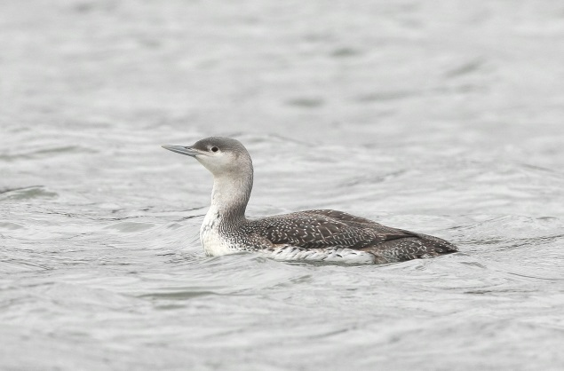
Dave King

Seasonality – Numbers peak in autumn with low numbers present all year.

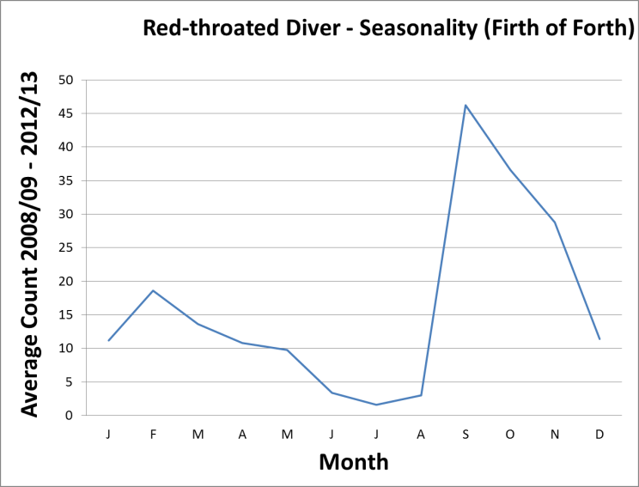

Pressures and population trends can be found for Outer Firth of Forth and St Andrews Bay Complex SPA in the Conservation and Management advice (CMA) document within site 'documents and links' section on Sitelink.
Fulmar
Fulmarus glacialis
For the most up to date information on site conservation status and population trends go to Sitelink:

Conservation status
SPA Population at Classification: 798 Pairs
UK: AMBER (endangered in Europe, localised breeding).
Global: Least Concern.

Origin – Adult birds spend the winter offshore in Scottish waters, with immatures wandering more widely around the North Atlantic.

Behaviour – Can forage very long distances from breeding sites. Surface feeder, frequently following fishing vessels, also feeds on bioluminescent prey at night.

Diet – Fish, squid, crustaceans, other marine invertebrates, and material discarded from fishing vessels.

Habitat – Fulmars are a marine species feeding out at sea during both day and night. In the Forth, most breed on cliffs and stacks on offshore islands. Small numbers also breed on the mainland coast on cliffs and occasionally man-made structures.

 | Low tide | High tide
Open water
Intertidal mud | - | -
Saltmarsh | - | -
Rocky shore
Coastal fields | - | -
Inland fields | - | -
Offshore islands

Distribution
Inner Forth | Rare
Outer areas | Widespread, common

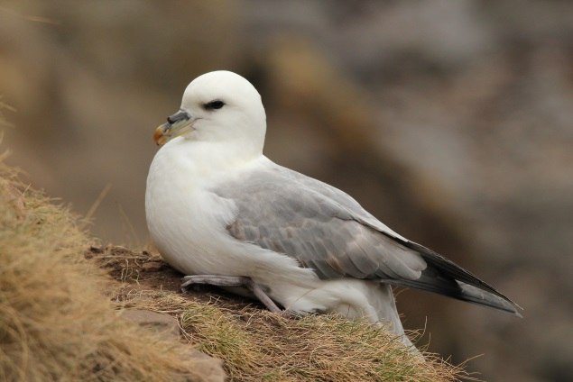
Anne Cotton

Seasonality – Most breeding birds are back at their nests in January. All birds have left breeding cliffs by September. Scarce at sea outside nest occupation period.

Pressures – Discards from fishing supported an expansion of the population during the 20th century. Changes in treatment of fishing discards might have significant population effects on this species.

Population trends – Breeding numbers have declined on the Forth islands in recent years.

Manx shearwater
Puffinus puffinus
For the most up to date information on site conservation status and population trends go to Sitelink:

Outer Firth of Forth and Tay Bay Complex SPA.

Sitelink provides feature condition assessment details, with feature conservation objectives provided in either a Conservation Advice Package (CAP), Conservation and Management Advice (CMA) or generic Conservation Objectives.

Origin – A North Atlantic species of which 80% nest on islands off the west coast of Britain and Ireland. Manx shearwaters are predominantly spring and autumn migrants off the east coast of Scotland. They winter in the south Atlantic off South America.

Behaviour – Manx shearwaters are a long-distance migrant, able to cover very large distances over the sea. This species feeds on the surface as well as underwater, where it actively pursues prey using its wings.

Diet – Manx shearwater diet consists mainly of fish and squid.

Habitat – Oceanic but mainly over the continental shelf, only coming ashore to breed on predator-free offshore islands.

 | Low tide | High tide
Open water
Intertidal mud | - | -
Saltmarsh | - | -
Rocky shore | - | -
Coastal fields | - | -
Inland fields | - | -
Offshore islands

Distribution
Inner Forth | Rare
Outer areas | Uncommon

Small or moderate numbers are intermittently recorded offshore from the Outer Forth areas during summer and early autumn. Some are driven into the Inner Forth during particularly strong winds.

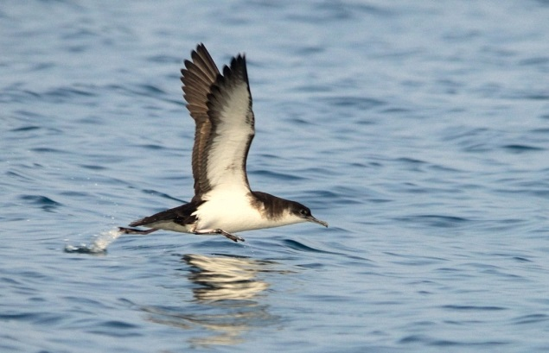
Alex Barclay

Seasonality – A rare breeder on the Isle of May where small numbers of birds return from their wintering grounds in April. Peak numbers in the Forth are movements of birds not breeding in the Forth – particularly between July and September

Pressures and population trends can be found for Outer Firth of Forth and St Andrews Bay Complex SPA in the Conservation and Management advice (CMA) document within site 'documents and links' section on Sitelink.

Gannet
Morus bassanus
For the most up to date information on site conservation status and population trends go to Sitelink:

Forth Islands SPA,
Outer Firth of Forth and St Andrew’s Bay Complex SPA.

Sitelink provides feature condition assessment details, with feature conservation objectives provided in either a Conservation Advice Package (CAP), Conservation and Management Advice (CMA) or generic Conservation Objectives.

SPA Population at Classification: 21,600 pairs

Origin – Breeds throughout the North Atlantic with Scotland holding half the world population in 14 colonies. The Bass Rock in the Firth of Forth is the world’s largest single colony. Winter out at sea as far south as West Africa. As birds grow older they winter closer to the breeding grounds.

Behaviour – Breeding birds fly between their colony and foraging areas up to 500 km away. Large feeding flocks occur in the Forth. Gannets can catch prey at a wide range of depths. Prey is caught by plunge-diving from height or occasionally by diving from the surface.

Diet – A diverse range of fish and squid, including fisheries discards.

Habitat – Gannets are a marine species that rarely come to land except to breed. They breed on sheer cliffs and stacks, but where conditions are right, as on Bass Rock, also on flat surfaces.

 | Low tide | High tide
Open water
Intertidal mud | - | -
Saltmarsh | - | -
Rocky shore | - | -
Coastal fields | - | -
Inland fields | - | -

Distribution
Inner Forth | Scarce
Outer areas | Locally numerous

In the Forth only breeds on Bass Rock.

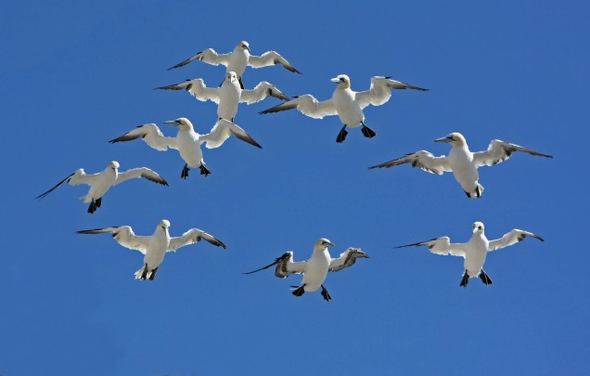
Jill Pakenham

Seasonality – Gannets are present all year but more numerous during the breeding season. They return to their nesting sites in January. Most egg laying takes place in April and fledging peaks in early to mid-September.

Pressures and population trends can be found for Outer Firth of Forth and St Andrews Bay Complex SPA in the Conservation and Management advice (CMA) document within site 'documents and links' section on Sitelink.

Cormorant
Phalacrocorax carbo
For the most up to date information on site conservation status and population trends go to Sitelink:

Firth of Forth SPA
Forth Islands SPA,

Sitelink provides feature condition assessment details, with feature conservation objectives provided in either a Conservation Advice Package (CAP), Conservation and Management Advice (CMA) or generic Conservation Objectives.
SPA Population at Classification: 200 Pairs

Origin – Resident breeders supplemented by migrants in winter. Most Scottish Cormorants are of the sub-species P.c. carbo.

Behaviour – In the Forth breeds on cliffs and stacks on islands. Feeds by diving underwater from the surface.

Diet – A wide range of small fish (generally smaller than 20 cm in length) such as butterfish, sandeels, flatfish and eels.

Habitat – Feeds in shallow water, generally less than 20 m deep. Foraging range up to 50 km. Roosts on man-made structures (e.g. buoys, jetties, harbour walls) as well as natural rocky headlands, islands, beaches and on estuaries at low tide.

 | Low tide | High tide
Open water
Intertidal mud | -
Saltmarsh | - | -
Rocky shore
Coastal fields | - | -
Inland fields | - | -
Offshore islands

DISTRIBUTION
Inner Forth | Widespread, common
Outer areas | Widespread, common

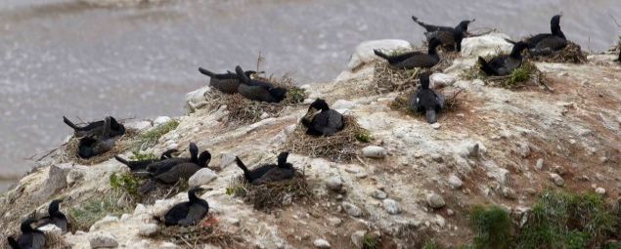
Edmund Fellowes

Seasonality – Numbers peak in autumn, bolstered by young birds.

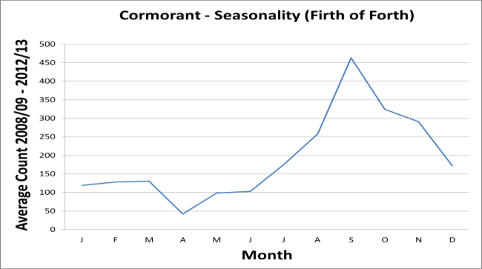

Pressures – Cormorant are shot under licence at inland fisheries in Scotland.

Population trends – The winter population in the Firth of Forth is declining but tracking the Scottish trend.

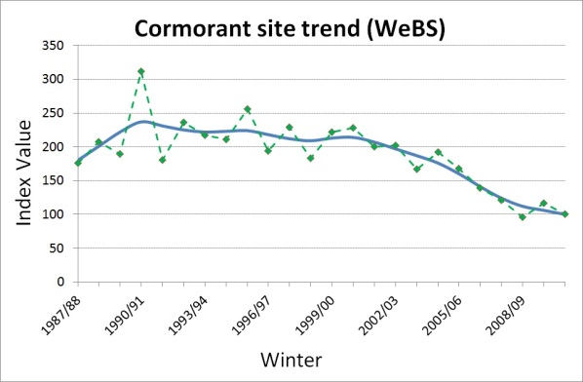

The breeding population on the Forth islands is declining.

Shag
Phalacrocorax aristotelis
For the most up to date information on site conservation status and population trends go to Sitelink:

Forth Islands SPA
Outer Firth of Forth and Tay Bay Complex SPA

Sitelink provides feature condition assessment details, with feature conservation objectives provided in either a Conservation Advice Package (CAP), Conservation and Management Advice (CMA) or generic Conservation Objectives.
SPA Population at Classification: 2,400 Pairs

Origin – A resident and dispersive species with interchanges of birds between the Forth and elsewhere in Scotland, England and Norway.

Behaviour – Shags dive from water surface pursuing fish underwater. Can form large flocks, both at roosting and feeding sites.

Diet – Small fish, most commonly sandeels, even in winter months. Young are fed almost exclusively on lesser sandeels Ammodytes tobianus.

Habitat – Almost exclusively marine, breeding on most of the islands in the Forth. Shags are seldom seen far from shore and do not forage far from breeding colonies. Roosts on man-made structures (e.g. buoys, jetties, harbour walls) as well as natural features such as rocky headlands and islands.

 | Low tide | High tide
Open water
Intertidal mud | -
Saltmarsh | - | -
Rocky shore
Coastal fields | - | -
Inland fields | - | -
Offshore islands

Distribution
Inner Forth | Rare
Outer areas | Widespread, common

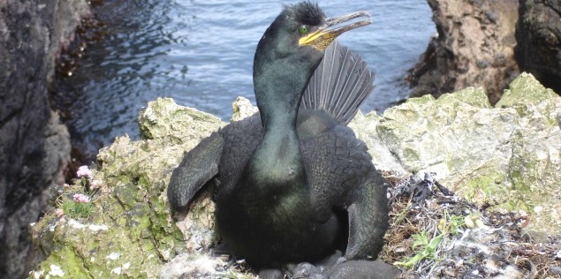
Hugh Insley

Seasonality – Numbers peak in autumn, bolstered by young birds.

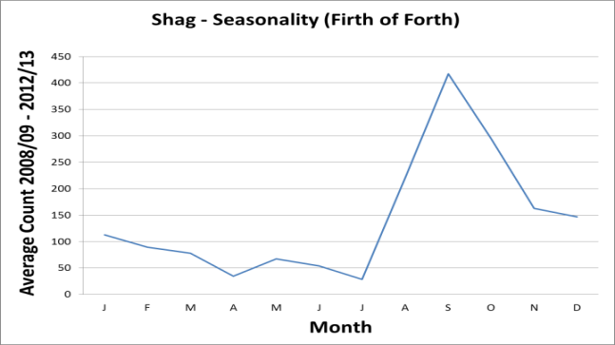

Pressures and population trends can be found for Outer Firth of Forth and St Andrews Bay Complex SPA in the Conservation and Management advice (CMA) document within site 'documents and links' section on Sitelink.

Great crested grebe
Podiceps cristatus
For the most up to date information on site conservation status and population trends go to Sitelink:

Firth of Forth SPA

Sitelink provides feature condition assessment details, with feature conservation objectives provided in either a Conservation Advice Package (CAP), Conservation and Management Advice (CMA) or generic Conservation Objectives.

SPA Population at Classification: 646

Origin – Most wintering birds probably breed
locally but there are few ring recoveries. Little
is known about the amount of interchange
between Britain and continental Europe.

Behaviour – Largely solitary during winter,
though temporary aggregations may form.

Diet – Includes large fish, insects,
crustaceans (e.g. crayfish and shrimps) and
molluscs.

Habitat – Overwinters on large lakes and
reservoirs, and in inshore coastal waters
especially when inland waters are frozen.

 | Low tide | High tide
Open water
Intertidal mud | -
Saltmarsh | - | -
Rocky shore | - | -
Coastal fields | - | -
Inland fields | - | -

Distribution
Inner Forth | Widespread, uncommon
Outer areas | Widespread, uncommon

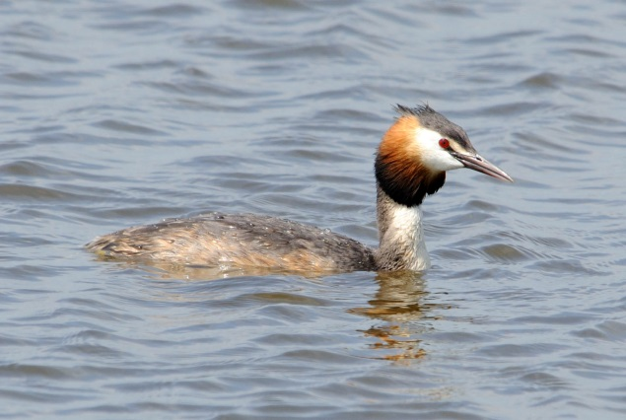

Seasonality – Mainly a winter visitor and
passage migrant with peak in September.
Many pairs breed on nearby lakes and
reservoirs, especially in Fife.

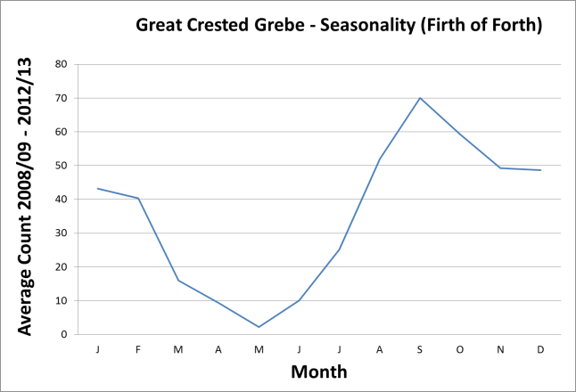

Pressures – None specified but note the
severe declining trend for this species.

Population trends – Severe and steady
decline. The trend for the Forth is broadly
tracking the Scottish trend, although a
declining proportion of Scottish wintering birds
are being supported by the site. This
suggests that conditions for this particular
species are deteriorating on the site.

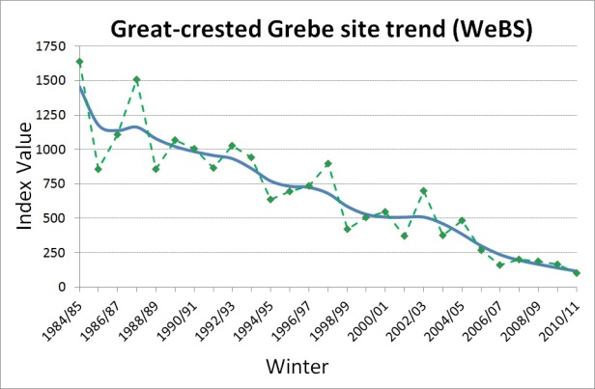
Slavonian grebe
Podiceps auritus
For the most up to date information on site conservation status and population trends go to Sitelink:

Firth of Forth SPA
Outer Firth of Forth and St Andrew’s Bay Complex SPA.

Sitelink provides feature condition assessment details, with feature conservation objectives provided in either a Conservation Advice Package (CAP), Conservation and Management Advice (CMA) or generic Conservation Objectives.

Origin – Birds wintering in the Firth of Forth
probably breed in Iceland and Norway.

Behaviour – Slavonian grebe dive
underwater from the surface to catch prey.

Diet – Mainly small fish and crustaceans.

Habitat – In winter predominantly a marine
species, preferring sheltered sites.

 | Low tide | High tide
Open water
Intertidal mud | - | -
Saltmarsh | - | -
Rocky shore | - | -
Coastal fields | - | -
Inland fields | - | -

Distribution
Inner Forth | Rare
Outer areas | Local and  uncommon

Most regular between Musselburgh and
Gullane on the south side of the Forth and in
Largo Bay in Fife.

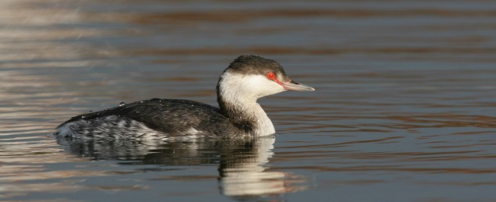
Adrian Dancy

Seasonality – Numbers increase from
August onwards, peaking in late winter.
Absent in summer.

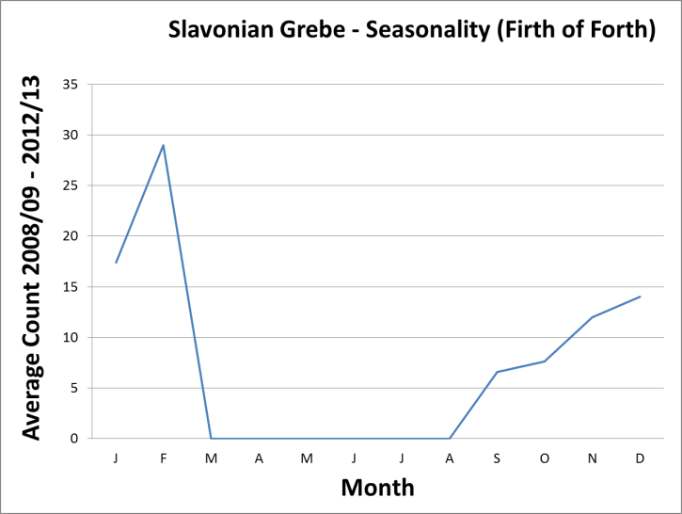

Pressures and population trends can be found for Outer Firth of Forth and St Andrews Bay Complex SPA in the Conservation and Management advice (CMA) document within site 'documents and links' section on Sitelink.

Oystercatcher
Haematopus ostralegus
For the most up to date information on site conservation status and population trends go to Sitelink:

Firth of Forth SPA

Sitelink provides feature condition assessment details, with feature conservation objectives provided in either a Conservation Advice Package (CAP), Conservation and Management Advice (CMA) or generic Conservation Objectives.

SPA Population at Classification: 7,846

Origin – Some wintering birds breed in
Scotland. Large numbers also come from
Iceland, the Faroes and Norway.

Behaviour – Prey is detected by both sight
and touch and birds feed by day and
night. Many oystercatchers are site
faithful, returning to the same shellfish beds,
though others roam over a wider area. Less
sensitive to disturbance than other
waders.

Diet – Predominantly shellfish, especially
large cockles Cerastoderma edule and
mussels Mytilus edulis. Also include
ragworms Nereis species and lugworms
Arenicola species on mudflats and
earthworms.

Habitat – Mostly on shellfish beds on
intertidal mudflats, using nearby mixed wader
roost sites when feeding areas are covered by
tides. Some also feed on adjacent greenfield
areas.

 | Low tide | High tide
Open water | - | -
Intertidal mud |  | -
Saltmarsh
Rocky shore
Coastal fields
Inland fields

DISTRIBUTION
Inner Forth | Widespread, numerous
Outer areas | Widespread, numerous

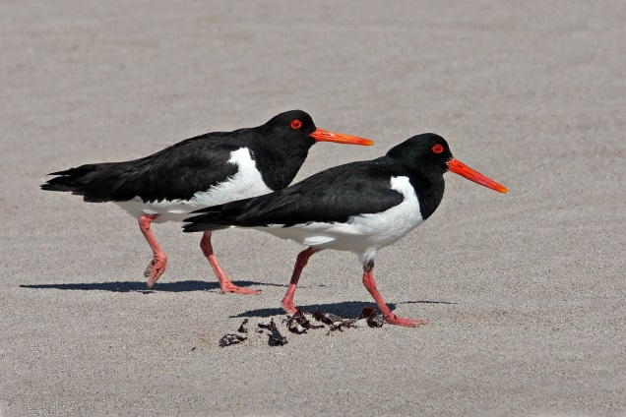
Jill Pakenham

Seasonality – Modest numbers breed
along rocky coasts and in fields adjacent to
the estuary and coasts. Highest numbers
occur during autumn passage through to mid
winter, birds begin vacating the site early in
the year.

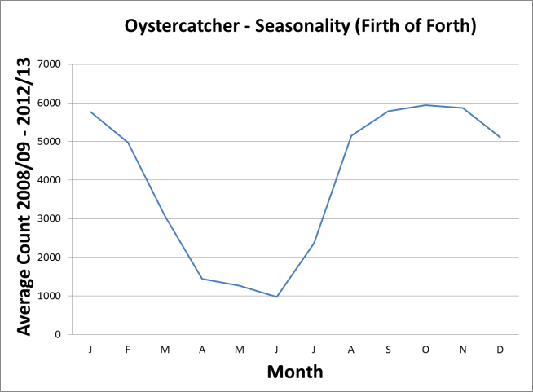

Pressures – Dredging for shellfish, habitat
loss (including loss of high tide roost sites).

Population trends – The proportion of
Scottish wintering birds using the Forth has
remained stable after an increase in the early
1990s. This suggests conditions on the site
remain favourable for this particular species.

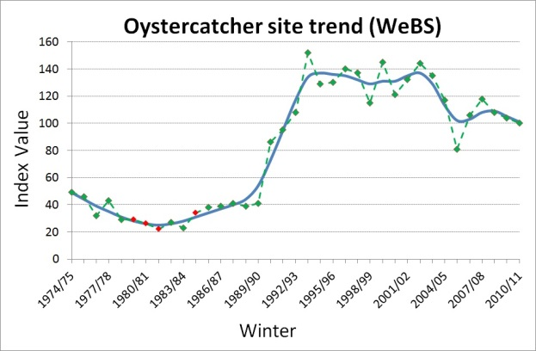
Golden plover
Pluvialis apricaria

For the most up to date information on site conservation status and population trends go to Sitelink:

Firth of Forth SPA

Sitelink provides feature condition assessment details, with feature conservation objectives provided in either a Conservation Advice Package (CAP), Conservation and Management Advice (CMA) or generic Conservation Objectives.

SPA Population at Classification: 2,949

Origin – Wintering birds on the Forth
breed in Britain, Fennoscandinavia and
Iceland.

Behaviour – Birds forage by day and by
night, returning to the same favoured sites
each year. Tend to be more tolerant of
disturbance than other waders, with flight
distances of approximately 50m compared
with almost 100m for Redshank and Curlew.

Diet – Mainly insects, especially beetles; also
other invertebrates and some plant material.

Habitat – Feeds mainly on pasture and
arable farmland in winter with mudflats and
saltmarshes mainly used for roosting.

 | Low tide | High tide
Open water | - | -
Intertidal mud |  | -
Saltmarsh
Rocky shore | - | -
Coastal fields
Inland fields

DISTRIBUTION
Inner Forth | Locally common
Outer areas | Locally common

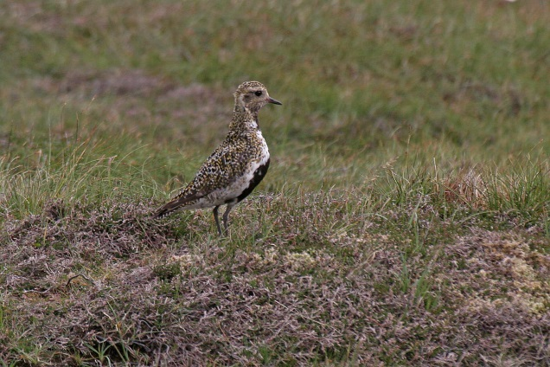
Jill Pakenham

Seasonality – Present during autumn
passage and early winter (mainly September
to December). Some breed in nearby uplands.

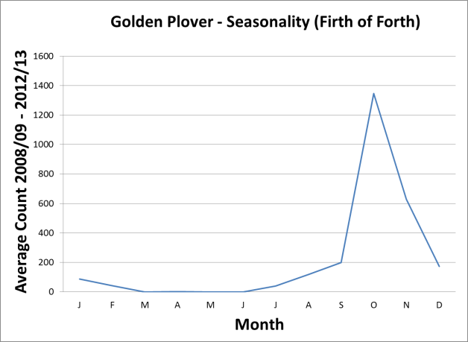

Pressures – Long term declines may be
associated with changing conditions in
breeding areas.

Population trends – The Forth trend is
broadly tracking the Scottish trend, although a
declining proportion of Scottish wintering birds
are being supported by the site. This
suggests that conditions on the site are
deteriorating for this species.

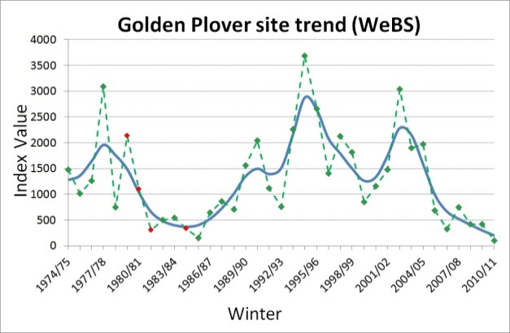

Grey plover
Pluvialis squatarola
For the most up to date information on site conservation status and population trends go to Sitelink:

Firth of Forth SPA

Sitelink provides feature condition assessment details, with feature conservation objectives provided in either a Conservation Advice Package (CAP), Conservation and Management Advice (CMA) or generic Conservation Objectives.

SPA Population at Classification: 724

Origin – All birds come from the population
breeding in western Siberia.

Behaviour – Site faithful, defending
individual feeding territories within and
between winters. Feeds by sight but can
forage by night as well as day.

Diet – Predominantly marine (polychaete)
worms, molluscs and crustaceans.

Habitat – Estuaries and lagoons, feeding on
mudflats and joining mixed wader roosts.
Roost sites may include man-made artefacts
or occasionally adjacent fields.

 | Low tide | High tide
Open water | - | -
Intertidal mud |  | -
Saltmarsh
Rocky shore | - | -
Coastal fields | -
Inland fields | - | -

Distribution
Inner Forth | Scarce
Outer areas | Widespread, uncommon

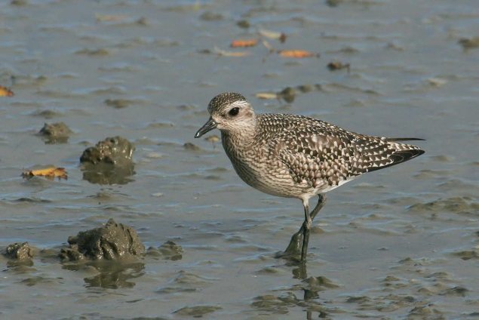
Jill Pakenham

Seasonality – Winter visitor, with first
passage or returning birds as early as July.

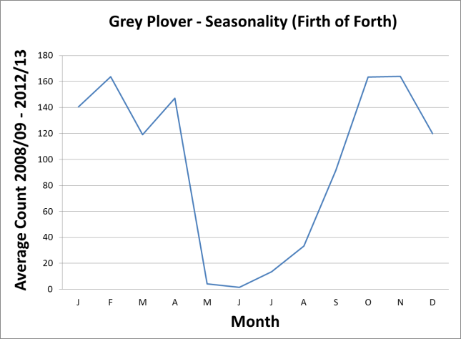

Pressures – There is some evidence that
the distribution of this species is shifting north
eastwards in response to climate change.
Sensitive to disturbance by walkers and dogs.

Population trends – The trend for the
Forth is broadly tracking the Scottish trend,
although a declining proportion of Scottish
wintering birds are being supported by the
site. This suggests that conditions for this
species are deteriorating on the site.

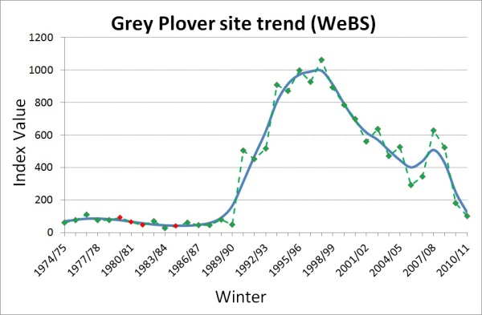
Lapwing
Vanellus vanellus

For the most up to date information on site conservation status and population trends go to Sitelink:

Firth of Forth SPA

Sitelink provides feature condition assessment details, with feature conservation objectives provided in either a Conservation Advice Package (CAP), Conservation and Management Advice (CMA) or generic Conservation Objectives.

SPA Population at Classification: 4,148

Origin – The majority of wintering birds come
to the UK from central Europe and Russia.

Behaviour – Lapwings feed by sight, but
have large eyes and so can feed at night,
especially during brighter nights.

Diet – Wide range of invertebrates including
beetles and earthworms.

Habitat – Feeds mainly on pasture, wet
meadows and arable farmland in winter.
Roosts in fields or on saltmarsh. Estuarine
sites are especially important in cold weather
when inland sites freeze.

 | Low tide | High tide
Open water | - | -
Intertidal mud |  | -
Saltmarsh
Rocky shore | - | -
Coastal fields
Inland fields

Distribution
Inner Forth | Locally common
Outer areas | Locally common

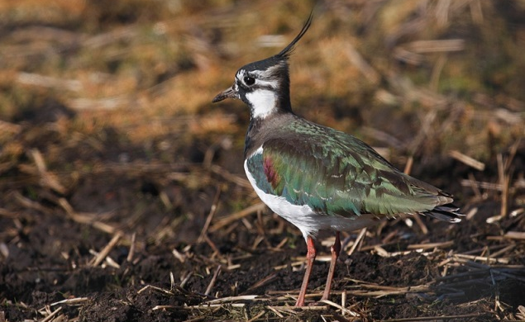
Adrian Dancy

Seasonality – Mainly a passage migrant
with some birds wintering. Breeds inland
around the estuary and suitable areas of the
SPA such as Aberlady Bay. The first
continental birds return in July.

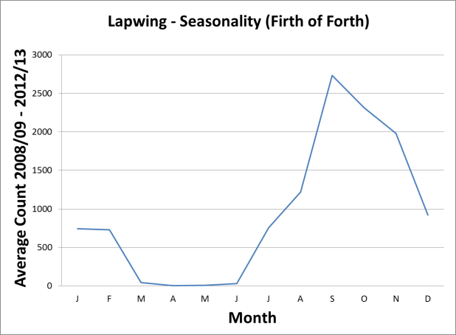
Pressures – Steep declines in western Europe have been linked to agricultural intensification. Climate change may further reduce the value of Scottish sites as a winter destination.

Population trends – The trend for the
Forth tracks the Scottish trend, although with
an increasing proportion of Scottish wintering
birds being supported by the site. This
suggests that, despite the ongoing decline in
numbers, conditions on the site remain
relatively favourable for this species.

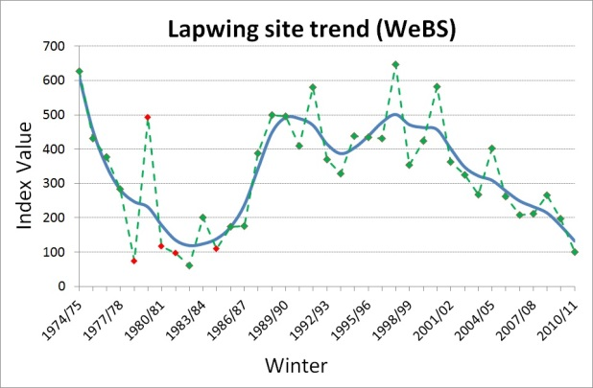
Ringed plover
Charadrius hiaticula

For the most up to date information on site conservation status and population trends go to Sitelink:

Firth of Forth SPA

Sitelink provides feature condition assessment details, with feature conservation objectives provided in either a Conservation Advice Package (CAP), Conservation and Management Advice (CMA) or generic Conservation Objectives.

SPA Population at Classification: 328

Origin – Movements are poorly understood.
Wintering birds may be local or from further
north in Scotland, or elsewhere around the
North Sea. Birds from Fennoscandinavia,
Iceland and Greenland probably occur mainly
on passage.

Behaviour – Can occur in large flocks in
winter. Feeds by sight.

Diet – Mainly marine worms, crustaceans and
molluscs.

Habitat – Predominantly sand and shingle
shores, sandbanks and mudflats, roosting
close to the feeding sites on bare ground and
in low vegetation. May also join mixed wader
roosts including those on man-made artefacts.

 | Low tide | High tide
Open water | - | -
Intertidal mud |  | -
Saltmarsh
Rocky shore | - | -
Coastal fields | - | -
Inland fields | - | -

Distribution
INNER FORTH | Widespread in small numbers
OUTER AREAS | Widespread in small numbers

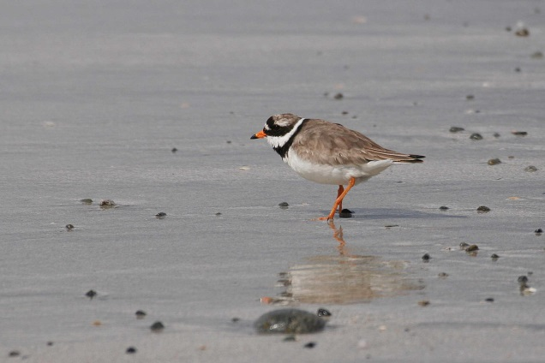
Jill Pakenham

Seasonality – Mainly a passage migrant
and winter visitor with peak in autumn
(August-September). Small numbers breed
on shore and nearby ‘broken’ ground
(including man-made surfaces and
unvegetated patches in fields).

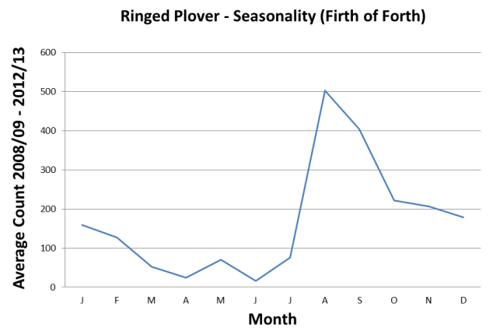

Pressures – Disturbance to breeding birds
is a major threat to this species.

Population trends – Numbers have
declined recently. Despite the decrease in
numbers on the site an increasing proportion
of Scottish wintering birds are supported by
the Firth of Forth, suggesting site conditions
remain relatively favourable for this species.

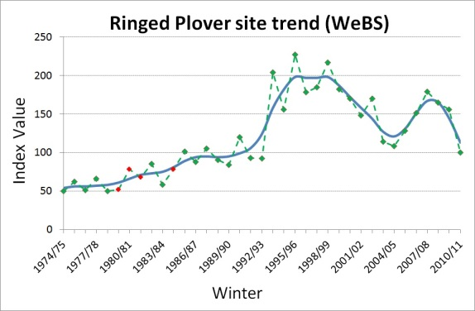
Curlew
Numenius arquata
For the most up to date information on site conservation status and population trends go to Sitelink:

Firth of Forth SPA

Sitelink provides feature condition assessment details, with feature conservation objectives provided in either a Conservation Advice Package (CAP), Conservation and Management Advice (CMA) or generic Conservation Objectives.

SPA Population at Classification: 1,928

Origin –The vast majority of curlew in
eastern Scotland in winter are from
Fennoscandinava.

Behaviour – Gregarious during winter,
occurring in flocks. Birds tend to be site
faithful within and between winters. Curlew
feed primarily by touch. Sensitive to
disturbance.

Diet – Invertebrates, including intertidal
worms, crustaceans, molluscs and
earthworms.

Habitat – muddy shorelines of estuaries,
lagoons, lakes and rivers, with some birds
also using inland fields. Roosts at high tide,
usually among mixed wader flocks. Roost
sites can include man-made artefacts as well
as more natural habitats.

 | Low tide | High tide
Open water | - | -
Intertidal mud |  | -
Saltmarsh
Rocky shore
Coastal fields
Inland fields

Distribution
INNER FORTH | Widespread, numerous
OUTER AREAS | Widespread, numerous

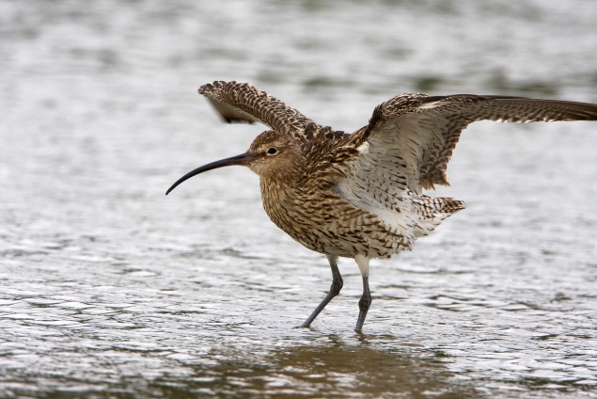
John Harding

Seasonality – Peaks occur in autumn and
in late winter. A small (and declining)
population breeds in fields adjacent to the
estuary and coasts.

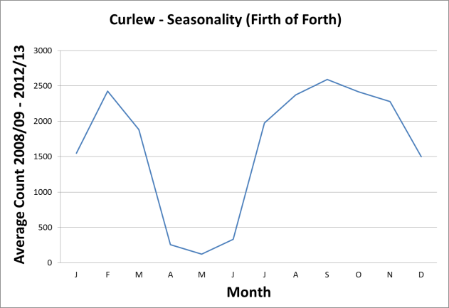

Pressures Agricultural intensification,
afforestation and predation threatens breeding
birds. Disturbance at feeding and especially
roost sites by walkers and dogs.

Population trends – Winter numbers
are variable but increased to a maximum
count of 2,582 in 2008/09 and have
decreased slightly since to 1,777 in 2012/13.
The Forth trend is similar to the Scottish trend.
This suggests that conditions on the site
remain relatively favourable for this species.

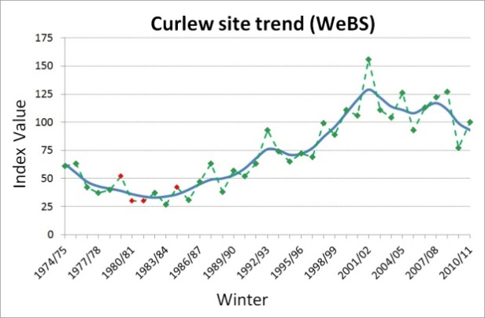

Bar-tailed godwit
Limosa lapponica

For the most up to date information on site conservation status and population trends go to Sitelink:

Firth of Forth SPA

Sitelink provides feature condition assessment details, with feature conservation objectives provided in either a Conservation Advice Package (CAP), Conservation and Management Advice (CMA) or generic Conservation Objectives.

SPA Population at Classification: 1,974

Origin – Wintering birds breed in northern
Europe and western Siberia (lapponica race).

Behaviour – Highly gregarious in winter,
forming large flocks. Many birds are site
faithful but small numbers do move sites
within or between winters. Relatively sensitive
to disturbance compared to other waders.

Diet – Mainly marine worms from mudflats.

Habitat – Mudflats in estuaries, preferring
the outer parts of estuaries where substrates
are generally most sandy. Joins mixed wader
roosts at high tide.

 | Low tide | High tide
Open water | - | -
Intertidal mud |  | -
Saltmarsh
Rocky shore
Coastal fields
Inland fields

Distribution
INNER FORTH | Local, common
OUTER AREAS | Local, numerous

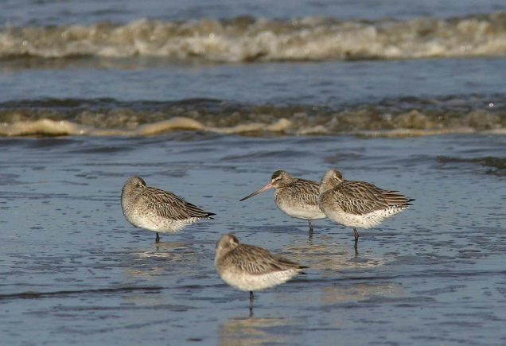
Al Downie

Seasonality – Mainly winter visitor but
some spring passage migrants are present in
May and return passage may begin in July.

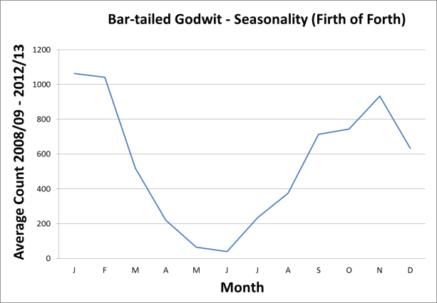

Pressures – Disturbance of feeding flocks
and especially roosts by walkers and dogs.

Population trends – The trend for the
Forth is broadly tracking the Scottish trend,
although an increasing proportion of the
Scottish wintering birds are supported by the
site. This suggests that despite the ongoing
decline in numbers, conditions on the site
remain relatively favourable for this species.

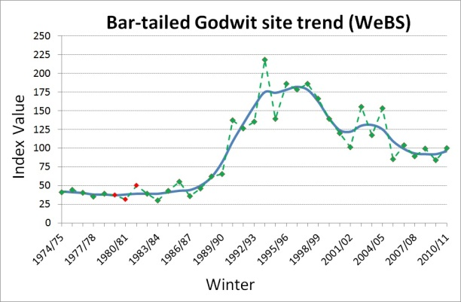

Turnstone
Arenaria interpres

For the most up to date information on site conservation status and population trends go to Sitelink:

Firth of Forth SPA

Sitelink provides feature condition assessment details, with feature conservation objectives provided in either a Conservation Advice Package (CAP), Conservation and Management Advice (CMA) or generic Conservation Objectives.

Origin – Wintering turnstone breed in
Canada and Greenland. Baltic birds occur in
the Forth on migration.

Behaviour – Locates food by sight, often by
turning over pebbles or seaweed. Highly site
faithful, both within and between winters, often
remaining in flocks with the same
membership. Not particularly sensitive to
disturbance compared to other wader species.

Diet – A very wide range of invertebrates and
other material, including carrion.

Habitat – Often along rocky or stony shores,
but also on mudflats or sandy shores and
especially on tide wrack. May join mixed
wader roosts, including on man-made
artefacts.

 | Low tide | High tide
Open water | - | -
Intertidal mud |  | -
Saltmarsh | - | -
Rocky shore
Coastal fields | - | -
Inland fields | - | -

Distribution
Inner Forth | Local, scarce
Outer areas | Locally common

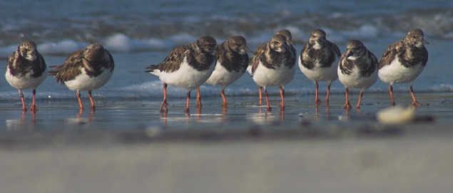
Rob Robinson

Seasonality – Wintering numbers are just
exceeded by a passage peak in October. A
few non-breeders spend the summer.

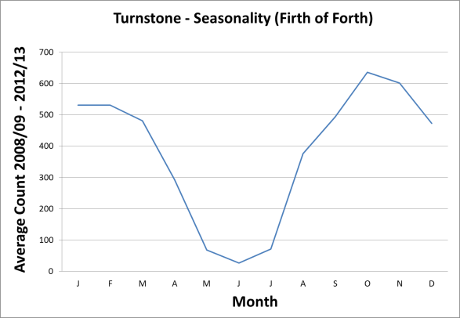

Pressures – Climate change may be the
cause of a northerly shift in wintering range of
turnstone.

Population trends – The proportion of
Scottish wintering birds using the Forth has
remained stable after increasing in the early
1990s. This suggests the Forth area remains
relatively favourable for this species.

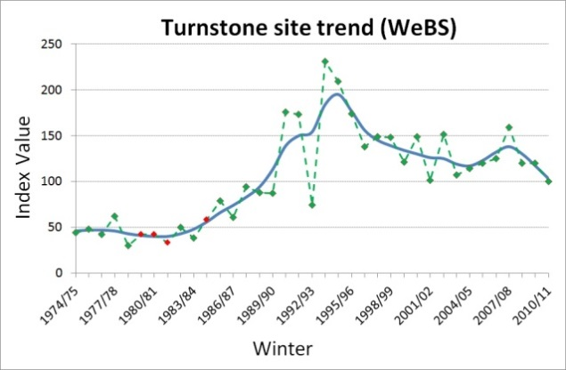

Knot
Calidris canutus
For the most up to date information on site conservation status and population trends go to Sitelink:

Firth of Forth SPA

Sitelink provides feature condition assessment details, with feature conservation objectives provided in either a Conservation Advice Package (CAP), Conservation and Management Advice (CMA) or generic Conservation Objectives.

SPA Population at Classification: 9,258

Origin – Most birds wintering in Britain are
from Greenland and Arctic Canada.

Behaviour – Knot feed in very large dense
flocks on open mudflats, catching food mainly
by touch. Flocks will move with the tide and
may cover very extensive areas of mudflat.
Sometimes fly many kilometres to roost sites
Sensitive to disturbance, especially at roost
sites.

Diet – Mainly molluscs, including tellins
Macoma balthica, mussels Mytilus edulis,
cockles Cerastoderma edulis and mudsnails
Hydrobia ulvae, the latter especially in early
winter.

Habitat – Extensive intertidal mudflats.
Knot roost sites may include man-made
artefacts and occasionally fields adjacent to
the shore.

 | Low tide | High tide
Open water | - | -
Intertidal mud |  | -
Saltmarsh
Rocky shore | - | -
Coastal fields | -
Inland fields | - | -

Distribution
Inner Forth | Widespread and  numerous
Outer areas | Locally numerous

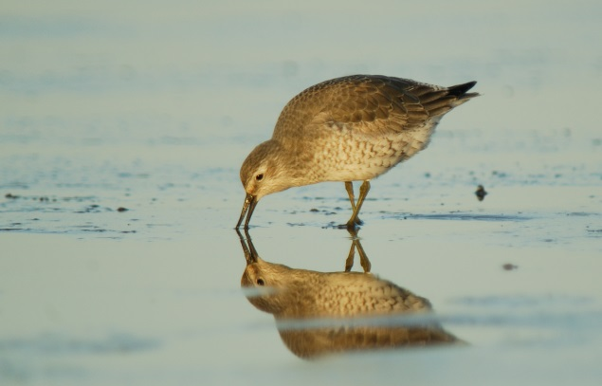
Neil Calbrade

Seasonality – Winter visitor. Mainly
October to March, peak in January/February.

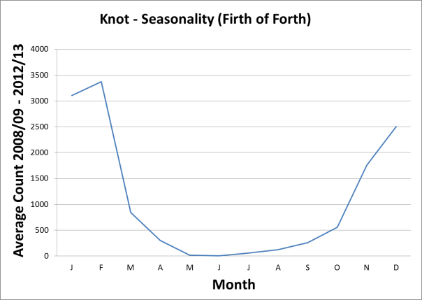

Pressures – Climate change may be the
cause of an easterly shift in the wintering
distribution of this species

Population trends – The trend for the
Forth broadly tracks the Scottish trend,
although a declining proportion of Scottish
wintering birds are being supported by the
site. This suggests that conditions on the site
are deteriorating for this species.

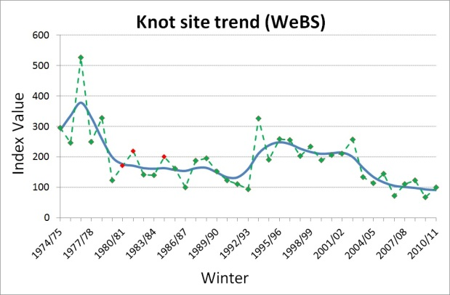

Dunlin
Calidris alpina
For the most up to date information on site conservation status and population trends go to Sitelink:

Firth of Forth SPA

Sitelink provides feature condition assessment details, with feature conservation objectives provided in either a Conservation Advice Package (CAP), Conservation and Management Advice (CMA) or generic Conservation Objectives.

SPA Population at Classification: 9,514

Origin – The majority of wintering birds are
from northern Fennoscandinavia and
European Russia. Dunlin from Iceland and
southeastern Greenland are common on passage.

Behaviour – Feeds by touch and sight by
day and night according to tides, remaining in
large flocks during winter. Site faithful to
winter roost sites both within and between
winters.

Diet – Invertebrates, mainly marine worms
and small gastropods during winter.

Habitat – Estuarine and non-estuarine
intertidal mudflats. Joins wader roosts near
feeding areas; will roost on open fields during
highest tides.

 | Low tide | High tide
Open water | - | -
Intertidal mud |  | -
Saltmarsh
Rocky shore
Coastal fields | -
Inland fields | - | -

Distribution
Inner Forth | Widespread and numerous
Outer areas | Widespread and numerous

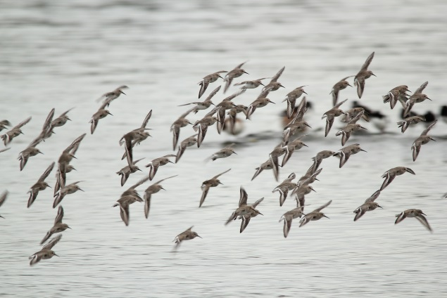
Anne Cotton

Seasonality – Winter visitor (September to
March).

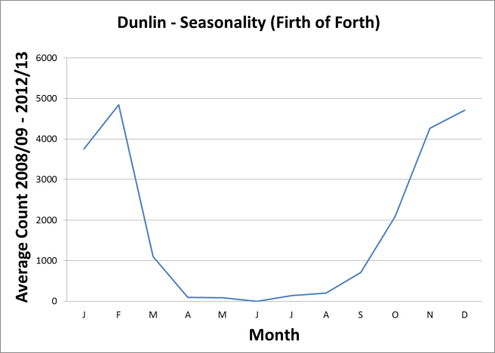

Pressures – There is evidence of an
easterly shift in the wintering distribution of
this species in Europe which may be a result
of climate change.

Population trends – The trend for the
Forth is broadly tracking the Scottish trend,
although with an increasing proportion of
Scottish wintering birds being supported by
the site. This suggests that despite the recent
decline in numbers, conditions on the site
remain relatively favourable for this species.

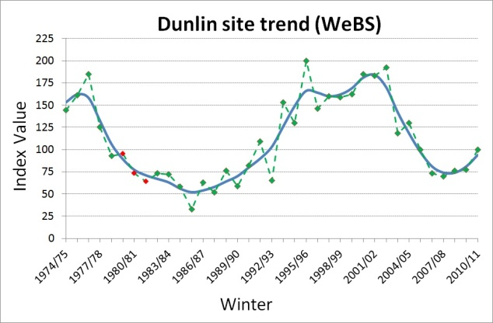

Redshank
Tringa totanus
For the most up to date information on site conservation status and population trends go to Sitelink:

Firth of Forth SPA

Sitelink provides feature condition assessment details, with feature conservation objectives provided in either a Conservation Advice Package (CAP), Conservation and Management Advice (CMA) or generic Conservation Objectives.

SPA Population at Classification: 4,341

Origin – Most wintering birds are Icelandic
breeders with some Scottish birds present.

Behaviour – Redshank are usually site
faithful in winter, though long-distance
movement sometimes occurs, probably in
response to cold weather.

Diet – Invertebrates, including insects,
spiders, annelid worms, molluscs and
crustaceans (especially amphipods).

Habitat – Mainly coastal, including mudflats
and tidal estuaries joining mixed wader roosts
at high tide. Roost sites may be on man-made
artefacts as well as natural sites.

 | Low tide | High tide
Open water | - | -
Intertidal mud |  | -
Saltmarsh
Rocky shore
Coastal fields
Inland fields | - | -

Distribution
Inner Forth | Widespread and numerous
Outer areas | Widespread and numerous

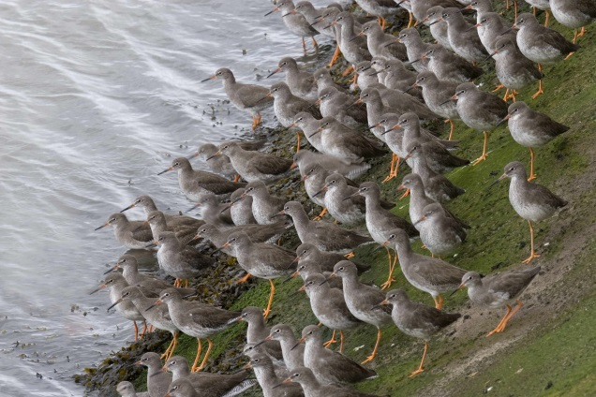
John Harding

Seasonality – Peak numbers occur in
autumn, dropping slightly by mid winter. Small
numbers breed nearby.

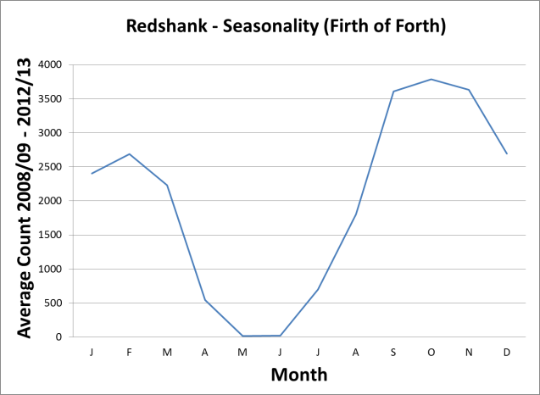

Pressures – Widespread declines in Britain
and Europe have been attributed to
agricultural intensification on the breeding
grounds. Redshank are particularly
susceptible to disturbance in severe weather.
As they take small prey, they need to feed for
longer periods during the tidal cycle than other
species and have less scope for extending
feeding time when necessary to meet their
energy requirements.

Population trends – The trend for the Forth broadly tracks the Scottish trend, although a declining proportion of Scottish wintering birds are being supported by the site. This suggests conditions for this species on the site are deteriorating relative to other sites.

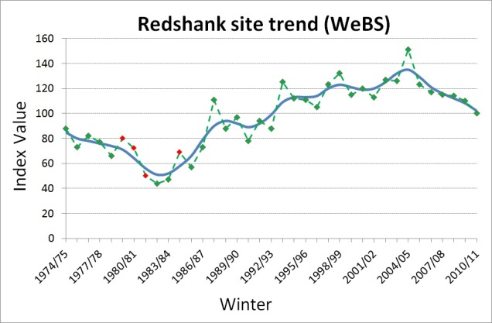
Puffin
Fratercula arctica
For the most up to date information on site conservation status and population trends go to Sitelink:

Forth Islands SPA
Outer Firth of Forth and Tay Bay Complex SPA

Sitelink provides feature condition assessment details, with feature conservation objectives provided in either a Conservation Advice Package (CAP), Conservation and Management Advice (CMA) or generic Conservation Objectives
SPA Population at Classification: 14,000

Origin – Puffin breed on several of the
islands in the Firth of Forth. Outside of the
breeding season, movements at sea are
poorly understood.

Behaviour – Breed in colonies mainly on
offshore islands with no mammalian
predators. Feed at sea, diving from surface.

Diet – Small fish, with sandeels being the
main prey species fed to young during the
breeding season.

Habitat – Breed in burrows on offshore
islands. Birds on the Isle of May are known
to forage up to 64km from the island (most
less than 40 km).

 | Low tide | High tide
Open water
Intertidal mud | - | -
Saltmarsh | - | -
Rocky shore | - | -
Coastal fields | - | -
Inland fields | - | -
Offshore islands

Distribution
Inner Forth | Rare
Outer areas | Locally numerous

Breeds on islands in Forth Islands SPA.

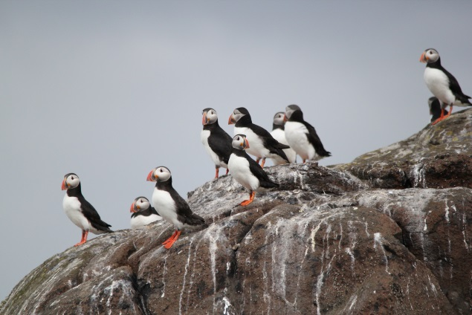
Anne Cotton

Seasonality – Return to their colonies in
late March-early April. Most young fledge in
July. This species is pelagic in winter and
very rarely observed from land.

Pressures and population trends can be found for Outer Firth of Forth and St Andrews Bay Complex SPA in the Conservation and Management advice (CMA) document within site 'documents and links' section on Sitelink.

Razorbill
Alca torda
For the most up to date information on site conservation status and population trends go to Sitelink:

Forth Islands SPA
Outer Firth of Forth and Tay Bay Complex SPA

Sitelink provides feature condition assessment details, with feature conservation objectives provided in either a Conservation Advice Package (CAP), Conservation and Management Advice (CMA) or generic Conservation Objectives.
Origin – Razorbills breed on several of the
islands in the Firth of Forth. Local breeders
winter in shallow coastal waters, most in the
North Sea with some moving south to the Bay
of Biscay. Winter birds may include birds
from Iceland, the Faroes and Scandinavia.

Behaviour – Breed in colonies of varying
sizes mainly on cliffs and offshore islands.
Feed at sea, diving from surface.

Diet – Predominantly small fish (sprats
Sprattus sprattus, herring Clupea harengus
and sandeels), with prey size being
intermediate between those caught by puffin
and guillemot.

Habitat – In the Forth, Razorbill breed on
cliffs and boulder-scree slopes on offshore
islands.

 | Low tide | High tide
Open water
Intertidal mud | - | -
Saltmarsh | - | -
Rocky shore | - | -
Coastal fields | - | -
Inland fields | - | -
Offshore islands

DISTRIBUTION
Inner Forth | Scarce
Outer areas | Locally numerous

Breeds on a number of offshore islands in the
outer Forth.

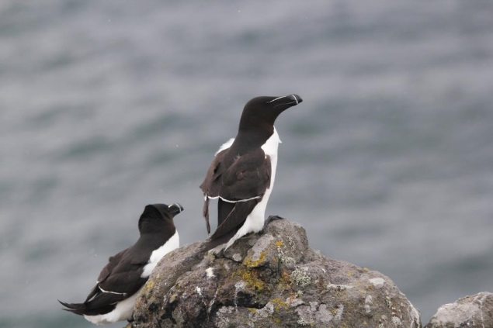
Anne Cotton

Seasonality – Birds are in the Forth all
year round (lowest numbers in winter), with
most returning to their colonies in late March.
Chicks leave their nests during the first week
of July when still flightless and are fed by the
males for several weeks.

Pressures and population trends can be found for Outer Firth of Forth and St Andrews Bay Complex SPA in the Conservation and Management advice (CMA) document within site 'documents and links' section on Sitelink.

Guillemot
Uria aalge

For the most up to date information on site conservation status and population trends go to Sitelink:

Firth of Forth SPA

Sitelink provides feature condition assessment details, with feature conservation objectives provided in either a Conservation Advice Package (CAP), Conservation and Management Advice (CMA) or generic Conservation Objectives.

SPA Population at Classification: 16,000
pairs

Origin – Guillemot nest on several of the
islands in the Firth of Forth. Large numbers of
these birds winter off the east coast of

Scotland with some moving as far west as
Scandinavia, and as far south as the Bay of
Biscay. Winter birds may include some from
the Faroes and Norway and other British
colonies.

Behaviour – Guillemot spend most of their
time on the sea, catching their food by diving
under the water from the surface. Guillemot,
unlike puffins and razorbills only carry one
item of prey at a time back to their nest.

Diet – Predominantly small fish such as
sandeels, herring and sprats.

Habitat – Outside the breeding season
Guillemot are a pelagic species, though a
few make short visits to the nesting cliffs in
clement weather. In the Forth, Guillemot
breed at high densities on sheer cliffs on
offshore islands.

 | Low tide | High tide
Open Water
Intertidal mud | - | -
Saltmarsh | - | -
Rocky shore | - | -
Coastal fields | - | -
Inland fields | - | -
Offshore islands

Distribution
Inner Forth | Uncommon
Outer areas | Locally numerous

Breeds on a number of offshore islands in the
outer Forth.
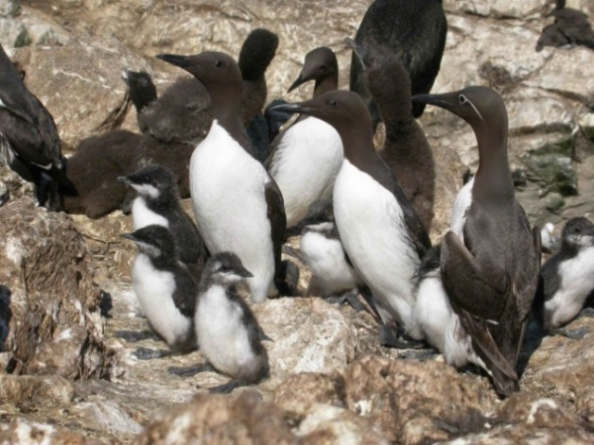
Stuart Newson

Seasonality – Breeding adults return to
their colonies by late March. Chicks leave
their nests during late June and early July
when still flightless and are fed by the males
for up to eight weeks.

Pressures – Sensitive to the availability of
suitable size (age-class) fish.

Population trends – Numbers increased
in the Firth of Forth through the 1980s and
1990s, but have declined since 2003,
particularly on the Isle of May, the largest
colony in the Forth.

Sandwich tern
Sterna sandvicensis
For the most up to date information on site conservation status and population trends go to Sitelink:

Firth of Forth SPA
Forth Islands SPA,

Sitelink provides feature condition assessment details, with feature conservation objectives provided in either a Conservation Advice Package (CAP), Conservation and Management Advice (CMA) or generic Conservation Objectives

SPA Population at Classification: 440 Pairs

Origin – The site is designated as an SPA
for the large numbers that congregate in the
Forth post-breeding. Ringed birds have
originated from breeding sites in Scotland,
England, Belgium and The Netherlands.
Sandwich terns winter off west Africa,
travelling as far as South Africa and the Indian
Ocean.

Behaviour – Nests in colonies usually in
association with other terns and gulls. Roosts
in flocks often with other terns. Dives into the
water to catch prey.

Diet – Small fish caught in surface waters.

Habitat – Principally a marine species, but
roosts on offshore islands, exposed rocks,
estuaries at low tide, and on coastal lagoons.
Has nested on offshore islands, undisturbed
beaches and sand dunes in the Forth.

 | Low tide | High tide
Open Water
Intertidal mud
Saltmarsh | - | -
Rocky shore
Coastal fields | - | -
Inland fields | - | -
Offshore islands

Distribution
Inner Forth | Uncommon
Outer areas | Common  and widespread

Large roosts found between Musselburgh and
Aberlady Bay, and also in Tyninghame Bay.
Occasionally found in the upper reaches of
the estuary when terns follow large shoals of
small fish moving upstream.

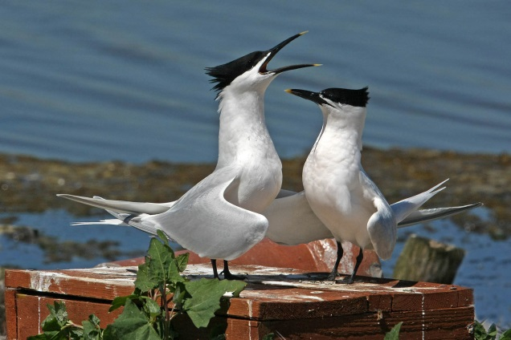
Jill Pakenham

Seasonality – Large numbers build up in
the Forth in July and August (over 2000 in
August 2014) with most birds leaving by the
end of September.

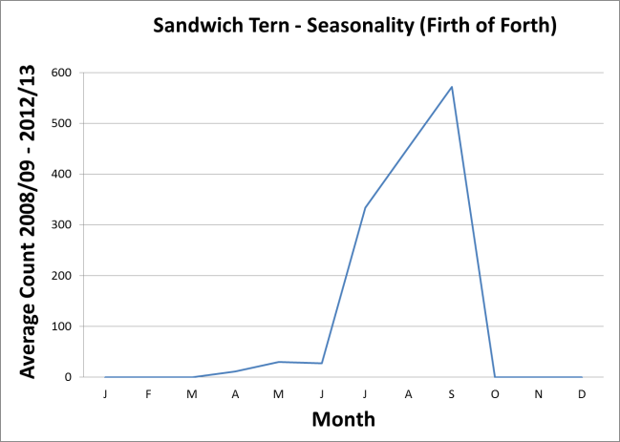

Pressures – Potentially displaced from
colonies by disturbance, predation and
increasing gull colonies. Sensitive to the
availability of suitable size (age-class) fish.

Population trends – The number of
colonies in Scotland has declined dramatically
from up to 25 in the past to 7 in 2000, with the
subsequent loss of all colonies in the Forth
reflecting this.

Common tern
Sterna hirundo
For the most up to date information on site conservation status and population trends go to Sitelink:

Firth of Forth SPA
Outer Firth of Forth and St Andrew’s Bay Complex SPA.

Sitelink provides feature condition assessment details, with feature conservation objectives provided in either a Conservation Advice Package (CAP), Conservation and Management Advice (CMA) or generic Conservation Objectives.

SPA Population at Classification: 558 Pairs

Origin – Breeding birds from the UK winter
off west Africa. Birds breeding in Iceland,
Scandinavia and western Siberia occur on
passage.

Behaviour – Nests in colonies. Roosts
communally often with other tern species.
Feeds by diving into surface waters from an
aerial dive.

Diet – Small fish, principally sandeels.

Habitat – Mostly a marine species in
Scotland. Nesting on flat ground on offshore
islands and formerly on beaches along the
Forth coast. Forages over both inshore and
offshore waters. Roosts on islands, exposed
rocks, estuary shores at low tide.

 | Low tide | High tide
Open Water
Intertidal mud
Saltmarsh | - | -
Rocky shore
Coastal fields | - | -
Inland fields | - | -
Offshore islands

Distribution

Inner Forth | Common
Outer areas | Widespread, common, locally numerous
Important colonies are present at Imperial Dock Lock, Leith SPA, the Isle of May and scattered smaller colonies elsewhere.

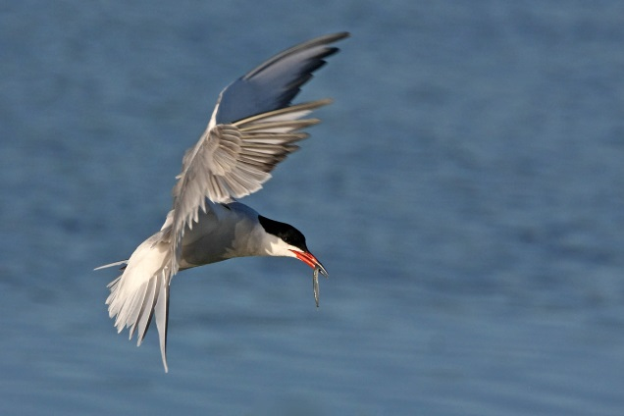
Jill Pakenham

Seasonality – The first common tern
arrive in the Forth in mid April with the
majority back by early May. Most have left by
the first week in September.

Pressures and population trends can be found for Outer Firth of Forth and St Andrews Bay Complex SPA in the Conservation and Management advice (CMA) document within site 'documents and links' section on Sitelink.
Roseate tern
Sterna dougallii
For the most up to date information on site conservation status and population trends go to Sitelink:

Forth Islands SPA

Sitelink provides feature condition assessment details, with feature conservation objectives provided in either a Conservation Advice Package (CAP), Conservation and Management Advice (CMA) or generic Conservation Objectives.
SPA Population at Classification: 8 Pairs

Origin – Now an irregular breeder, birds
visiting the Firth of Forth area are likely to be
from colonies in Northumberland. Roseate
terns winter off west Africa.

Behaviour – Nests in colonies usually with
other terns but often amongst rocks and under
artificial cover. Roosts in flocks often with
other tern species

Diet – Small fish, principally sandeels in
surface waters, which are caught from an
aerial dive.

Habitat – Away from their breeding grounds
roseate terns are a highly marine species
and feed further offshore than most other tern
species. Roosts on islands, exposed rocks,
estuary shores at low tide.

 | Low tide | High tide
Open water
Intertidal mud
Saltmarsh | - | -
Rocky shore
Coastal fields | - | -
Inland fields | - | -
Offshore islands

Distribution
Inner Forth | Rare
Outer areas | Rare

Formerly a regular breeder, they are still seen
annually, including amongst colonies of other
terns.
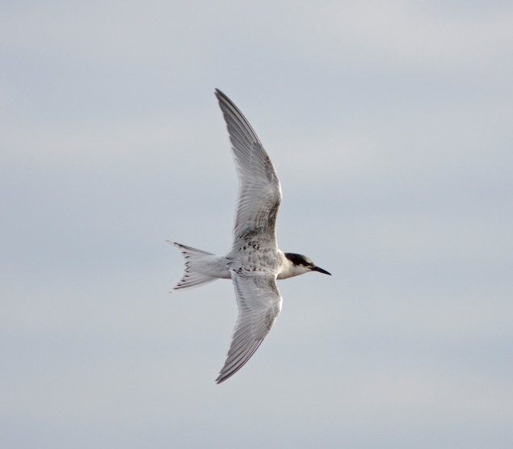
Graham Catley

Seasonality – Roseate tern arrive in
Scottish waters between late April and early
June. Post-breeding, occasional birds wander
into the Forth in August and early September.

Pressures – Displaced from former
colonies by human disturbance, predation and
increasing gull colonies. Sensitive to the
availability of suitable size (age-class) fish.

Population trends – The UK and Irish
population underwent a large decline in the
20th century, with only a few of the large
colonies extant. Numbers at these colonies
have been increasing since 2000. With an
extant colony in Northumberland, and birds
recorded annually in the Forth, re
establishment of breeding remains possible.

Arctic tern
Sterna paradisaea
For the most up to date information on site conservation status and population trends go to Sitelink:

Forth Islands SPA
Outer Firth of Forth and Tay Bay Complex SPA

Sitelink provides feature condition assessment details, with feature conservation objectives provided in either a Conservation Advice Package (CAP), Conservation and Management Advice (CMA) or generic Conservation Objectives.
SPA Population at Classification: 540 Pairs

Origin – A highly migratory species spending
northern winters in the southern oceans, with
some reaching Antarctic pack ice. Birds
breeding elsewhere in northern Britain,
Iceland, Scandinavia and western Siberia are
likely to pass through.

Behaviour – Nests in colonies. Roosts in
flocks often with other tern species.

Diet – Small fish, principally sandeels in
surface waters which are caught from an
aerial dive.

Habitat – Nests on flat ground. Roosts on
offshore islands, exposed rocks, estuaries at
low tide, coastal lagoons.. Away from their
breeding grounds Arctic tern are a highly
marine species. Feeds in inshore and
offshore waters.

 | Low tide | High tide
Open water
Intertidal mud
Saltmarsh | - | -
Rocky shore
Coastal fields | - | -
Inland fields | - | -
Offshore islands

Distribution
Inner Forth | Uncommon
Outer areas | Widespread, common, locally numerous

Nested historically on several of the islands in
the Firth of Forth, although only on the Isle of
May since 1998.

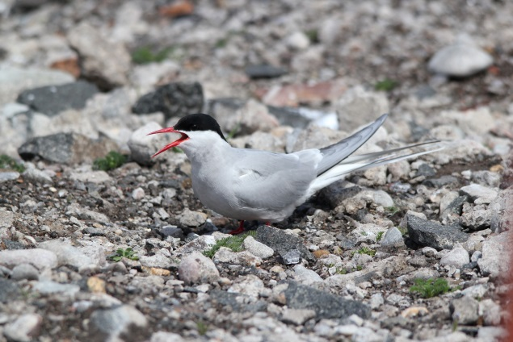
Anne Cotton

Seasonality – The first arctic tern arrive
back in the Forth in mid April with the majority
back by mid May. Most have left by early
September.

Pressures and population trends can be found for Outer Firth of Forth and St Andrews Bay Complex SPA in the Conservation and Management advice (CMA) document within site 'documents and links' section on Sitelink.
Kittiwake
Rissa tridactyla
For the most up to date information on site conservation status and population trends go to Sitelink:

Forth Islands SPA
Outer Firth of Forth and Tay Bay Complex SPA

Sitelink provides feature condition assessment details, with feature conservation objectives provided in either a Conservation Advice Package (CAP), Conservation and Management Advice (CMA) or generic Conservation Objectives.
SPA Population at Classification: 8,400
Pairs

Origin – A marine species breeding in the
North Atlantic and North Pacific. Scottish birds
winter at sea and may travel as far as North
Africa and the east coast of North
America. Birds from Norway winter in the
North Sea.

Behaviour – Breeds in colonies. Food is
caught through shallow plunge-dives or
picked from the surface of the sea.

Diet – Sandeels are main prey species for
both adults and young in the Forth. In winter,
their diet consists mainly of marine
invertebrates and small fish.

Habitat – Breeds on cliffs or buildings. Most
colonies are on the Forth islands with a few
on mainland. Feeds in the open sea. The
Banks (area of shallow sea 40 km east) is an
especially important feeding ground.

 | Low tide | High tide
Open water
Intertidal mud
Saltmarsh | - | -
Rocky shore
Coastal fields | - | -
Inland fields | - | -
Offshore islands

DISTRIBUTION
Inner Forth | Locally numerous  post breeding
Outer areas | Widespread and  locally numerous

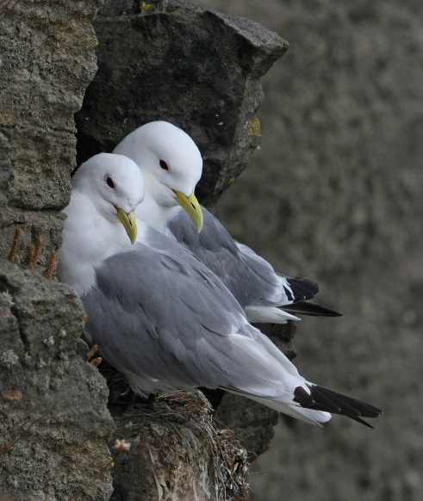
Jill Pakenham

Seasonality – Kittiwake return to their
colonies in late February or March. The timing
of egg-laying depends on weather and
feeding conditions. Nesting colonies are
deserted by late August but large feeding
concentrations and passage along the east
coast occur late into autumn. Some
kittiwake winter in the North Sea, but only
come close to the coast in inclement weather.

Pressures and population trends can be found for Outer Firth of Forth and St Andrews Bay Complex SPA in the Conservation and Management advice (CMA) document within site 'documents and links' section on Sitelink
Black-headed gull
Chroicocephalus ridibundus
For the most up to date information on site conservation status and population trends go to Sitelink:

Outer Firth of Forth and Tay Bay Complex SPA

Sitelink provides feature condition assessment details, with feature conservation objectives provided in either a Conservation Advice Package (CAP), Conservation and Management Advice (CMA) or generic Conservation Objectives.

Origin – Some winter birds may breed
locally;many others breed in northern Europe
especially Fennoscandinavia and the Baltic
States.

Behaviour – Gregarious throughout the
year. Roosts at night in large flocks in winter
on the sea, estuary or inland reservoirs, often
feeding inland. Often tolerant of humans.

Diet – Mainly aquatic and terrestrial
invertebrates. Also artificial food sources
provided by humans such as discards or
landfill.

Habitat – Most common in winter in coastal
habitats though generally avoids rocky
coastlines and occurs inland in many
different natural and urban habitats.

 | Low tide | High tide
Open water
Intertidal mud |  | -
Saltmarsh
Rocky shore
Coastal fields
Inland fields

Distribution
Inner Forth | Widespread and  numerous
Outer areas | Widespread and  numerous

Small numbers breed close to the SPAs.

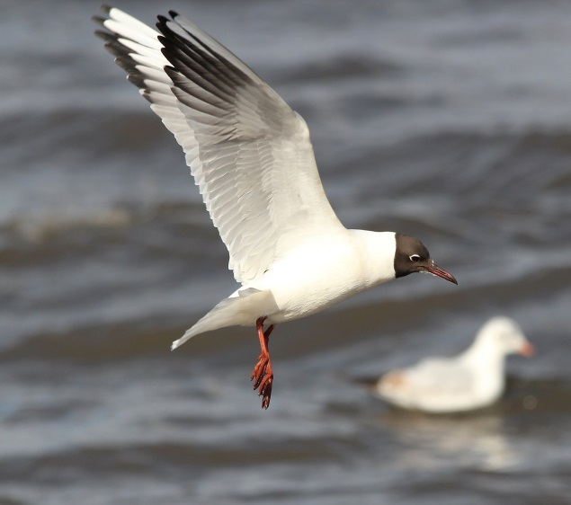
Anne Cotton

Seasonality – Mostly a winter visitor.
Failed breeders or post-breeding birds start
returning from late June. Peak in September.

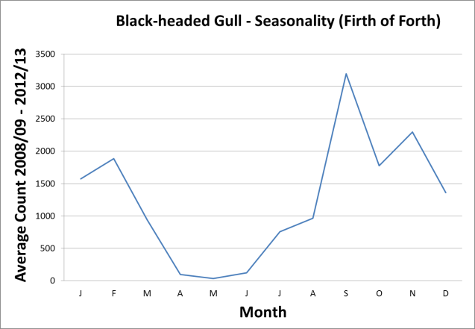

Pressures and population trends can be found for Outer Firth of Forth and St Andrews Bay Complex SPA in the Conservation and Management advice (CMA) document within site 'documents and links' section on Sitelink
Little gull
Hydrocoloeus minutus
For the most up to date information on site conservation status and population trends go to Sitelink:

Outer Firth of Forth and Tay Bay Complex SPA

Sitelink provides feature condition assessment details, with feature conservation objectives provided in either a Conservation Advice Package (CAP), Conservation and Management Advice (CMA) or generic Conservation Objectives.

Origin – A spring and autumn passage bird
in eastern Scotland. The main breeding
range is in northwest Russia, the Baltic and in
Siberia. Several hundred remain in the
North Sea for the winter when strong easterly
winds can push birds close to shore..

Behaviour – Feeds by picking food items
off the surface of water, sometimes in large
flocks.

Diet – When in Scottish waters mostly small
fish and invertebrates.

Habitat – Roosts on sheltered water,
estuaries and beaches, feeding offshore
during the day.

 | Low tide | High tide
Open water
Intertidal mud |  | -
Saltmarsh | - | -
Rocky shore
Coastal fields | - | -
Inland fields | - | -
Offshore islands | - | -

Distribution
Inner Forth | Rare
Outer areas | Scarce

Largest numbers in eastern Scotland are
found in the Tay Bay, but flocks of several
hundred have been recorded in the Forth.

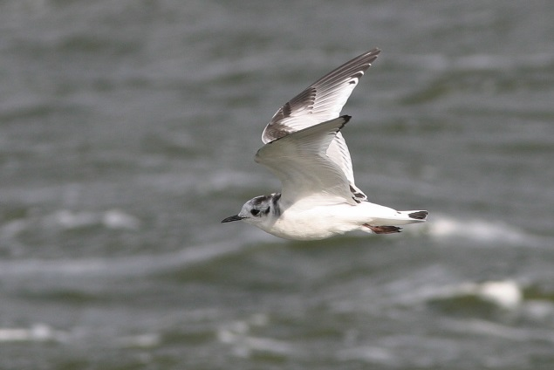
Dave King

Seasonality – Two peaks of birds occur in
autumn with young birds and adults migrating
at different times.

Pressures and population trends can be found for Outer Firth of Forth and St Andrews Bay Complex SPA in the Conservation and Management advice (CMA) document within site 'documents and links' section on Sitelink.

Common gull
Larus canus

For the most up to date information on site conservation status and population trends go to Sitelink:

Outer Firth of Forth and Tay Bay Complex SPA

Sitelink provides feature condition assessment details, with feature conservation objectives provided in either a Conservation Advice Package (CAP), Conservation and Management Advice (CMA) or generic Conservation Objectives.

Origin – Some winter birds breed in
Scotland;many others breed in northern
Europe especially Fennoscandinavia.

Behaviour – Gregarious in winter and joins
mixed gull roosts at night.

Diet – Mainly earthworms, insects, aquatic
and terrestrial invertebrates and small fish.

Habitat – Uses both inland and coastal
habitats, including farmland and urban
habitats. Large night-time roosts form along
the coast.

 | Low tide | High tide
Open water
Intertidal mud |  | -
Saltmarsh
Rocky shore
Coastal fields
Inland fields

Distribution
Inner Forth | Widespread and  numerous
Outer areas | Widespread and  numerous

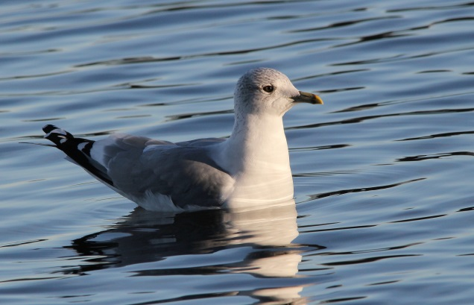
Anne Cotton

Seasonality – Winter visitor mainly present
September to March. Small numbers breed
close to the Forth (including urban nesting).

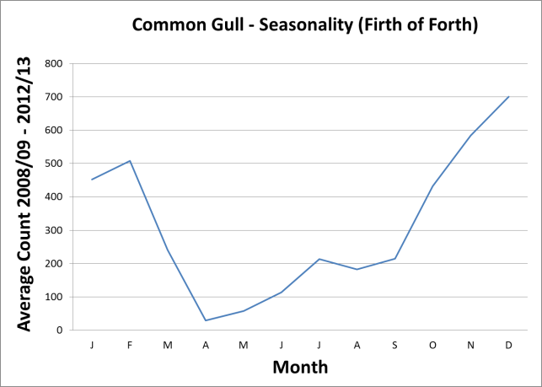

Pressures and population trends can be found for Outer Firth of Forth and St Andrews Bay Complex SPA in the Conservation and Management advice (CMA) document within site 'documents and links' section on Sitelink
Lesser black-backed gull
Larus fuscus

For the most up to date information on site conservation status and population trends go to Sitelink:

Forth Islands SPA

Sitelink provides feature condition assessment details, with feature conservation objectives provided in either a Conservation Advice Package (CAP), Conservation and Management Advice (CMA) or generic Conservation Objectives.
SPA Population at Classification: 6,600
pairs

Origin – A common and widespread local
breeder. Scottish birds can travel in winter to
Spain and north Africa although increasing
numbers winter in the UK.

Behaviour – Adaptable species, exploiting
a range of habitats and food resources. At
sea it is a surface feeder, foraging behind
fishing boats or catching fish and
invertebrates.

Diet – An omnivore that eats a wide range of
fish, invertebrates, carrion, live prey and
human waste.

Habitat – Tends to forage further out to sea
than other large gulls. Also forages in
agricultural and urban areas, using rubbish
dumps and sewage plants. Away from
breeding sites this species forms large roosts
with other gulls on sheltered open water,
inland or in bays in the Forth.

 | Low tide | High tide
Open Water
Intertidal mud
Saltmarsh
Rocky shore
Coastal fields
Inland fields
Offshore islands

Distribution
Inner Forth | Widespread and numerous
Outer forth | Widespread and numerous

Breeds in large colonies on Forth islands and
also in urban areas (rooftops).

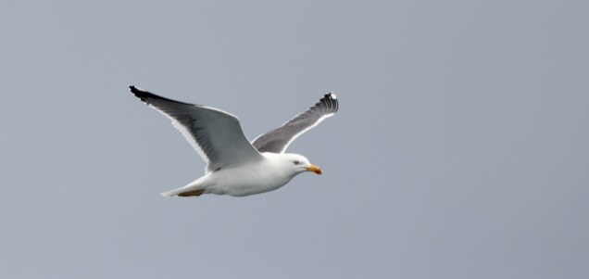
Anne Cotton

Seasonality – Migrants return to the Forth
in February and March with birds passing
through on their way north at this time as well.

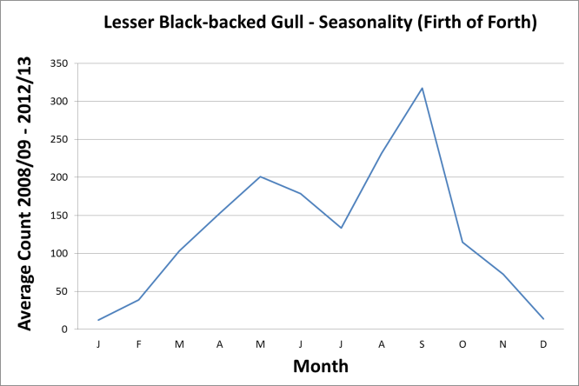

Pressures – Abundance and distribution
influenced by availability of human food and
fishery discards as well as natural food
sources. Urban nesting can cause conflict
with humans in some areas.

Population trends – Increased through
much of 20th century. Regular counts on the
Isle of May suggest a recent increase in
population which is counter to the national
48% decline for breeding birds between 2002
and 2012. Increased incidence of urban
nesting also contrasts with a wider decline.

Herring gull
Larus argentatus

For the most up to date information on site conservation status and population trends go to Sitelink:

Forth Islands SPA
Outer Firth of Forth and Tay Bay Complex SPA

Sitelink provides feature condition assessment details, with feature conservation objectives provided in either a Conservation Advice Package (CAP), Conservation and Management Advice (CMA) or generic conservation objectives.

SPA Population at Classification: 6,600
Pairs

Origin – Local breeders can remain through
the year but some move south in winter
including to mainland Europe. Winter
population also includes by birds from
northern Scotland, Iceland and Scandanavia.

Behaviour – Adaptable species, exploiting
a range of habitats and food resources.

Diet – An omnivore that eats a wide range of
fish, invertebrates, carrion, live prey and
human waste.

Habitat – Breeds on offshore islands,
coastal cliffs and buildings. Forages in the
intertidal zone, agricultural and urban areas,
ubbish dumps and sewage plants.

 | Low tide | High tide
Open water
Intertidal mud
Saltmarsh
Rocky shore
Coastal fields
Inland fields
Offshore islands

Distribution
Inner Forth | Widespread and numerous
Outer areas | Widespread and numerous

Breeds in large colonies on Forth islands and
also in urban areas (rooftops).

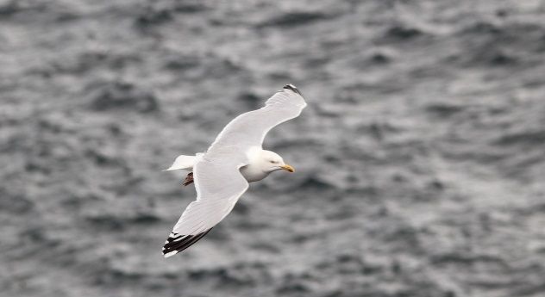
Anne Cotton
AnnAnne Cotton

Seasonality – Large numbers of birds are
present in the Forth year-round. Adult males
tend to stay near their breeding colonies year
round. Egg-laying takes place from late April
and young fledge from early July onwards.

Pressures and population trends can be found for Outer Firth of Forth and St Andrews Bay Complex SPA in the Conservation and Management advice (CMA) document within site 'documents and links' section on Sitelink.

Marine Mammals and Fish
The species accounts for mammals and fish include similar information to that provided in the bird accounts as well as summarised details to the designated sites to which they relate.

Bottlenose dolphin
Tursiops truncatus
Conservation status
Moray Firth SAC Population at designation: 101-250

Sitelink provides feature condition assessment details, with feature conservation objectives provided in either a Conservation Advice Package (CAP), Conservation and Management Advice (CMA) or generic Conservation Objectives.

Origin – Bottlenose dolphins in the Firth of Forth are considered to be part of the Coastal East Scotland Management Unit population. The Moray Firth in north-east Scotland supports the only known resident population of bottlenose dolphins in the North Sea. Dolphins are present in the Moray Firth all year round, and, while they range widely, they appear to favour particular areas. They may range further afield and occur regularly in the Firths of Tay, Forth and St Andrews Bay. For this reason, it is difficult to separate consideration of the SAC population from the Coastal East Scotland population. The most recent estimate for the Coastal East Scotland population was in 2013, which estimated 195 animals (95% CI 162-253).
Behaviour – Sightings are usually of small groups of between 2 and 29 individuals within the Firth of Forth, primarily around the southeast coast of Fife. They are most often observed foraging or travelling through an area, occasionally seen breaching. Females can produce a calf approximately every two years, though a three-year interval between calves is most common in the Coastal East Scotland population. In the wild they can live up to 20-50 years. Calves can be born any time of year but there is a slight peak between May – October. Calves have been recorded in the Firth of Forth in recent years.
Diet – A wide range of fish species, squid, crabs and shrimp.

Habitat – Usually seen close inshore rather than far offshore. Limited data means there is
little understanding of the relative importance of the Firth of Forth in terms of habitat.

 | Low tide | High tide
Open water
Inshore water

Distribution
Inner Forth | Absent
Outer areas | Locally regular or occasional

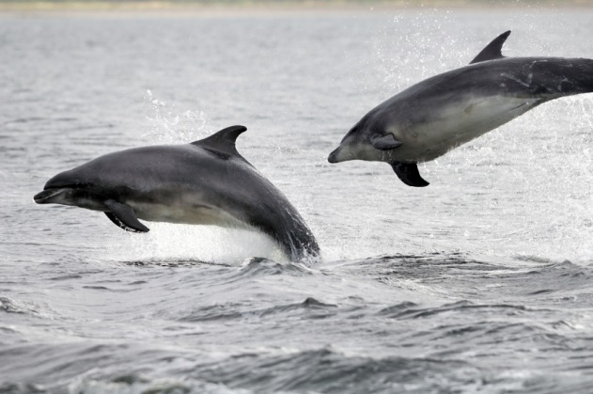
Seasonality – Most records in the Forth have been between May-September, but the limited nature of the data means it is not currently possible to make firm conclusions on how animals may be distributed.

Pressures – Underwater noise from development activity and vessels. Examples include piling, blasting, dredging and seismic survey. Noise propagates more effectively in water and dolphins are dependent on their hearing for social behaviours and for feeding. Different degrees of noise can cause disturbance, displacement, damage to animals hearing and in extreme circumstances death. Because the species is long lived and reproduces slowly, long term chronic
pressures (pollution,disturbance) that reduce breeding success can be a significant issue.
Collision (boat strike or propellor strike) – from commercial and/or recreational boat traffic is another little-understood pressure.

Population trends – Numbers appear stable. Modelling has been focused on the Moray Firth population with confidence Intervals of (95% CI)

Harbour seal
Phoca vitulina
Conservation status
Firth of Tay & Eden Estuary SAC Population at designation: 600

Sitelink provides feature condition assessment details, with feature conservation objectives provided in either a Conservation Advice Package (CAP), Conservation and Management Advice (CMA) or generic Conservation Objectives.

Origin – Resident
Behaviour – Harbour seals are found on sandflats and estuaries, and on rocky shores in Scotland. As pups swim almost immediately after birth, seals can breed on sheltered tidal areas where banks allow access to deep water. Seals may range widely in search of prey, but individuals often return to favoured haul-out sites. Harbour seals have limited daily foraging ranges of around 20km. They will often remain relatively close to their main haul-out and pupping sites. Over the longer term there is interchange between animals on different haul-outs and there is movement between the Tay and the Forth, but unlike grey seals they generally do not travel very long distances, either for foraging or seasonally. Notable haul-out sites in the Forth include the rocky coastline south of Kirkcaldy and around Inchmickery and nearby smaller islands.
Diet – Fish, marine invertebrates.

Habitat – Rocky shore, sandbanks, open water.
 | Low tide | High tide
Open Water
Sandbanks |  | -
Rocky shore

Distribution
Inner Forth | Uncommon
Outer areas | Locally common

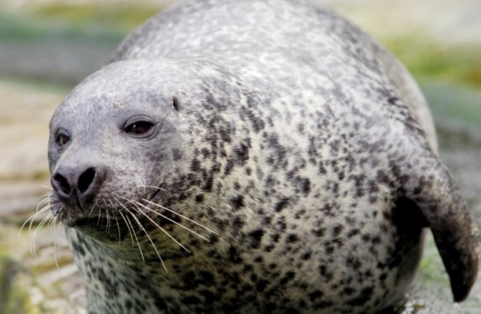

Seasonality – Pupping is during June-July followed by an adult moulting period August-September.

Pressures – Underwater noise, disturbance of haul-out sites. Possible contributory factors to the population drop noted below include a general increase in disturbance, changes in prey species abundance or disease. In some areas of the UK predation and unregulated shooting have also be put forward as potential factors in population declines. Harbour seals’ faithfullness to a fairly small home range means that colonies that crash or become extinct may be slow to recover as immigration is uncommon.
Population trends – There has been a substantial reduction in numbers on the east coast. The Firth of Tay and Eden Estuary breeding population dropped by over 90% from over 600 to 40-50 by 2014 but it is not clear what has caused this.

Grey seal
Halichoerus grypus

Conservation status
Isle of May SAC Population at designation: 5900
Berwickshire and North Northumberland Coast SAC Population at designation: 501-1000

Sitelink provides feature condition assessment details, with feature conservation objectives provided in either a Conservation Advice Package (CAP), Conservation and Management Advice (CMA) or generic Conservation Objectives.
Origin – Resident
Behaviour – Grey seals forage in the open sea and return regularly to haul out on land where they rest, moult and breed. They may range widely to forage and frequently travel over 100 km between haul-out sites. Foraging trips last anywhere between 1 and 30 days. These can involve long distance movements, with some individuals crossing the North Sea from Britain to the European mainland as far afield as Norway.
Diet – Fish and marine invertebrates.

Habitat
 | Low tide | High tide
Open water
Intertidal mud |  | -
Rocky shore |  | -

Distribution
Inner Forth | Widespread,
Outer areas | Widespread, common

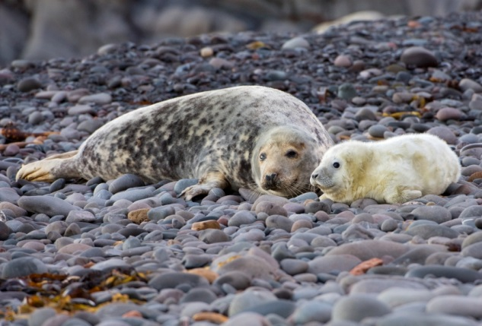

Seasonality – In September to late November females congregate on secluded beaches to pup and are joined by smaller numbers of dominant males who mate with them post-pupping. In some places large numbers of seals at high density are found, such as on the Isle of May. For the remainder of the year, they disperse widely around Scotland and further afield. Numbers are resident within the Forth throughout the year, with main pupping sites at Isle of May, Fast Castle coast, Craigleith and Inchkeith.

Pressures – Underwater noise, disturbance of haul-out sites, fisheries interactions and shooting. Underwater noise impacts similar to those discussed for bottlenose dolphin also apply for both seal species.
Population trends – The Isle of May is the largest east coast breeding colony of grey seals in Scotland and the fourth-largest breeding colony in the UK, contributing approximately 4.5% of annual UK pup production, though Fast Castle coastline has increasingly become an important large breeding colony. Inchkeith and Craigleith islands are also notable grey seal breeding colonies.

Atlantic salmon
Salmo salar

River Teith SAC

Sitelink provides feature condition assessment details, with feature conservation objectives provided in either a Conservation Advice Package (CAP), Conservation and Management Advice (CMA) or generic Conservation Objectives.

Origin – The Rivers Forth, Teith, Allan and tributaries.

Behaviour - Atlantic salmon using the Forth have a complex life cycle which begins and ends in freshwater spawning grounds in the catchments of the rivers Forth, Teith, Allan and tributaries. In Scotland Atlantic salmon typically spend around four years as juveniles in freshwater. They progress through several life stages before becoming smolts, migrating downstream and out to sea. Adult salmon spend up to four years growing at sea, then migrate back to the spawning grounds where they came from. This strong homing connection leads to genetically distinct populations.

Fish which spend only one year at sea are called grilse and are relatively small. A proportion of the Atlantic salmon stock may stay at sea for two or three years, in feeding grounds as far away as West Greenland, before returning. The timing of return is important from both a fisheries and conservation perspective. If these fish return to Scottish rivers between the months of January-June, they are referred to as 'spring salmon', and this stock component has shown a long-term decline since records began in 1952.

Diet - Juveniles feed on a wide range of aquatic invertebrates species such as caddisflies, stoneflies and mayflies. Adult Atlantic salmon feed on range of prey items, including marine amphipods, shrimps and squid and include sandeels, capelin and herring.

Habitat – It is thought that Atlantic salmon use inshore waters when migrating through the Firth of Forth rather than the mid-channel. Post-smolt Atlantic salmon typically occupy the upper layers of the water column as they pass out to sea, though this can be variable. Tagged Atlantic salmon typically occupied near-surface habitats during a study on the north coast of Scotland

Distribution
Inner Forth | Seasonally common
Outer areas | Seasonally common

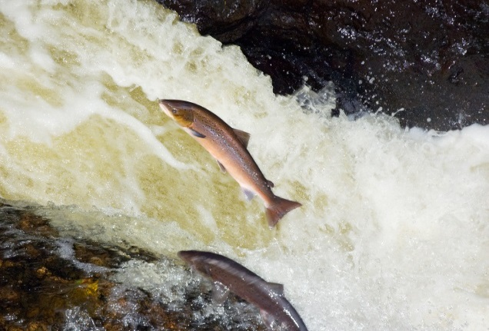

Seasonality - Salmon may enter Scotland's rivers throughout the year. Juvenile smolts migrate from river to sea during the months of March to May. Fish that stay at sea for two or three years are known as multi sea winter salmon (MSW). Adults may migrate to their natal rivers at any time of year. Peak spawning occurs between November-December but in some localities such as larger rivers may extend from October - late February.

Pressures - Underwater noise and vibration such as piling, blasting dredging or seismic survey. Noise effects upon fish range from disturbance and displacement, damage to hearing, organs and even immediate death.

Population trends
Data, available from 1952 to present, shows considerable variation in annual abundance. Overall number of recorded Atlantic salmon returning to Scottish rivers increased over recent years but dropped each year since 2010.

The number of salmon retained and released by anglers in the Forth District during the period 1952-2013. (Data MSS, Crown copyright)

Sea lamprey
Petromyzon marinus

River Teith SAC

Sitelink provides feature condition assessment details, with feature conservation objectives provided in either a Conservation Advice Package (CAP), Conservation and Management Advice (CMA) or generic Conservation Objectives.

Origin - Sea lamprey live in freshwater as juveniles but migrate to sea to grow into adults. There is no evidence that adult sea lamprey return to their river of origin but may be attracted to suitable rivers by chemical cues from juveniles (ammocoetes). Adults return to the River Teith SAC and freshwater reaches of the River Forth in every year.

Behaviour - Sea lamprey return to British rivers to spawn in gravel or cobbles when the water temperature reaches at least 15ºC. Adults die after spawning is completed. Juvenile sea lamprey (ammocoetes) settle in silt beds within the River Teith SAC for up to five years. They may use deeper habitats in rivers than those of brook or river lamprey, and their abundance in surveys may be under-reported. Sea lamprey typically migrate downstream and to sea in autumn to mid-winter. Most movement occurs during darkness and may be connected to periods of increased water discharge. They spend 18 to 24 months at sea feeding, before migrating back to the River Teith SAC.

Diet - Juveniles are filter feeders. Diet mainly consists of diatoms (algae) and river detritus. Adults are parasitic, using their teeth to attach to cetaceans and large fish to feed on their blood and flesh.

Habitat - As transformers these fish may utilise currents to assist movement, but there is no evidence that adults or transformers are predominantly, or exclusively, found in either inshore or offshore areas. Lamprey ammocoetes can be found wherever suitable habitat is located downstream of spawning sites, including the lower reaches of rivers towards their tidal limits.

Distribution
Inner Forth | Seasonally common
Outer areas | Seasonally common
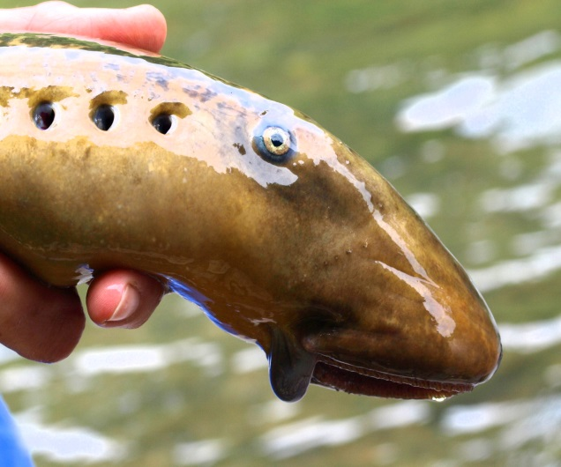
Brian Morland/Bellflask Ecological Surveys

Seasonality - Metamorphosis from juvenile to adult takes place between July and September. Pre-adult sea lamprey migrate from river, through the Firth of Forth to the open sea between October - December. Mature sea lamprey return through the Firth to freshwater to spawn in the rivers Forth and Teith. This can occur as early as April and these fish typically spawn in late May or June.

Pressures – Noise: underwater noise and vibration, though less sensitive than salmon. The most obvious source of these effects are piling and blasting, although the noise associated with other operations may also be significant. Electromagnetic Fields (EMF): Sea lamprey are likely to encounter EMF from subsea cables but it is unclear what impact EMF may have on the movement of emigrating or returning sea lamprey. Water quality: Significant pollution can eliminate whole populations of sea lamprey from rivers and prevent migration. Lighting: Anadromous lampreys avoid the light during the daytime, hiding under rocks or river banks and resuming their upstream movement only during the hours of darkness. Lamprey may be sensitive to non-natural lighting, although this may also be influenced by the availability of cover. Exploitation: no fisheries exist for this species within the UK.

River lamprey
Lampetra fluvialis

River Teith SAC

Sitelink provides feature condition assessment details, with feature conservation objectives provided in either a Conservation Advice Package (CAP), Conservation and Management Advice (CMA) or generic Conservation Objectives.

Origin - River lamprey live in freshwater as juveniles but migrate to sea to grow into mature adults. There is no evidence that adult river lamprey return to the same river in which they themselves were spawned but evidence suggests that they are attracted back to rivers through their ability to detect chemical cues from juvenile lamprey. River lamprey adults return to the River Teith SAC in every year. They have also been recorded in freshwater reaches of the a number of other rivers which flow into the Firth of Forth, including the rivers Allan, Devon, Forth and the Water of Leith.

Behaviour - Spawn in nests excavated in clean gravel or cobble substrates in freshwater reaches at water temperature 10-11ºC. Juvenile river lamprey (ammocoetes) disperse into silt beds within the River Teith SAC for three to five years. During this time, river lamprey are indistinguishable from brook lamprey. Transformers migrate downstream in darkness to estuaries. River lamprey may spend a significant part of their adult life within the Firth of Forth and other coastal areas. They may spend 18 to 24 months in coastal waters, before migrating back to the SAC.

Diet - Juvenile river lamprey are filter feeders. Diet mainly consists of microorganisms and river detritus. Adult river lamprey are parasitic, and feed on blood and flesh of other fish. River lamprey can feed for many months in estuarine environments and that the size of lamprey and its host are related, with Clupeids an important prey in the Forth.

Habitat There is evidence that river lamprey may use inshore waters when present in Firth of Forth and be present throughout the Firth.

Distribution
Inner Forth | Seasonally common
Outer areas | Seasonally common

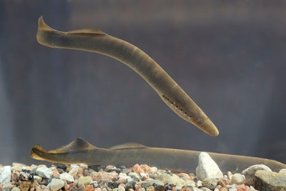
Tiit Hunt/ CC-BY-SA-3.0

Seasonality – River lamprey return to the rivers from coastal and estuarine areas from October to December and typically spawn in late March to May. Metamorphosis from the juvenile to adult form takes place between July and September.

Pressures - Noise: underwater noise and vibration, though less sensitive than salmon. The most obvious source of these effects are piling and blasting, although the noise associated with other operations may also be significant. Electromagnetic Fields (EMF): River lamprey are likely to encounter EMF from subsea cables but it is unclear what impact EMF may have on the movement of emigrating or returning lamprey. Water quality: Significant pollution can eliminate whole populations of lamprey from rivers and prevent migration. Lighting: Anadromous lampreys avoid the light during the daytime, hiding under rocks or river banks and resuming their upstream movement only during the hours of darkness. Lamprey may be sensitive to non-natural lighting, although this may also be influenced by the availability of cover. Exploitation: not exploited in Scotland, but are exploited elsewhere in a limited number of locations within the UK. River lamprey fisheries in the Humber and Yorkshire Ouse catchments are used to supply the angling market. No fish are sold for human consumption.

Further Reading

HRA Process
The Conservation (Natural Habitats & c.) Regulations 1994; http://www.legislation.gov.uk/uksi/1994/2716/contents/made

Habitats Regulations Appraisal; http://www.snh.gov.uk/protecting-scotlands-nature/protected-areas/international-designations/natura-sites/hra-help-and-advice/

Appropriate assessment (AA); http://www.snh.gov.uk/protecting-scotlands-nature/protected-areas/international-designations/natura-sites/hra-appropriate-assessment/

Likely to have a significant effect (LSE); http://www.snh.gov.uk/protecting-scotlands-nature/protected-areas/international-designations/natura-sites/hra-likely-significant-effect/

Sitelink; http://gateway.snh.gov.uk/sitelink/index.jsp

Help and advice on HRA; http://www.snh.gov.uk/protecting-scotlands-nature/protected-areas/international-designations/natura-sites/hra-help-and-advice/

European Guidance
Guidelines on the implementation of the birds and habitats directives in estuaries and coastal zonesWith particular attention to port development and dredging

Birds
Bird discussion and species accounts in this document are based on SNH Commissioned Report 804: A review of literature on the qualifying interest species of Special Protection Areas (SPAs) in the Firth of Forth and development related influences which contains a comprehensive reference list.
Eaton M, Aebischer N, Brown A, Hearn R, Lock L, Musgrove A, Noble D, Stroud D & Gregory R (2015) Birds of Conservation
Concern 4: the population status of birds in the UK, Channel Islands and Isle of Man. British Birds 108: 708–746

Marine Mammals
Cheney, B., Graham, I.M., Barton, T.R., Hammond, P.S. and Thompson, P.M. 2014. Site
Condition Monitoring of bottlenose dolphins within the Moray Firth Special Area of
Conservation: 2011-2013. Scottish Natural Heritage Commissioned Report No. 797.

Quick, N., Arso, N, Cheney, B, Islas, V, Janik, V, Thompson P. M. and Hammond, P
The east coast of Scotland bottlenose dolphin population: Improving understanding of ecology outside the Moray Firth SAC
UK Department of Energy and Climate Change offshore energy Strategic Environmental Assessment (SEA) programme.

Russell, D. J. F., McConnell, B., Thompson, D., Duck, C., Morris, C., and Harwood, P.

and Jason Mathiopoulos – Uncovering the links between foraging and breeding regions in a

highly mobile mammal Journal of Applied Ecology 2013, 50, 499-509.

Wilson, D. R. B. 1995. The ecology of bottlenose dolphins in the Moray Firth, Scotland : a population at the northern extreme of the species' range – Aberdeen University Thesis.

Fish
Bergstedt, R. A. & Seelye, J. G.1995. Evidence for lack of homing by sea lamprey. Transactions of the American Fisheries Society 124, 235–239.
Gaudron, S. M. & Lucas, M. C. 2006. First evidence of attraction of adult river lamprey in the migratory phase to larval odour. Journal of Fish Biology, 68, 640–644.
Gill, A.B. & Bartlett, M. 2010. Literature review on the potential effects of electromagnetic fields and subsea noise from marine renewable energy developments on Atlantic salmon, sea trout and European eel. Scottish Natural Heritage Commissioned Report No.401
Godfrey, J.D., Stewart, D.C., Middlemas, S.J. & Armstrong, J.D. 2014. Depth use and movements of homing Atlantic salmon (Salmo salar) in Scottish coastal waters in relation to marine renewable energy development. Scottish Marine and Freshwater Science Vol 05, No 18
Hardisty, M.W. 2013. Biology of the Cyclostomes. Springer, London.
Maitland, P.S. 2003. Ecology of the River, Brook and Sea Lamprey. Conserving Natura 2000 Rivers Ecology Series No. 5. English Nature, Peterborough.
Maitland, P.S., Morris, K.H. East, K., Schoonoord, M. P., van der Wal, B. & Potter, I.C. 1984. The estuarine biology of the River lamprey, Lampetra fluviutilis, in the Firth of Forth, Scotland, with particular reference to size composition and feeding. Journal of the Zoological Society of London, 203, 211-225.
Malcolm, I.A., Godfrey, J. & Youngson, A.F. 2010. Review of migratory routes and behaviour of Atlantic salmon, sea trout and European eel in Scotland’s coastal environment: implications for the development of marine renewables. Scottish Marine and Freshwater Science 1: No 14.
Riley W.D., Bendall B., Ives M.J., Edmonds N.J. & Maxwell D.L. 2012. Street lighting disrupts the diel migratory pattern of wild Atlantic salmon, Salmo salar L., smolts leaving their natal stream. Aquaculture, 330-333, 74-81.
Smith, I.P. & Smith, G.W. 1997. Tidal and diel timing of river entry by adult Atlantic salmon returning to the Aberdeenshire Dee, Scotland. Journal of Fish Biology 50, 463–474.
Vrieze, L. A. & Sorensen, P. W. 2001. Laboratory assessment of the role of a larval pheromone and natural stream odor in spawning stream localization by migratory sea lamprey (Petromyzon marinus). Canadian Journal of Fisheries and Aquatic Sciences, 58, 2374–2385.

Annex 1: Glossary for Conservation Objectives and References

Conservation Objective term | Definition
Distribution | The “distribution” is how the qualifying feature is spread out within the  site.
Favourable condition | This refers to the assessed condition of a feature through Site Condition Monitoring. Features considered to be in favourable condition for the purposes of these Conservation Objectives are those that have an assessed condition of either:  - Favourable declining - The attribute targets set for the natural feature have been met, but evidence suggests that its condition will worsen unless remedial action is taken.  - Favourable Maintained - the attribute targets set for the natural features have been met, and the natural feature is likely to be secure on the site under present conditions.  - Favourable Recovered - the condition of the natural feature has recovered from a previous unfavourable condition, and attribute targets are now being met.
Generation length | Generation length is “the average age of parents of the current cohort”.  Generation length therefore reflects the turnover rate of breeding  individuals in a population (IUCN, 2019).
Maintain | Where a qualifying feature of the SPA is assessed as being in  favourable condition the conservation objective is ‘maintain’. This means  that the various attributes of the feature should be kept at that  favourable level. This can include increasing/improving condition as  well, but not a permanent decline.
Marine birds | This term encompasses true seabirds and waterfowl (seaducks, divers, and grebes).
Metapopulation | A group of connected populations of a species within a defined area, where the individual populations may interact with one another.
Restore | Where a qualifying feature of the SPA is assessed as being in unfavourable condition the conservation objective is ‘restore’. This means that the various attributes of the feature should be returned to the favourable level by increasing/improving condition.
Site integrity | The integrity of a site is defined in general terms as the coherence of its ecological structures and function, across its whole area, which enables it to sustain the habitat, complex of habitats and and/or the levels of populations of the species for which it was designated.
Site reference population | This refers to the estimated population figure for the site and should be used to form the basis of carrying out HRAs. In most cases, the site reference population will be the baseline population (figure at designation). However, where recent surveys show a population to have increased or stayed stable, the current population is considered the most appropriate population figure to use for HRA’s.
Supporting habitats and processes | This includes the following environmental conditions (but is not limited to) which are important for maintaining/restoring the protected features, e.g. hydrography and supporting water currents, chemical water quality parameters, suspended sediment levels, radionuclide levels.
Unfavourable condition | This refers to the assessed condition of a feature through Site Condition Monitoring. Features considered to be in unfavourable condition for the purposes of these Conservation Objectives are those that have an assessed condition of either:  - Unfavourable recovering - One or more of the attribute targets have not been met on the site, but management measures are in place to improve the condition.  - Unfavourable no change - One or more of the attribute targets have not been met, and recovery is unlikely under the present management and activity on the site.  - Unfavourable declining - One or more of the attribute targets have not been met, evidence suggests that condition will worsen unless remedial action is taken.
Waterfowl | Encompasses seaducks, grebes and divers.

