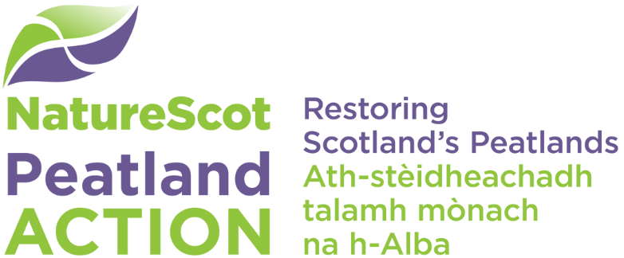

Fund Eligibility Criteria

General conditions
- There are no geographical restrictions or target areas for Peatland ACTION funding.
- The majority of the peatland within a project area must have a peat depth of over 50cm, but peat depths down to 30cm will be considered for restoration if they form an intrinsic component of the peat hydrological unit.
- Fens containing peat will be considered.
- Annual management payments will not be funded.

Scale of project
- Generally, we expect projects to be greater than 10 ha with a cost over £10,000.
- If you have a smaller project, please consider linking with other landholders to create a larger project. Our Project Officers are able to support you in developing larger proposals – please email us at peatlandaction@nature.scot.

Peatland ACTION will consider funding the following work/capital items
- Combined ditch/grip-blocking and re-profiling (preferred method over ditch blocking alone) *
- Ditch-blocking, although preference is for combined blocking and re-profiling*. Your application will need to justify why you are planning ditch-blocking alone.
- Gully re-profiling
- Gully blocking
- Bunding
- Bare peat restoration
- Surface-smoothing techniques on previously afforested sites
- Hag restoration
- Installation of sediment traps, timber or stone
- Scrub/woodland removal* only where it can be demonstrated that there is an overall benefit to the public purse by the inclusion of minor scrub/woodland removal work as part of a larger Peatland ACTION restoration project. In addition, the seed source must be eliminated and the hydrology of the site should be modified substantially to reduce the incidence of regeneration.
- Mulching
- Re-use of felled to waste material (e.g. brash, mulch) in restoration.
- Peat depth and peatland condition surveys**
- Interpretative materials* where it can be demonstrated that there is an overall benefit to the public purse by funding installation work as part of a larger Peatland ACTION restoration project.
- Community initiatives that include restoration and lead to wider public engagement.
- Professional fees that are appropriate and proportionate to the project.

* See information on Peatland ACTION and the SRDP - eligibility
** All data must be made publicly available.

Monitoring
- Capital items for monitoring equipment that forms part of a project that aims to meet the objectives of the Peatland ACTION monitoring strategy, along with staff time for maintenance of the items, where this funding is critical and is not available from other sources. If monitoring projects form part of restoration work, please submit a grant application. The monitoring strategy is available from peatlandactiondata@nature.scot.
- Monitoring projects with staff time to undertake surveys, data downloads, reporting and any other associated activity related to monitoring, where this funding is critical and is not available from other sources. If monitoring projects form part of restoration work, please submit a grant application.
- If monitoring projects are separate from restoration work please contact peatlandactiondata@nature.scot to arrange to discuss with a Data Officer, and do not submit a grant application.

Infrastructure items
Peatland ACTION will consider funding infrastructure items to support working in difficult environments. Our strong preference is for temporary solutions which can be re-naturalized or ensure that access routes are not significantly and adversely impacted by peatland restoration activities (e.g. track protection or track repairs).
However, it is recognised that in some exceptional circumstances, track upgrades or more permanent capital items could facilitate works in otherwise inaccessible areas of peatlands and funding may be considered if works unlock significant scale.
Affordability and value for money are key considerations, therefore funding will be offered for the lowest cost solution which is fit for purpose to enable peatland restoration activities. Infrastructure items must be costed separately and will be assessed by the core principles outlined below:
- Infrastructure investment will only be considered as part of a fully costed peatland restoration project. Both restoration and infrastructure works will need to demonstrate value for money.
- All means of access must have been assessed and a clear justification provided which demonstrates why the proposed infrastructure works are necessary to enable peatland restoration works. Where appropriate, specialist technical advice must inform analysis and the final business justification.
- Applicants must contribute funding towards upgrades or more permanent infrastructure items. This contribution should reflect core business and maintenance models, as well as any future commercial benefits beyond peatland restoration.
- Peatland ACTION will not fund any applicant or agent project management costs directly associated with any infrastructure works.
- Formal consent must have been provided by the legal owner and Peatland ACTION will not accept any ongoing liability or maintenance responsibility for infrastructure items.
- As with peatland restoration, infrastructure works must comply with all relevant statutory regulations/guidance e.g. Permitted Development Rights, The Construction (Design and Management) Regulations 2015.

Early engagement with Peatland ACTION is encouraged to help applicants to assess whether the scale of infrastructure investment is likely to align with future restoration opportunities and represent value for money prior to progressing a Peatland ACTION grant application.

Other items
- Restoration feasibility studies and site condition assessments** can be funded but you should contact peatlandaction@nature.scot to arrange to discuss with a Project Officer. Do not submit a grant application.
- Facilitation of engagement opportunities outwith specific Peatland ACTION projects.
- Staff based in other organisations, to facilitate activities related to peatland restoration activity but not currently covered by Peatland ACTION.
- Fences are generally not funded and if funded are only for small lengths or for experimental trial purposes*.
- Innovative methods and trials as part of a restoration project. We encourage and facilitate innovation in peatland restoration and are keen to hear of new ideas. Please contact the Peatland ACTION Project Manager at peatlandaction@nature.scot to discuss your ideas.
- Rhododendron control is limited to small areas or individual bushes that are part of the restoration area*.
- Forest to bog - where Peatland ACTION is asked to fund the removal of forest to restore bog, the profit from the sale of marketable timber products, including chipping, biomass, wood fuel and charcoal, is used to offset the costs of the restoration project. Your Funding Officer will discuss arrangements for confirming costs and the evidence needed to satisfy grant conditions.

* See information on Peatland ACTION and the SRDP - eligibility
** All data must be made publicly available.

In addition, we recognise that each site/proposal is unique and other non-standard items may be needed. You should discuss any other costs you are considering applying for with a Peatland ACTION Funding Officer before you submit your application. This will allow us to guide you on requirements such as State Aid implications and whether the proposed costs may be considered reasonable, in the circumstances. You can contact us by email at peatlandactiongrant@nature.scot.

Peatland ACTION and the SRDP – eligibility

Agri-Environment Climate Scheme (AECS)
Applicants can seek support for some activities that would have been eligible through AECS. These will be restricted to:
- Ditch blocking with plastic dams or peat dams only when combined with re-profiling ditches
- Limited fencing to support peatland restoration
- Limited scrub/rhododendron control where it can be shown that the removal will enhance peatland restoration.

Forestry Grant Scheme (FGS)
Peatland ACTION will not pay for activities eligible for FGS including woodland improvement work such as rhododendron control in woodland. We may consider limited funding by exception where it can be demonstrated that there is an overall benefit to the public purse by doing some minor eligible works, as part of a larger Peatland ACTION restoration project. For example, if without the activities the project will not gain the wider/total site benefits.

