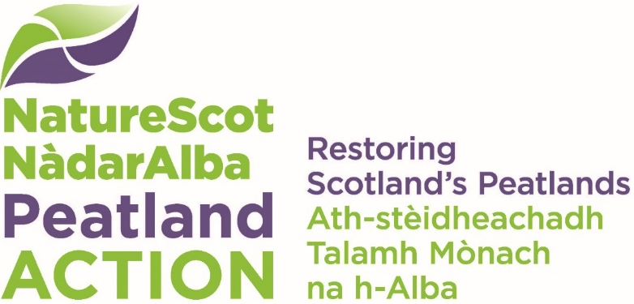

Monitoring project fund
  - Expression of Interest (EoI)
Projects requesting funding of over £30,000 should complete and submit this Expression of Interest (EoI) form to allow NatureScot Peatland ACTION to consult more widely on the higher investment. Budgets and staff resource for monitoring are limited and investment must be considered in the context of wider Scottish Government and delivery partner active projects. Projects where the total fund requested will be below £30,000 should complete the Monitoring Project Fund application form available on the download section of the webpages.
Please use this EoI form to tell us about your proposed project. We will then review your Expression of Interest and arrange for an Adviser to contact you to discuss it.
If we assess that your project could meet NatureScot Peatland ACTION priorities and is aligned with wider organisational/policy projects, we will send you an application form with a unique project reference number to complete. This will only be made available to those projects that have submitted an EoI and have been offered the opportunity to submit a full application. We will not accept any applications without a project reference number. The opportunity to complete a full application does not guarantee that your application will be successful.
Contact details
Applicant:
Project name:
Contact name:
Email:
Phone number:

I have read the outcomes and eligibility criteria and assess that this proposal meets the criteria (check box) ☐
Please select which of the topics listed in the eligibility criteria your project meets.
☐ | Objective A: Establish if restoration works are resulting in conditions favourable to the recovery of a functioning peatland habitat, e.g. using indicators such as water table level, vegetation cover, and bare peat extent.
☐ | Objective B: Compare the effectiveness of different restoration techniques for a specific feature of degraded peatland, e.g. drainage, erosion, bare peat.
☐ | Objective B: Compare the effectiveness of a specific restoration technique in different conditions or settings, e.g. peatland type, geographical location, elevation, topography.
☐ | Objective C: Contribute to the evidence base associated with the ecosystem services of peatlands, e.g. C1 Water quality, C2 Water quantity and flood alleviation, C3 Fire risk control, C4 Biodiversity, C5 Social and economic outcomes, C6 Greenhouse gas (GHG) storage and sequestration
☐ | Fill key evidence gaps in the reporting of peatland restoration, namely the area affected by restoration. The evidence gaps include ‘restoration footprint’ or zone of influence and greenhouse gas emissions reductions.
☐ | Develop or trial new methods for monitoring peatland condition and the effects of peatland restoration.
Briefly state the overall aim of your monitoring project.
Click or tap here to enter text.

Background - please summarise (400 words max) the need for the project such as evidence gaps that will be filled or how the results will be used to inform management.
Click or tap here to enter text.

Study site(s) – As far as possible please give a brief (250 words max) indication of the sites to be included in your project for example including geographical location, landownership and permissions, peatland type and condition, previous Peatland ACTION restoration funding and past and current management.
Click or tap here to enter text.

Project finances: Please tell us;
- how much you expect the project to cost in total
- how much you are requesting from NatureScot Peatland ACTION
- details of other funders (remember that a minimum of 10% of total project costs must be offered as match funding from other sources):

Click or tap here to enter text.

Please summarise the main outputs from the project including datasets, reports and publications. All raw data and a written final report must be shared with Peatland ACTION and can be made publicly available under Open Government Licence. Consider how your outputs will support knowledge transfer and learning across the Peatland ACTION delivery partnership.
Click or tap here to enter text.

It is a condition of grant that you acknowledge Peatland ACTION funding for your project. Please confirm which media would be used to promote the project and Peatland ACTION.
Media | Yes or No | Details
Facebook | Yes ☐ No ☐
X/Twitter | Yes ☐ No ☐
Instagram | Yes ☐ No ☐
YouTube | Yes ☐ No ☐
Website | Yes ☐ No ☐
Blog | Yes ☐ No ☐
Press/media | Yes ☐ No ☐
Publications | Yes ☐ No ☐
Interpretation | Yes ☐ No ☐
At site of work | Yes ☐ No ☐
Staff posts directly funded by us | Yes ☐ No ☐
Other | Yes ☐ No ☐

Please give a brief description of how advanced project planning is along with a summary of pre-project discussions and consultations (including with NatureScot staff) (250 words maximum):
Click or tap here to enter text.

Project timeframe
Start date
End date

Thank you for your interest in the NatureScot Peatland ACTION Monitoring fund. Please email peatlandactiongrant@nature.scot with your completed EoI form. We aim to respond within 20 working days.

