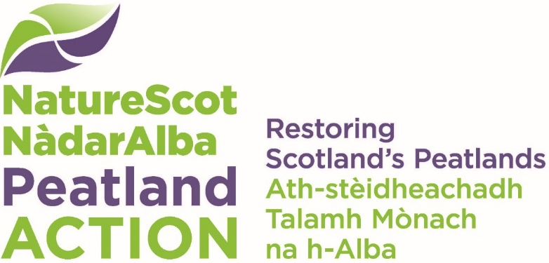

Monitoring project fund
  - Final report
A final report must be sent to peatlandactiongrant@nature.scot for each monitoring project funded by Peatland ACTION once monitoring activities are completed. These reports are a requirement of the Peatland ACTION funding.
Completed reports may be used by NatureScot to help raise awareness of the range of peatland monitoring work we are funding. Writing style for the open questions should be journalistic – telling stories, showing how challenges were overcome and what helped to achieve goals. The information gathered from these reports may also be used for research purposes and published under an Open Government Licence (information on costs will be anonymised). We may also use project information on our website and for our communications and advocacy purposes.
The final report should consist of three components:
- A completed version of this document.
- A folder containing the completed spatial data templates that represent your monitoring project. The following spatial data must contain at a minimum one feature in one of the tables either ‘Monitoring Points’, ‘Monitoring Lines’ or ‘Monitoring Areas’. This data is representative of your final monitoring project.
The report and spatial data must be submitted using the standardised format specified in the templates and guidance which are available on our website.
Name the folder: ‘Project ID code_FinalReport _Project name_YYYYMMDD’
e.g. ‘500123_FinalReport _Lower Moss_20191021’.
- A folder containing the monitoring data as agreed in the final grant offer.

For check boxes, double-click on the box to open and select ‘Checked’ as appropriate. Where needed add additional lines to tables. Finally, in order to complete this form you will need to have a copy of your Peatland ACTION application form for reference.

Section A - About you
- Applicant organisation
Click or tap here to enter text.

Section B - About your project
- Project ID number
Click or tap here to enter text.

- Project title
Click or tap here to enter text.

- Central grid reference(s) of study site(s) (if there is more than one site, please enter a grid reference for each site separately). Recommended format: e.g. NS520190 (two letters, 6 figures, no spaces).
Click or tap here to enter text.

Period when monitoring activity was on-going.
Start date
End date

- A line / sentence / quote as a captivating statement about the project (could be from the project manager or a stakeholder)
Click or tap here to enter text.

- Project synopsis (please use snappy subtitles if possible) (max 750 words in total). This should include:
- Introduction (overall aim and specific questions)
- Study site(s) summary
- Data collection (sampling strategy and methods)
- Outputs and outcomes (outputs show what was produced or accomplished, outcomes show the effect of these outputs on the desired result)
Click or tap here to enter text.

- Please provide links to any published outputs
Click or tap here to enter text.

- Did the project involve any partnership working and/or make links with any other projects? (e.g. Central Scotland Green Network, Pearls in Peril) if so, please briefly describe:
Click or tap here to enter text.

- Do you have future plans to continue the monitoring activities?
Click or tap here to enter text.

Section C – your costs
All costs must be broken down by financial year (01 April to 31 March).
Project costs we need to know:
- Cash costs of your project. A cash cost is an item you pay for such as buying a piece of equipment or hiring a venue or piece of equipment or paying for sub-contractors. Please note that we are interested in the total cash cost of your project – this includes all cash items even if you’re not looking for us to fund them.
- In-kind contributions. An in-kind contribution is an item donated to the project at no actual “cash” cost to the project such as volunteer time, services or materials.

Summary of costs
- Please provide a summary of costs.
Cash costs summary | Grant Requested Year 1 | Grant Requested Year 2 | Grant Requested Year 3 | Total
Total project cost | £ | £ | £ | £
Total cash cost | £ | £ | £ | £
Cash requested from NatureScot | £ | £ | £ | £
Cash contributions from you or other funders | £ | £ | £ | £
Total | £ | £ | £ | £

- In those cases where your costs have changed with respect to those indicated in Q33 - 35 of the Application form, please specify reasons for changes in cost. If there were no changes, please leave blank.
Click or tap here to enter text.

- If additional (non-Peatland ACTION) funding was secured as part of the project, please provide details:
Click or tap here to enter text.

In-kind contributions
- Please tell us about any in-kind contributions, including your own. Provide an estimate of the total incurred in-kind contributions by you or any third-party organisation that may have been listed in Q37 of the Application form.
Contributor | Description of in-kind contribution | Cash Cost Year20__ -20___ | Cash Cost Year20__ - 20__ | Cash Cost Year20__ - 20__
 |  | £ | £ | £
 |  | £ | £ | £
 |  | £ | £ | £
Total | NA | £ | £ | £

- Was social media (e.g. X/Twitter, Facebook, Instagram), public media (e.g. TV, radio), or a public event(s) used to promote the project? Yes ☐ No ☐

If yes, please describe in the following table
Brief details (including number of people engaged)
Facebook
Number of likes/ comments/shares
X/Twitter
Total number of likes/ retweets/favourites
Instagram
YouTube
Website
Number of views
Blog
Number of views
Newspaper/newsletter
Circulation of publication
TV
Radio
On-site interpretation materials
Other

- If you have hosted any demonstration events and/or community engagement events, please describe, including the number of attendees.
Click or tap here to enter text.

- How many volunteers were involved with the project and how many volunteer-days did this amount to?
Click or tap here to enter text.

- If schools were involved, how many students were engaged with the project?
Click or tap here to enter text.

End of report

