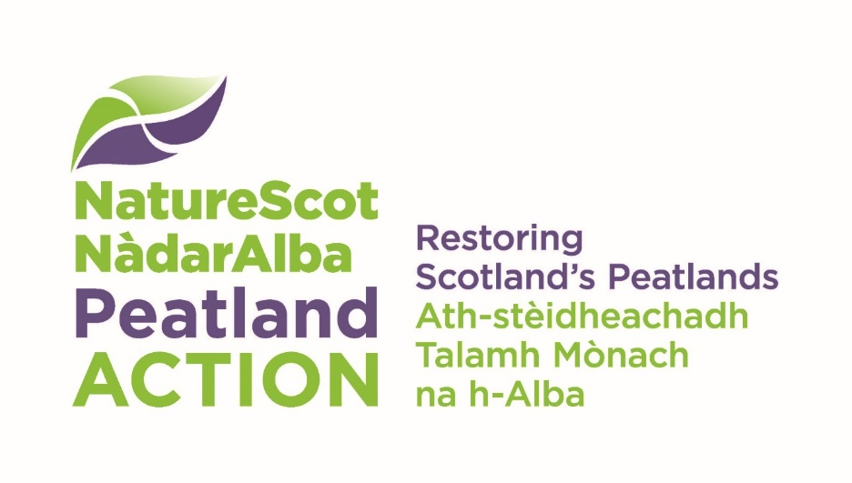[Web address: nature.scot/peatlandaction](http://www.nature.scot/PeatlandACTION)

Peatland restoration feasibility assessment checklist

The following checklist has been developed for open bog habitats.

|  |  |  |
| --- | --- | --- |
| Number | Feasibility assessment checklist for peatland restoration projects | Tick |
| 1 | PA carry out a desk-based analysis to determine potential distribution of degraded peatland habitat(s) within landholding using aerial imagery, the [Carbon and peatland map 2016](https://map.environment.gov.scot/Soil_maps/?layer=10&layer=10), slope analysis etc to assist. |  |
| 2 | Carry out full peat depth survey within mapped survey areas in accordance with [version 2.0 of the Peatland Code protocol](https://www.iucn-uk-peatlandprogramme.org/sites/default/files/2023-03/FieldProtocol_%20v2_clean_0.pdf) but with the following caveats. Peat depths must be recorded to the nearest cm and surveyors must use a peat probe with sufficient length of rods to measure the full depth of the peat. To clarify, photos will be required from roughly 25% of points, capturing any representative features where possible. Please also try to keep the file sizes of photos down if possible. Please note any signs of burning or protected species which are encountered. A minimum of 50% of the peat depths recorded on the 100 x 100 m grid within all Assessment Units must be greater than or equal to 30cm for the site to meet Peatland ACTION eligibility requirements. [The survey data must be recorded using our peat depth and peatland condition recording form (Excel template)](https://www.nature.scot/peatland-action-peat-depth-and-peat-condition-survey-guidance-and-recording-form-guidance) and displayed on a map at the appropriate scale. |  |
| 3 | Carry out a baseline hydrological assessment and identify all of the distinct hydrological units present within the study area. Provide hydrological assessment maps showing all drainage / flow pathways (including direction of flow), clearly demarcating all man-made channels which appear on 1:50,000 scale OS maps (for SEPA CAR licensing purposes). Provide this data in GIS format. |  |
| 4 | Carry out an assessment of average depth and width across a representative sample of drains and gullies (in metres), and assess peat depths at the base of drains and gullies in order to inform the most appropriate specification of dam or bund. |  |
| 5 | Carry out an assessment of the extent and distribution of all drainage/erosion features (i.e. drains, haggs, gullies, bare peat pans, surface micro-erosion etc.). [Produce maps and provide spatial data using our GIS template](https://www.nature.scot/doc/peatland-action-spatial-data-guidance-support-your-project).  Please adhere to our guidance on using this spatial data template and include a restoration footprint up to 50m. |  |
| 6 | Record soil pH in-situ within representative bare peat areas using soil pH meter / pH testing kit. |  |
| 7 | [Record and geo-reference any signs of peat instability noted in the field](https://www.gov.scot/publications/peat-landslide-hazard-risk-assessments-best-practice-guide-proposed-electricity/). These include gully sidewall collapse; collapsed peat pipes; slumping along a watercourse; tension cracks; tears; compression ridges / bulging; ‘ribbons’ of vegetated peat separated by tears and cracks filled with slurried basal peat; exposed mineral substrates with stranded rafts and blocks of material downslope of the scar. The contractor must take account of any potential effects and/or impacts of peat instability on proposed restoration activities. |  |
| 8 | Carry out an assessment to determine the underlying geology / mineral layer composition (e.g. clay, iron pan etc.) across the proposed restoration area(s). |  |
| 9 | Carry out an assessment of scrub / woodland and regeneration / self-seeding potential across the proposed restoration area(s). Provide a scrub control/woodland removal plan (if required). |  |
| 10 | Carry out habitat impact assessments (HIA) within mapped survey areas, following the [Best Practice Guidance survey assessment methodology for blanket bog](https://bestpracticeguides.org.uk/impacts/blanket-bog/). [Data can be recorded using the form provided](https://bestpracticeguides.org.uk/contact-us/forms/) and submitted in Excel format with associated maps also produced. Roughly 3 HIA plots per 100ha is acceptable but for most sites we will specify that a higher density is required. |  |
| 11 | Produce a Peatland Restoration Management Plan for the Estate - Including defining the restoration specification. Provide data on total length of drains and/or gullies to be blocked, total number and type of dams/bunds required (e.g. peat / plastic / timber / mineral / stone / composite), total area of bare peat restoration, total length and average height of haggs/cuttings to be re-profiled, total length and type of bunds required etc. Produce associated maps and provide spatial data using the appropriate GIS template. Identify possible donor sites for materials suggested in restoration specification such as heather mulch, stone for stone dams or turf availability where appropriate. |  |
| 12 | Provide a cost analysis of restoration options / techniques. |  |
| 13 | Detail recommendations for restoration, including proposed techniques, project specification, and working methods and controls – Provide details on specific operations / techniques (including innovative techniques) / materials required to help deliver restoration. Please [refer to our Technical Compendium](https://www.nature.scot/doc/peatland-action-technical-compendium) if required. |  |
| 14 | Provide an assessment of ground suitability and logistics for machine access, including watercourse crossings, gate widths, and particularly sensitive habitats and/or inaccessible areas. |  |
| 15 | Provide recommendations for machine specification including the use of specialist low ground pressure machinery (machine type / size of undercarriage / bucket size / machine weight (Tonnes) / machine width (metres) / track pad width (mm) / average ground pressure (psi)), and any potential requirement for use of bog mats. |  |
| 16 | Identify all key constraints to restoration, including land management restrictions, altitudinal effects, site access difficulties, willingness of landowners/land managers to participate, any protected / notable species present, and any associated mitigation or species protection plans. Provide details on appropriate timing / scheduling of practical works relative to any constraints. |  |
| 17 | Provide details on programming of work, including prioritisation and multi-year phasing of projects. |  |
| 18 | Provide details on any statutory designated conservation sites (i.e. SSSI/SPA/SAC) that may be affected by any proposals and carry out an assessment of potential impacts on notified features of interest. Provide details of any SSSI consent(s) from NatureScot to allow proposed works to proceed. |  |
| 19 | Provide confirmation on whether the proposed restoration area falls within a Scottish Water drinking water protected area (DWPA) and provide details on any associated requirements for working within DWPAs, including development of appropriate mitigation e.g. Pollution Prevention Control and/or Diffuse Pollution & Surface Water Run-off Control Plans. |  |
| 20 | Provide details of SEPA licensing / Scottish Forestry permissions and/or Scottish Water regulatory requirements. Consider requirement for EIA where applicable. |  |
| 21 | Provide details of past and current land management including stocking/deer densities, and any previous funding obtained for this management (where applicable) e.g. SRDP / Management Agreements etc. Provide details on future grazing and/or game management requirements. |  |
| 22 | Provide details on any features of historical and/or archaeological interest that could be affected by proposed works, including restoration areas and access corridors.  Much of Scotland's historic environment records can be accessed online as [interactive maps](https://pastmap.org.uk/map) or [dataset downloads](https://portal.historicenvironment.scot/downloads).  Each hold different data so as part of the feasibility study both of these will need to be checked.   Not all of Scotland's historic environment interests are recorded in these datasets. Additional records exist within local authorities. Therefore, in order to fully understand the historic environment interest on any site a check against these records is required. This can be done by contacting the relevant local authority archaeologist and providing them with a search area for them to consider. [Contact details for all of Scotland's Local Authority archaeologists](http://smrforum-scotland.org.uk/her-contacts/) are available online. |  |
| 23 | Provide details on any utilities (e.g. gas pipelines, underground power cables) affecting the proposed restoration areas and site access. Free to use websites such as ‘Linesearch before U dig’ can be used for this purpose. |  |
| 24 | Provide details on any Health and Safety considerations for contractors. |  |
| 25 | Provide details of any recommendations for future monitoring (e.g. vegetation, water quality/quantity, drone surveys). |  |
| 26 | Provide an estimate of the overall reduction in carbon emissions as a result of implementing proposed works using the [IUCN emissions calculator](https://www.iucn-uk-peatlandprogramme.org/sites/default/files/header-images/PC_Bog%20Emissions%20Calculator_v2%20-%20locked.xlsx)and associated[field protocol](https://www.iucn-uk-peatlandprogramme.org/sites/default/files/2023-03/FieldProtocol_%20v2_clean_0.pdf). |  |
| 27 | Provide details on currently available funding options for peatland restoration. |  |