[Web address: nature.scot/peatlandaction](http://www.nature.scot/PeatlandACTION)

Restoration footprints

What are they and how do I draw them?

# Definitions

Version 2.0 of the Peatland Action spatial data model includes changes to the terminology around peatland restoration sites. These changes were made to give a better distinction between areas where restoration is proposed or has been undertaken (sites) and the subsequent outcome of restoration (restoration footprint). The two terms are defined below:

### Site outline (“Sites”):

* Recorded as the site_outline in the spatial data template.
* Sites are areas where the peatland restoration activity is planned (i.e. the area to be restored), is taking place or has been completed.
* Defined at the convenience of the user – may represent a particular phase of work, a specific geographic area or one year of a multi-year funded project.
* At least one site must be recorded with an application or final report. It is important that there are the same number of site outlines as restoration footprints.
* Sites should encompass all site-based restoration features (hags, gullies, peat dams etc.) for a given area.

### Restoration footprint:

* Recorded as the restoration_footprint in the spatial data template. Previously referred to as subsite.
* Area around site-based restoration features - 50m buffer (use less than 50 meters only when cases described in the FAQs section)
* Why 50 meters? The 50 meters is an average distance reflecting the benefit to the range of ecosystem services.  Using this buffer distance allows reporting to Scottish Government therefore to be standardised, as this is the distance used by vast majority of agents.
* Used to calculate the areas of peatland “put on the road to recovery” under a given project for subsequent reporting to Scottish Government
* Should omit areas of non-peatland or other unsuitable areas.
* Should be associated with a single site outline.
* The restoration footprint HA’s should be quoted in the tables in section 39 of the application form and section 9 of the final report.

# Why does Peatland Action need this information?

The restoration footprint is used to calculate the area (in hectares) included within the project. These areas are used by Peatland Action to report to the Scottish Government on the total area of peatlands “put on the road to recovery” in a financial year. It is therefore very important that all applicants are providing this boundary consistently so we can be confident in our evidence.

# Steps for drawing restoration footprints

1. Map your Site boundary and features that you are going to restore/have been restored. For more information, see associated software-specific guidance and spatial data template documentation.

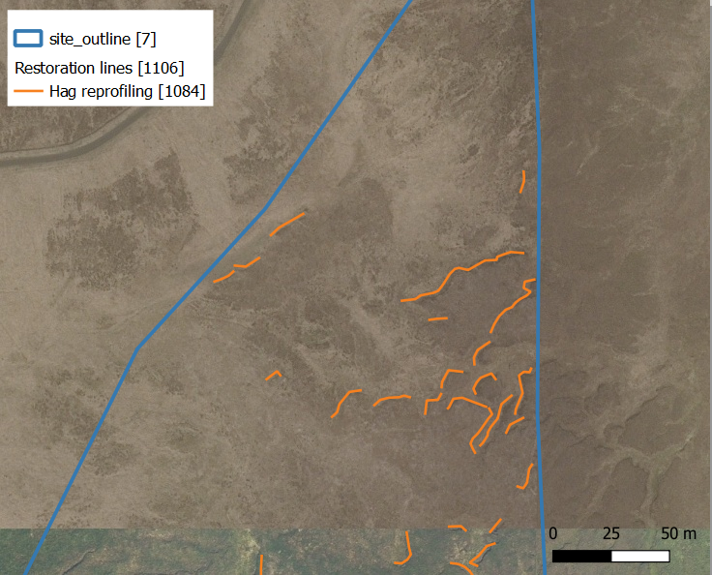

Figure 1. Example of digitised restoration features and site outline.

1. Draw the restoration footprint around the site-based restoration features (hags, gullies, peat dams etc.). The restoration footprint must not be more than 50 metres away from these restoration features[1]. It may be appropriate to use the buffer tool included with your GIS software.

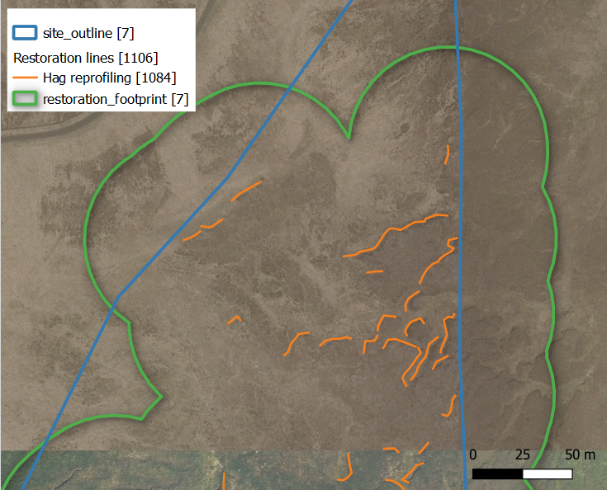

Figure 2. Example of a restoration footprint applied to digitised restoration features.

1. All non-peatland areas (such as rocky outcrops) should be excluded from restoration footprints. For more information of what should and should not be included see FAQ section.
2. The subsequent polygons indicate the extent of the restoration footprint. Group the buffered restoration features by the relevant Site. Be sure not to double count areas by overlapping restoration footprints.
3. Calculate the area in hectares of the restoration footprint for each Site to **two decimal places.** The total hectares for your project will be the sum of the restoration footprint hectares for all Sites. Note if you are using the QGIS spatial data template, this calculation will be completed for you in the Restoration area measurement table.
4. Repeat the above steps for the final report starting at 1 and editing the Site-based restoration features based on the actual work done. Make sure you use the same Site ID as the application form in the final report unless you have a completely different Site due to changes to the project scope.
5. Restoration footprint buffer tool (from QGIS 3.28 or above): The QGIS template comes with a restoration footprint buffer tool that helps you to generate the restoration footprint from the mapped features. However, the tool does not cut the restoration footprint polygon to any non-peatland areas (unless you have map them into the unrestorable layer), so the user still needs to manually crop them. Before running the tool, make sure the correct site ID for every line, point and polygon feature have been assigned. To access the tool, go to the processing toolbox, then “Models” and then select the “Restoration footprint buffer” tool.

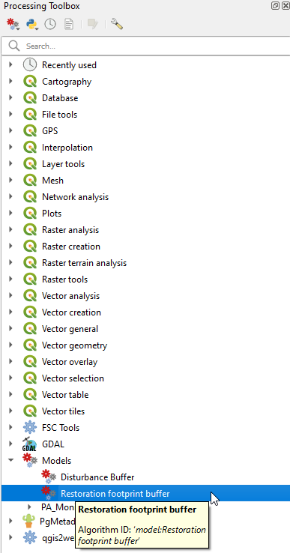

Figure 3. Location of the restoration footprint buffer tool

For more details, check specific QGIS guidance. If you require clarification or help with mapping, please contact [peatlandactiondata@nature.scot](mailto:peatlandactiondata@nature.scot)

# FAQ’s

#### What features should or shouldn’t be included in the restoration footprint?

The following include some examples of areas that shouldn’t be included within the area “put on the road to recovery”, note this list is not exhaustive.

* Roads and/or areas falling on the opposite side of the road from site-based restoration features.
* Rivers/lakes and/or areas falling on the opposite side of the river/lake from site-based restoration features.
* Areas of non-peatland habitat, for example bare rock, shoreline, or non-peatland soils.
* Areas adjacent or within sites that are to remain under forest cover.
* Adjacent areas of excessively degraded peatland.
* Due to the nature of forest to bog areas, which normally belong to parcels surrounded by forest areas or with physical barriers of anthropic origin such as roads, it is possible that no buffer can be applied. In these cases, the restoration footprint will be estimated on a case by case basis.

Where present, the above areas should be removed from restoration footprints.

1. If you have a reason for a distance of more than 50 metres (for example, the whole hydrological unit will be affected) then the details of the slope, flow and terrain must be mapped and explained in the application form and final report.