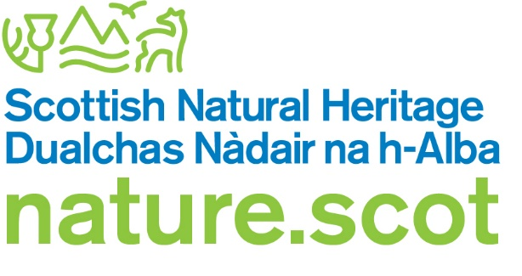

# Licence application form – for land on which red grouse may be killed or taken

## About this form

This form is intended for offline use and may not be fully accessible.

It is quick and easy to fill in this form online at <https://licensing.nature.scot/red-grouse/apply>

Contact the Licensing team if you need help completing this form.

**Email**: [licensing@nature.scot](mailto:licensing@nature.scot)

**Telephone**: 01463 725364

## Who should use this form

Use this form to apply for a licence for land used for the killing or taking of red grouse.

You must be the landowner or occupier.

An occupier is someone who has the rights to kill or take red grouse on the land. For example, a sporting tenant.

## The proposed licence holder must complete this form.

## Before you start

You must confirm that you will comply with the code of practice for grouse moor management at: <https://www.nature.scot/doc/guidance-code-practice-grouse-moor-management>

Find further information and examples of maps in our [licence guidance](https://www.nature.scot/professional-advice/protected-areas-and-species/licensing/species-licensing-z-guide/red-grouse-and-licensing) at: <https://www.nature.scot/professional-advice/protected-areas-and-species/licensing/species-licensing-z-guide/red-grouse-and-licensing>

### Modifications

To modify an existing licence, contact the Licensing team and quote your licence number, details of any required updates and the reason for this change.

### Returns

You will be required to submit annual returns. You must keep details of:

* the number of red grouse killed or taken during the licence period (even if it is nil)
* how you have complied with the code of practice for grouse moor management

If you fail to complete a return, we may suspend or revoke your licence.

### Wildlife crime

We can suspend or revoke this licence if the licence holder – or a person involved in managing the land – commits a relevant offence on the land.

We will write to let you know if we intend to do this. We will also let you know how to appeal against our decision.

It is illegal to operate under this licence when it is suspended or revoked.

A relevant offence for the purpose of this licence is an offence under:

* part 1 of the Wildlife and Countryside Act 1981
* the Protection of Badgers Act 1992
* part 3 of the Conservation (Natural Habitats, &c.) Regulations 1994 (S.I. 1994/2716)
* section 1 of the Wild Mammals (Protection) Act 1996
* section 19 of the Animal Health and Welfare (Scotland) Act 2006
* the Hunting with Dogs (Scotland) Act 2023

## Section A: Your details

Table 1: Your details

|  |  |
| --- | --- |
| Full name (as it appears on official documents) |  |
| Organisation name (optional) |  |
| Address line 1 |  |
| Address line 2 (optional) |  |
| Town or city |  |
| County (optional) |  |
| Postcode |  |
| Email address |  |
| Telephone number (optional) |  |
| Are you the owner or occupier? |  |

## Section B: Location of land for grouse shooting

This licence is for an area of land on which you have the right to kill or take red grouse.

For help with grid references, visit the Ordnance Survey website at:

<https://getoutside.ordnancesurvey.co.uk/guides/beginners-guide-to-grid-references/>

Table 2: Landholding details

|  |  |
| --- | --- |
| Name of landholding |  |
| National grid reference within the landholding.It can be between 6 and 12 digits.For example: SJ8632197947. |  |
| Does the landholding have Wildlife Estates Scotland Level 2 accreditation? |  |

## Section C: Required documents checklist

You must include a map which shows both the landholding boundary and area over which you have the right to kill or take red grouse. These two boundaries must be made clear via a map key or by annotation. You must note if those two boundaries are the same.

We advise you use Ordnance Survey mapping (for example OS 1:25,000 or 1:50,000) and apply a scale bar to the map.

The file must be smaller than 10MB. Suggested file types include PDF, JPEG and PNG.

Tick the box below to confirm you have included a relevant map.

I have included a map with this application

## Section D: Declaration

* I am the owner/occupier of the land
* I have the right to kill or take red grouse on the land
* I will comply with the code of practice for grouse moor management
* I understand it is against the law to provide false information
* the information provided is correct and up to date
* NatureScot can contact me in relation to this application
* I agree with the privacy policy of this service at [licensing.nature.scot/red-grouse/privacy](https://licensing.nature.scot/red-grouse/privacy)

|  |  |
| --- | --- |
| **Date**: Click here to enter a date. | **Print name:**  Signature: Signature field |

## Submitting your form

You can send this form by email or post.

### Send by email

Send the completed form and any supporting documents to[**licensing@nature.scot**](mailto:licensing@nature.scot)

Do not send zip files as these may be blocked by our security system.

A signature is not required if you are the licence holder sending this form by email.

### Send by post

If you do not have access to email, you can print out and send your signed form to the address below.

Licensing Department

Scottish Natural Heritage

Great Glen House

Leachkin Road

Inverness

IV3 8NW