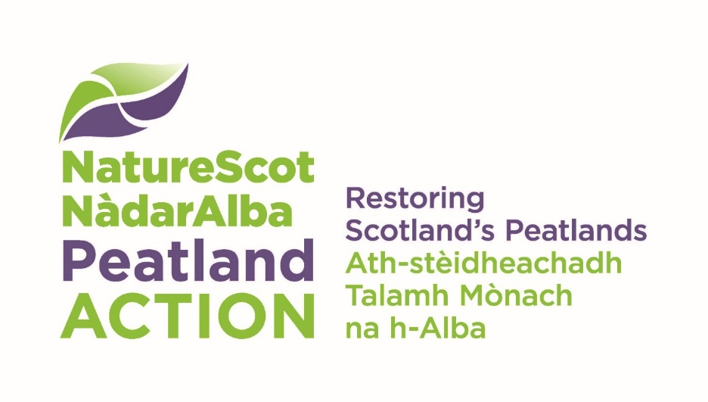[Web address: nature.scot/peatlandaction](http://www.nature.scot/PeatlandACTION)

Machine Operator Training Scheme

Application Form

# Background

You should read the Information for Applicants before filling in this form. This scheme is only for funding training placements in peatland restoration skills that meet the eligibility criteria in the Information for Applicants.

Your completed application form and any supporting information must be submitted by 11:59 on 14th October 2024 to [peatlandactiontraining@nature.scot](mailto:peatlandactiontraining@nature.scot)

## Section A - About you

Please complete the about you section below.

### Your details

This should be the person and/or organisation that is applying for the grant and who will manage the placement(s).

|  |  |
| --- | --- |
| Title | Applicant to complete this column |
| Applicant name | Select text and type your own content. |
| Name of business / Organisation | Select text and type your own content. |
| Position in Business / Organisation | Select text and type your own content. |
| Website / Facebook / Twitter / other (if applicable) | Select text and type your own content. |
| Address | Select text and type your own content. |
| Postcode | Select text and type your own content. |
| Landline phone number | Select text and type your own content. |
| Mobile phone number | Select text and type your own content. |
| Email | Select text and type your own content. |
| Business number (if applicable) | Select text and type your own content. |
| VAT registration number (if applicable) | Select text and type your own content. |

### Is your organisation (please check box below)

Public  Private business  Voluntary/charity/trust  Other

If Other, please describe the type of organisation:

Select text and type your own content.

### Are you applying in a partnership with another organisation(s)?

Yes  No

If yes, please list the other partners who will be involved in the placement, summarising their role.

Select text and type your own content.

### If you are receiving funding directly from NatureScot , or have received funding from NatureScot in the past two years, please give details:

Select text and type your own content.

## Section B – Your training placement proposal

Please provide details about your training placement proposals below.

### Placement description

Please describe your training proposal summarising what you are going to offer following the format outlined in the Machine Operator Training – Assessment Framework. Please detail what outcomes you hope to achieve for your organisation and for the trainee, with specific reference to the Project Aims in the ‘Information for Applicants.’ We will ask you for further details in the questions below.

Select text and type your own content.

### Approximate Placement Start Date:

Select text and type your own content.

### Placement terms of employment

|  |  |
| --- | --- |
| Title | Applicant to complete this column |
| Number of hours per week | Select text and type your own content. |
| Normal working pattern, e.g. Monday – Friday 9-5 / flexible | Select text and type your own content. |
| Expected location | Select text and type your own content. |
| Other – add any other details on the conditions for employment for the trainee. | Select text and type your own content. |

### Please confirm that the placement will meet the following criteria

Trainee is resident in Scotland  Yes

Trainee is not a current or past employee of your business   
or a family member  Yes

Payment to the trainee of £120/day will be made  Yes

### Advertising

Please indicate how/where you plan to advertise the training placement.   
(NatureScot may be able to help with or advice on this, but you must provide contact details for applications and manage the recruitment process.)

Select text and type your own content.

### Role requirements

Please describe the role requirements of the placement trainee(s) including their responsibilities, tasks, and work-based experience that they will undertake during the placement, in the form of information you would provide to potential applicants for the placement.

Select text and type your own content.

### Person specification

Please describe the type of person you will be looking for the trainee placement, i.e. person specification, including the criteria that you will use to assess applicants’ suitability for the placement.

Select text and type your own content.

### Information for Applicants

Please select which skills, as set out in the ‘Information for Applicants’ guidance and the Machine Operator Training – Assessment Framework will be enhanced as part of your placement proposal: (check all that apply).

Skills:

Drain blocking and reprofiling (peat dams and plastic piling)

Wave-damming and zipping

Reprofiling of hagg and peat bank

Reprofile and block erosion gullies

Surface and deep bunding

Forest to bog rewetting

Other

If ‘Other,’ please describe the skill(s):

Select text and type your own content.

### Mentoring arrangements

Please provide brief details of the skills and experience of the business enabling you to provide mentoring on the techniques selected (short CVs of the mentor(s) can be attached if you wish).

Please briefly outline what mentoring arrangements will be provided for the placement trainee, and what arrangements there will be for monitoring, feedback and formal assessment between the mentor and the trainee and vice versa.

Select text and type your own content.

### Accreditation

Will your trainee require to become CPCS/CSCS/NPORS accredited?

Yes  No

If yes, please explain why accreditation is required. If known, please include the full cost of this certification.

Select text and type your own content.

### Future employment opportunities

Please describe how you intend to assist the trainee to gain more experience in the sector at the end of the placement. This might be, for example, the intention to employ them for an additional amount of time, a willingness to sub-contract them or support to pursue future employment opportunities in this sector.

Select text and type your own content.

### Fair work practices and equality and diversity

Please outline how delivery of this training placement will demonstrate alignment with Fair Work[1] practices and your commitment to Equality and Diversity. A couple of sentences/short paragraph is all that is required; additional information, e.g. copies of People/HR policies, can be provided separately.

Select text and type your own content.

### Placement opportunity / opportunities

How ready are you to provide this placement opportunity/opportunities outline above? Please detail any specific action(s) not included within this application needed before the Placement can start and risks associated with these actions and/or other uncertainties (e.g. if there is an associated project that the placement is connected with that depends on other funding/practical issues/weather conditions).

How will you mitigate the risk of having a trainee on an active restoration site?

Select text and type your own content.

## Section C - Declaration

* I am the Applicant, and I am applying for a grant under the terms of the Natural Heritage (Scotland) Act 1991. I have the appropriate authority to submit this application.
* I confirm that the information I have given in this application is correct, to the best of my knowledge.
* I have read and accept Scottish Natural Heritage (NatureScot) Standard Terms and Conditions of Funding.  
  (You will find our Standard Conditions of Funding on our website.)

NatureScot will collect and hold your contact details. You should read our Funding Privacy Notice.

### Applicant signature

We prefer to receive an electronic copy of your application. You can either:

* insert a scanned copy of your hand-written signature, or
* insert your name and submit the application from an email address that is identifiable as you/your organisation.

|  |  |
| --- | --- |
| Date and Signature | Applicant to complete this column |
| Your signature |  |
| Date |  |

Please email your completed application form and any supporting documents to [peatlandactiontraining@nature.scot](mailto:peatlandactiontraining@nature.scot) **11:59 on 14th October 2024.**

1. More information on Fair Work practices can be found in the Fair Work tool: <https://fairworktool.scot/>