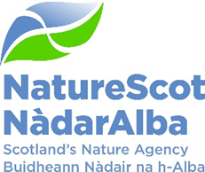

# Title: Communications & Engagement Strategy

**Date: 27 November 2024**

| **Purpose:** | Decision |
| --- | --- |
| **Which of the current Business or Corporate Plan priorities does this topic drive forward and in what way?:** | The Communications & Engagement Strategy supports delivery of NatureScot Corporate and Business Plans. |
| **Summary:** | Earlier this year the Board reviewed a draft Strategy. It sought changes and commissioned a Subgroup of Board members to support further development. The Board asked to approve the Strategy before implementation. |
| **Recommendations:** | * Approve the Communications & Engagement Strategy * Confirm the continuing operation of its Subgroup to support implementation and approve revisions based on new Business Plans on behalf of the Board. |
| **Report Author:** | Jason Ormiston |
| **Sponsor:** | Francesca Osowska |
| **Appendices**: | Annex 1: NatureScot Communications & Engagement Strategy |

## Purpose

1. Earlier this year the Board reviewed a draft of this Strategy. It sought changes and commissioned a Subgroup of Board members to support further development. The full Board asked to approve the Strategy before its implementation.
2. The Subgroup met twice and provided advice on approach and content before the submission of the Strategy to the Board. That advice covered among others behaviour change, timelines, channels, audiences, challenging debates and formatting. I would like to take this opportunity to thank the Subgroup members for their support.
3. The draft Strategy takes as its starting point the Corporate Plan and is built around the four key themes set out in the current business plan and activity associated with the Scottish Government’s biodiversity strategy. We look to storytelling techniques to influence our audiences and promote behaviour change. Our approach works to get audiences on a journey which carries them forward on the influence arc of *inform-support-act*.
4. The Communications Activity already supports delivery of the Business Plan’s four key themes and the Corporate Plan’s 15 Delivery Plans. However, we should recognise that we have now passed the halfway mark in the current financial year. Senior management is now looking to plans for 2025-26 and we will need to review and potentially refresh the Communications & Engagement Strategy to reflect any changes that are made.

## Conclusions

1. A proposed solution to the transition from this current business plan year to the next is to treat the Strategy as a framework which has sufficient flexibility to absorb new priorities within its overall approach. The Subgroup has recommended that in the event of changes to NatureScot priorities for 2025-26 that it is given the authority to approve any revisions on behalf of the Board.
2. Looking further ahead, a revised Communications & Engagement Strategy will be developed in line with the next Corporate Plan and any shifts in Scottish Government Strategy. I would expect to seek full Board support for this Strategy in 2026.
3. To finish, we believe that this Strategy will be successful when we have established a common ground with partners on what needs to be done to secure a nature rich future for all in Scotland. In occupying that ground we can build broad support – including from the wider public - for nature positive action.

## Recommendations:

* The Board is asked to approve the Communications & Engagement Strategy.

The Board is asked to confirm the continuing operation of its Subgroup to support implementation and approve revisions based on new Business Plans on behalf of the Board.

**Annex 1**



# Communications & Engagement Strategy

## Introduction

The NatureScot Communications Activity exists to demonstrate the value of taking action to protect, restore and value nature. If we do that, we strengthen our brand and reputation for leadership, and the reputation of the wider nature sector.

It is important to recognise that we can only stop the decline in biodiversity and then recover nature’s health in Scotland if we work in what our Chair calls ‘a renewed partnership for nature.’

We know that people in Scotland are concerned about the impacts of climate change and biodiversity loss. They do expect the Government and its agencies to strenuously drive nature recovery. We also know that many don’t know or have limited knowledge and skills about what nature positive action they themselves can take. NatureScot has a key role in bridging the gap between concern and action, whether it’s the farmer wanting to work with nature or the family wanting to make space for nature in their lives.

In previous years, messaging led with the world facing a climate and biodiversity crisis. This is the reality. But evidence shows this message turns people off. So, while we continue to share this reality of crisis in our messaging, there's a balance to be struck. If we are going to engage with and mobilise people to act, especially people in our 'harder to reach' groups we need to give them hope, a sense of purpose and an understanding that their expertise matters and is crucial to our shared endeavour.

The shift to a nature rich future in Scotland is urgently needed. This requires moving at pace and scale. This poses the risk that people, communities and businesses lose out from its benefits or face negative impact. The Communications Activity needs to be there listening to those concerns and supporting colleagues’ sensitive response to them. This puts collaboration front and centre of issues management.

But where collaboration and partnership has not been secured, we will face opposition, criticism and at times misinformation or disinformation. The arena we operate in can be challenging, combative even. We should welcome the scrutiny that comes with opposition and criticism. Misinformation or disinformation is harder to bear. Our response needs to be proportionate, evidence-based, quick and robust.

A good example where collaboration has worked well is the Avian Influenza Taskforce, which we led (see Case Study). The Communications Activity told the difficult and compelling story of the outbreak and in doing so established our leadership of the national response and strengthened our reputation. Building positive relationships with the media was key. This led to informed coverage on the BBC and STV, with online platforms vital. Print media was an important channel, whilst social media allowed us to communicate quickly at times when we had to act promptly. We also saw heightened interest from Scottish Government and political stakeholders.

This Communications Strategy is shaped by our insight and experience and works to deliver our current Corporate Plan and annual business plans objectives. We believe that we will be successful when we have established a common ground on what needs to be done to secure a nature rich future in Scotland, occupying that space and building broad support for nature positive action. Our focus will be the four key themes set out in the annual business plan.

## Strategy

The NatureScot Communications & Engagement Strategy (see Fig 1 for Strategy on a Page) works towards our goal of securing a nature rich future for all. It recognises the journey people and organisations are on. Initially we set out to inform people about the benefits of action to protect, restore and value nature. Having done that, we hope to encourage support for action – most effectively through peer-to-peer storytelling. And finally, being informed and supportive, people and organisations have the confidence to act in a nature positive way.

It is worth considering who our audience is at this point. The obvious answer with a Communications Strategy for a nationwide and complex organisation like NatureScot is to conclude everyone is. When it comes to behaviour change that might be true, but then looking at our audience in detail might lead us to prioritise one group over another because they offer the biggest impact. Or that a group does not have a strong voice and, in line with Just Transition principles, we work to hear that voice and be influenced accordingly. We will adopt this thinking with our work, including around the Scottish Biodiversity Strategy. The nature sector can be a data-rich arena and NatureScot’s investment in opinion surveys are important sources of insight.

If you look at our Strategy on a Page and the current [business plan](https://www.nature.scot/doc/naturescot-business-plan-2024-2025), we see the possibility of useful audience segmentation. We have limited resource, so this can be especially useful. It will be important, in line with good practice, that we research our audience carefully to ensure that our actions are effective. One particularly good example of this is our work to promote the Scottish Outdoor Access Code. Finding ways to reach groups that we typically struggled to connect with was important. We have worked closely with partners and deployed social media influencers to promote responsible access to the outdoors to new groups.

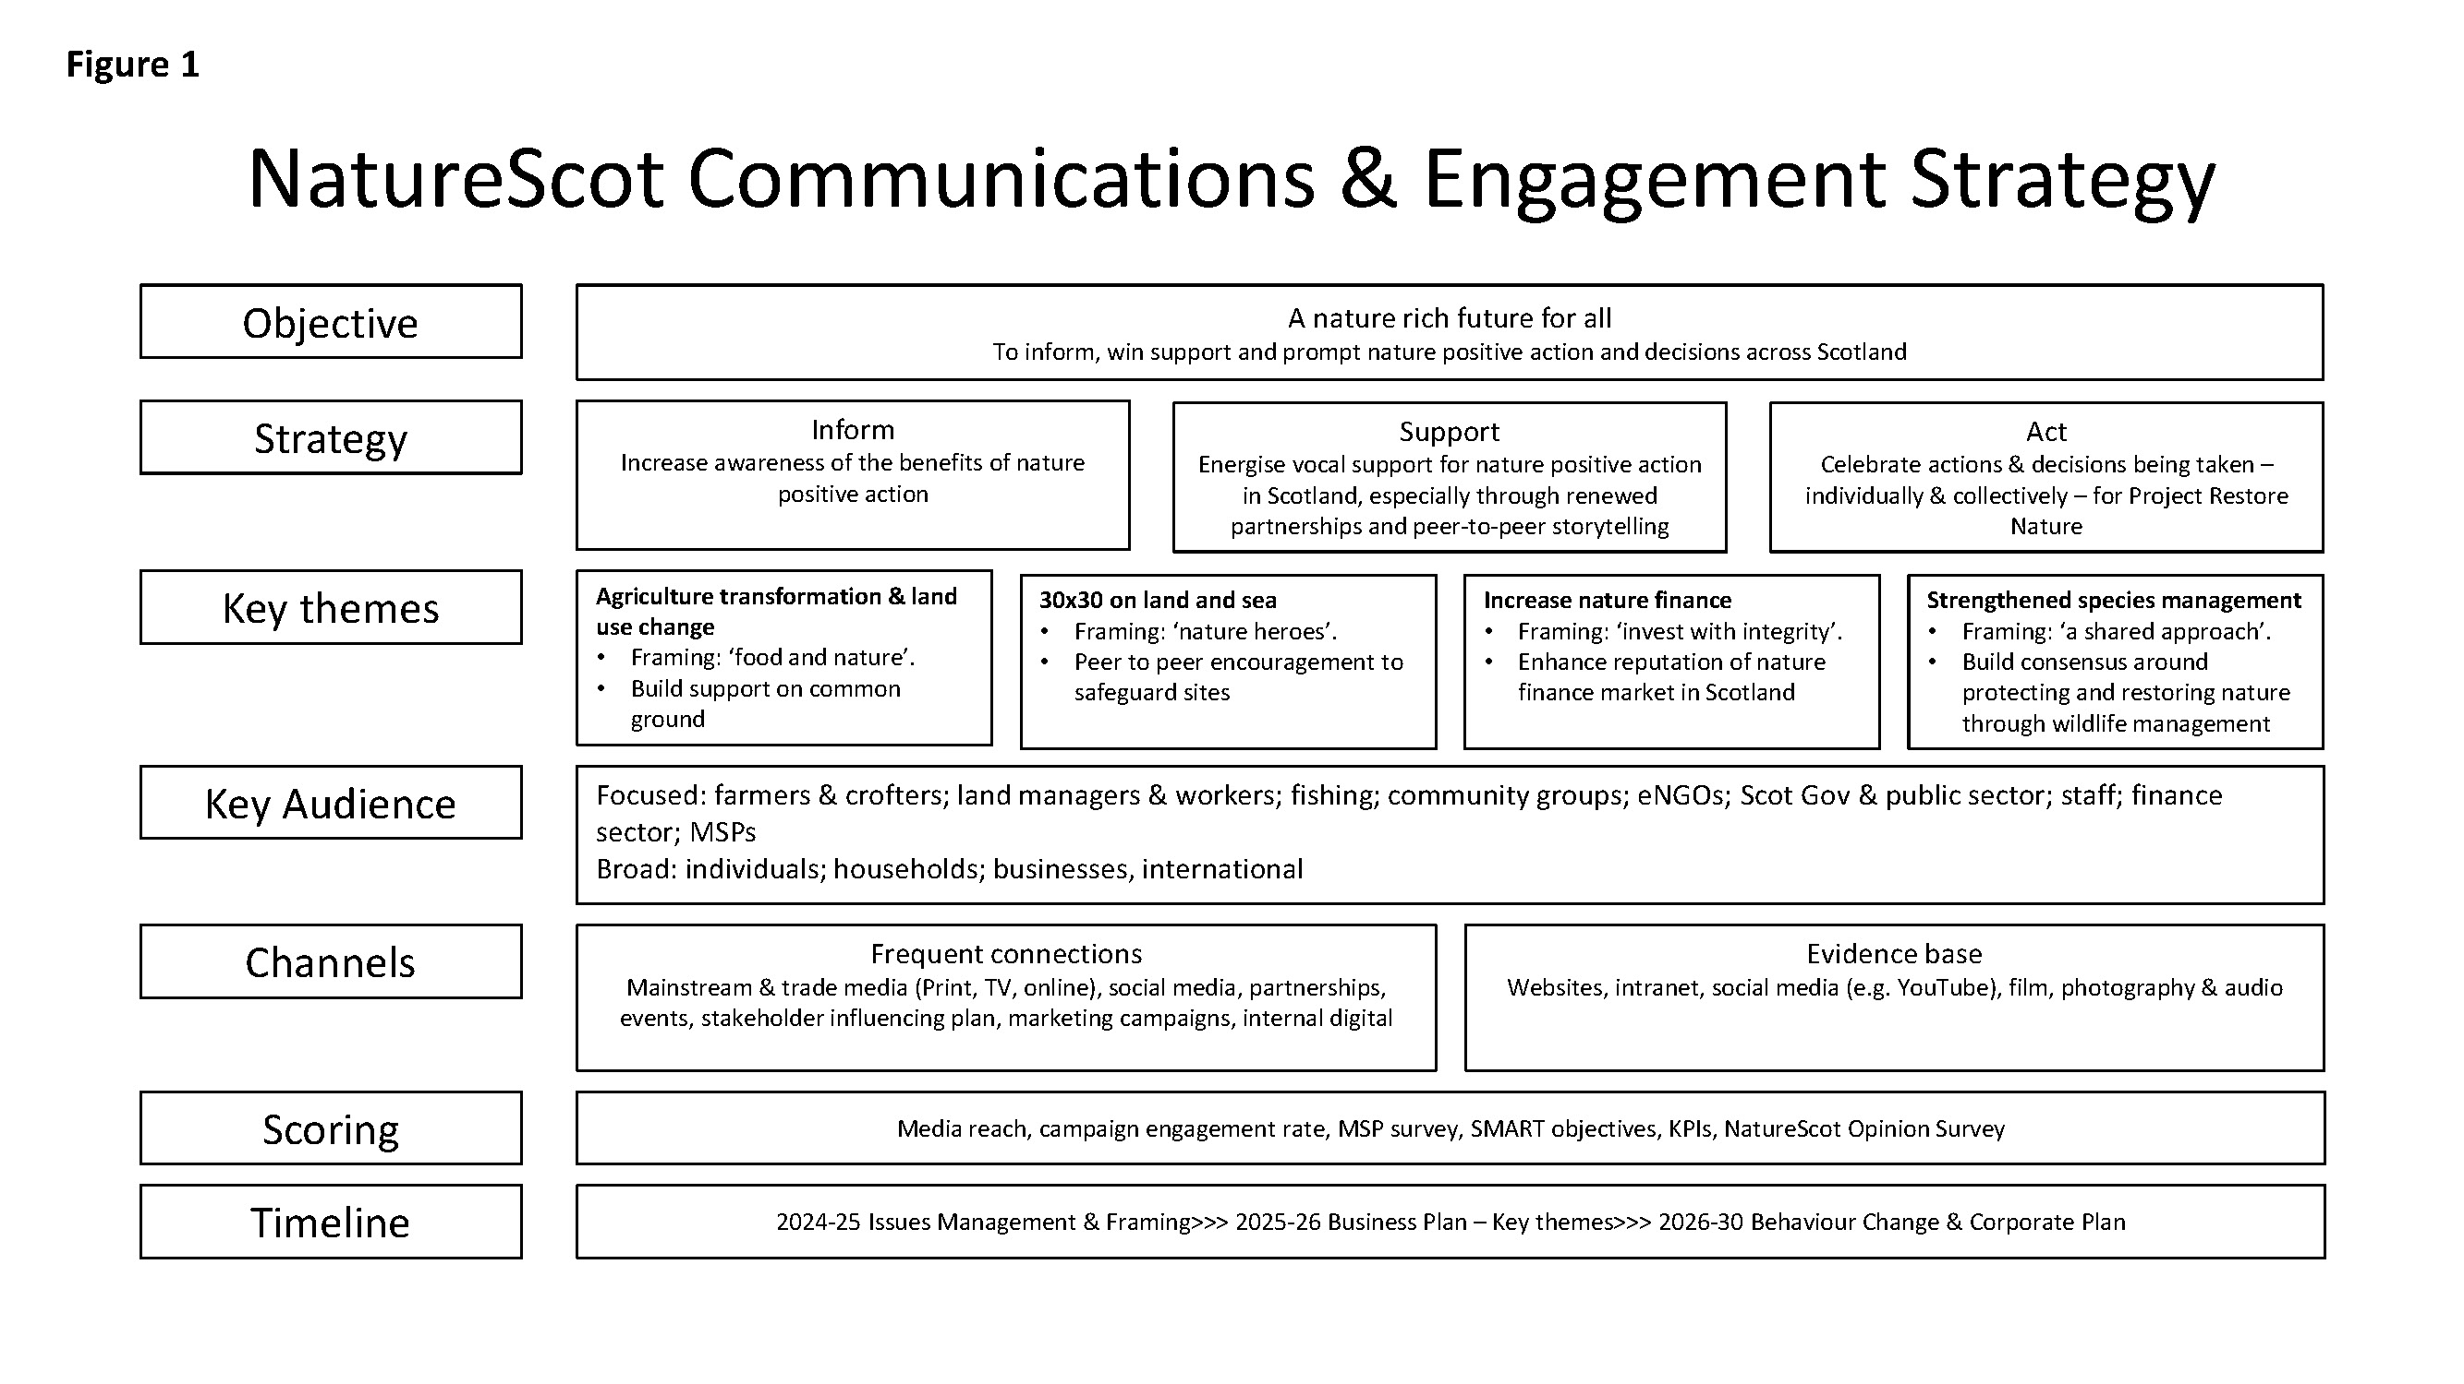

# CASE STUDY: Issue management - Avian flu NatureScot Banner visualising the Avian Flu response

**Background**

Since 2022, we have powerfully told the difficult and quickly moving story of the Highly Pathogenic Avian Influenza (HPAI) outbreak using a combination of news releases, social media posts, paid articles, media interviews with key staff, and timely, informative responses to media queries. We provided media training for the avian flu team, as the high number of requests for media interviews meant we needed greater numbers of staff ready and able to speak to reporters.

Throughout the outbreak, we: promoted the establishment and continuing work of the NatureScot-led Avian Flu Task Force gave regular updates on how different species and areas of Scotland were faring promoted the research work of NatureScot and our partner organisations publicised precautions taken on our NNRs, particularly in summer 2022, when we needed to close Noss and the Isle of May and advise on other islands stopping public landings to limit the spread of HPAI.

**Actions and results**

Since the HPAI outbreak began in 2022, we have issued 21 news releases mentioning HPAI, received 116 media inquiries, and placed a number of stories with key journalists. The result was over 650 news articles and broadcast stories mentioning HPAI and NatureScot, for a total reach of 435 million, worth an equivalent of £12.7m in advertising value. We earned these strong readership numbers through the main news sources for many Scots, including BBC online with the most reach, as well as the Times, the Daily Express, the Guardian, and the Daily Record.

As can be seen in the word cloud above showing the most common words used in press coverage, NatureScot was mentioned more often than ‘flu’, ‘bird’ or ‘avian’ in these stories – an impressive sign that the organisation was central to reporting results, giving advice and taking part in important research. This has not only boosted our reach enormously in the last few years, but also very likely improved NatureScot’s visibility and reputation.

**What next?**

We continue to promote the vital research that NatureScot staff are undertaking with the University of Edinburgh, RSPB and BTO to capture and test geese, as well as precautionary measures on our NNRs to stop any return of HPAI or other future viruses. We will also be looking at feature pieces exploring this scientific work further.

One last point on audience. The risk of focusing on external engagement is that the important internal audience can be forgotten. We must not fall into that trap. That is because the staff of NatureScot are powerful ambassadors of our brand through their own stakeholder engagement. It is important that they are well informed of what is going on within NatureScot and across the sector so that they align their own engagement with the organisation’s priorities. Further, communicating with colleagues offers an opportunity to motivate and inspire about NatureScot’s mission.

We have talked about the journey people are on (Inform, Support, Act). These range from the individual with whom we seek to engage to the wider public. Our activity involves planned influencing of individuals to wider behaviour change campaigns and many points in between.

On the individual or small-scale level, we break down our analysis of influence in the following way, shaped by the topic we are focused on:

Tier 1: The key players we must engage with on a regular, high-level basis - usually tackled by SLT, Chair and Board. This engagement can be a mix of issues management and the strategic level. An Influencing Plan would support this activity.

Tier 2: The important players essential to the success of our Delivery Plans. Everyone can be involved in this. This engagement would normally be supported by a plan drafted by operational leads.

Brand reinforcement: This is engagement in line with NatureScot values - [the NatureScot Way](https://snhgov.sharepoint.com/sites/IntranetFAQs/SitePages/The-NatureScot-Way.aspx) - whilst we network, provide services and just generally go about our business. Products like our Brand Story, Corporate Plan and Business Plan should support that contact.

We use Influencing Plans for Tier 1 stakeholders, corralled around a key topic where we feel we need to make biggest impact. These plans are focused, they seek a specific outcome and can vary in timeline depending on the topic. This targeted approach recognises that with limited resources active management of a defined group on a specific topic will lead to better outcomes.

On the wider level, we look to broad behaviour change. We know that actions to address the nature emergency need to be taken by most people in Scotland if we are to build resilience to climate change and secure nature recovery. This will require significant effort from the Communications Activity. Our Make Space for Nature (MSFN) campaign is one of many initiatives that moves the audience through inform to support to act (see Case Study). Starting in 2020, MSFN has had significant reach in multiple channels in social media, mainstream media and through advertising across commercial radio. We have lately deployed social media influencers meaning our message has reached a wider audience.

Our own Business Plan for 2024 and 25 recognises the big shifts in behaviour needed if we are to make substantial progress towards stopping the decline in biodiversity by 2030. The plan identifies four key themes for organisation-wide action. Our approach to storytelling, the language we use and the frames we put around them are key to having impact. We will make significant effort in these areas to help improve our performance.

We will now take a closer look at the framing around our Business Plan’s key themes. You can see from the Strategy on a Page, Figure 1, how it all fits together.

## Key theme: Agriculture transformation & land use change

**Framing: ‘food and nature’**

**Objective: Build on common ground to support transition to regenerative agriculture and land use**

Short narrative: We often see food production and security and nature recovery posed as incompatible. The evidence from those practicing nature friendly farming and regenerative agriculture shows that they can go together. We think the common ground is likely to centre on resilience, especially to the impact of climate change. Supporting landowners to plant trees and regenerate woodland and restore peatland will also be an important part of building resilience.

Main audience and channels: Farmers, crofters and land managers or owners are core audiences. Key players will also be investors and the supply chain. The main channels are typically trade-press and shows, with stakeholder engagement focused on trade associations, membership organisations and strategic influencers. Policy and decision makers in Government and the Scottish Parliament will also be important.

## Key theme: 30x30 on land and sea

**Framing: ‘nature heroes’**

**Objective: Peer to peer encouragement to expand and safeguard sites**

Short narrative: There is international agreement that to reverse biodiversity loss more safeguarding of naturally special places on land and at sea is needed. The opportunity – or challenge – is to persuade thousands of landowners and those that work the sea to support this change. We believe peer to peer communications will have the greatest impact.

Main audience and channels: There is significant cross over with interests in agriculture transformation and land use change. In addition, players in the marine sector will require

# CASE STUDY: behaviour change - Make Space for Nature NatureScot Banner showcasing the comms team work on social media for make Space for Nature Background

Make Space for Nature (MSFN) is NatureScot’s most high-profile campaign. It dovetails with and amplifies the strategic aims and objectives of the Scottish Government’s Let’s Do Net Zero campaign and has had an extremely strong performance to date.

Using a range of media platforms, the campaign aims to help address the societal disconnect with nature (one of the seven key pressures on biodiversity, identified as part of the Scottish Biodiversity Strategy), drive behaviour change and raise awareness of the twin crises of nature loss and climate change.

By simplifying complex messages into jargon free ‘top ten ways to help nature’, the campaign provides achievable and accessible ways for everyone to take action each season and make space for nature everyday - physically, emotionally and mentally.

**Results**

* During 2022-23 the campaign encouraged 2.5 million people (45.44% of the Scottish population) to take action by following ‘10 ways to help wildlife’.
* Social media activity achieved high average Click Through Rates (CTR) ranging between 2-6% (1% is considered good).
* 30-50k people visit the website each season, with a high 98% web engagement rate (70% is considered good).
* New audiences were reached through collaborations with targeted social media influencers, including LessWasteLaura and Chris Lawlor, with one influencer’s MSFN videos reaching 500k views.
* The podcast series has over 40 episodes and 16k downloads.

**What next?**

In line with key actions in the Scottish Biodiversity Strategy, expanding the campaign, and to particularly target less engaged audiences using relevant communication channels, will show that making small changes can make a big difference.

Measuring behaviour change is a key component to this campaign. Questions have been added to existing NatureScot public surveys to measure behaviour change, therefore future results will go beyond digital measurements.

## attention, particularly those that work the sea. The main channels are typically trade-press and shows, with stakeholder engagement focused on trade associations, membership organisations and strategic influencers. Policy and decision makers in Government and the Scottish Parliament will also be important.

## Key theme: Increase nature finance

**Framing: ‘invest with integrity’**

**Objective: Enhance reputation of nature finance market in Scotland**

Short narrative: The need for the right blend of public and private nature finance is understood, but there is concern that communities could be left out and that investment labelled nature positive enables greenwashing. The Scottish Government’s principles for responsible investment will be key. Communicating the widespread benefits of nature investment will be important in enhancing the sector’s reputation.

Main audience and channels: Financial institutions and their clients along with landowners will be a focus. As will stakeholders with an interest in land reform as well as communities and their representative organisations. Policy and decision makers in Government and the Scottish Parliament will also be important, along with those with an interest in developing nascent market frameworks. Main channels will be financial and business press and stakeholder engagement with potential investors and influencers around responsible investment.

## Key theme: Strengthened species management

**Framing: ‘a shared approach’**

**Objective: Build consensus around protecting and restoring nature through wildlife management**

Short narrative: The regulations supporting species management in Scotland have been well established, but with new legislation they are changing. Many practitioners are concerned about the impact on their livelihoods. With NatureScot’s lead role in applying the regulations a shared approach to design and delivery is key, especially if regulations are to support nature recovery. Celebrating effective partnerships will be important.

Main audience and channels: Landowners, managers and keepers along with environmental organisations will be core. Local authorities and local business organisations are gaining prominence. Scottish Government officials and parliamentarians are key partners. Given the broad public interest the debate plays out in the mainstream press and social media, and we will need to be active here. The ‘shared approach’ requires wide ranging stakeholder engagement in the public sector and direct to practitioners as well as those that monitor activity and look to shape policy and its implementation. Trade press and trade shows will be important arenas for dialogue.

## Timeline

The durability of this Strategy will depend on our ability to understand trends and account for uncertainty. We have chosen to adopt three time-horizons (see Figure 2) which enables us to think about the period of the current business plan, the remainder of the current Corporate Plan out to 2026 and then the period from 2026 to 2030.

It also indicates the scale of audience across those three horizons. In the near term we typically see quite narrow audiences targeted through specific tasks. Cumulatively this can add up to wider reach and awareness of NatureScot and our purpose and goal. As we progress through the timeline, we see the audience perspective broaden as we look at more strategic activity to a point where, in this case by 2030, we see wide reach and impact from a national endeavour.

The three-time horizons also allow us to think about our approach in each of those phases. The period to spring 2025, our current business plan, is short term for this strategy but allows us to think about what it is about business as usual that needs to change if we are to secure our long-term objectives. This Strategy and the Scottish Biodiversity Strategy campaigns we referenced above signal longer term opportunities and highlight the innovations or changes that we seek. The period to spring 2026, the remainder of the current Corporate Plan, sees those changes implemented. Then, as we look to a new Corporate Plan and the next session of the Scottish Parliament we see substantial progress to our long-term objectives, our mission. We can also expect a significant revision of this Communications and Engagement Strategy at the start of this period.

## Resources

Figure three shows the communications disciplines that we currently hold in house. This is a substantial commitment by NatureScot, reflecting the importance of demonstrating the value of action to protect, restore and value nature. We can enhance that value by coordinating our communications across all the disciplines, so that when we push stories out, we do so across all our channels, and, importantly, internally too.

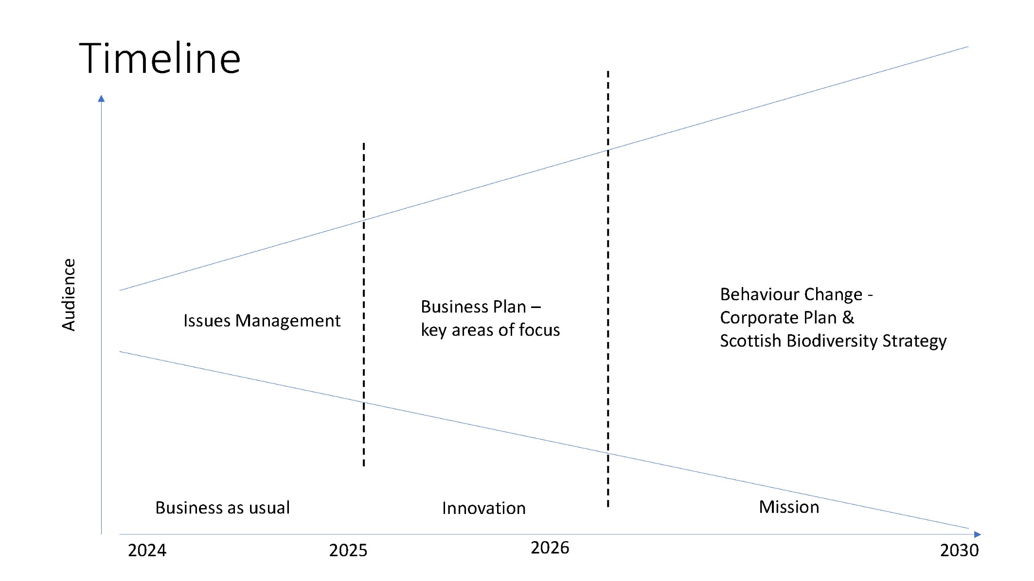

We benefit from some important resources. Considering frequency and extensive reach, the following are important: mainstream and trade media; digital media; targeted influencing plans; events, sponsorship, and stakeholder engagement; internal digital channels and, marketing campaigns. Underpinning these are assets such as our intranet, the Nature.Scot website, FAQs, expert internal advice and film and photography.

## Scoring

There are several datasets and analytical tools available to us to understand the impact we are having. These tools can also support the evolution of tactics and our strategy. They include our reach in media, promotional campaign returns, the MSP survey, public attitude surveys (our own and those conducted by others) and the deployment of SMART objectives on projects. The Corporate Plan measures currently assess engagement rates in the Make Space for Nature campaign and mainstream media reach.

## Conclusion

This Strategy will help staff deliver organisational priorities and key areas of focus by guiding the Communications Activity towards what really matters, using techniques that will make a difference. It should enable decision making and creativity at the most effective level of the organisation.

What we do must be in line with our purpose and goals. That is, we take a nature positive approach to tackling the nature and climate crises which builds resilience, improves wellbeing and strengthens our economy.

We want to be known as an organisation that listens and acts on what we hear. As a group of experts who stand up for what they believe in, based on the evidence we have gathered. And as an organisation that speaks with authenticity. If we do that, we will see our reputation grow, new partnerships forged and our ability to deliver for people and nature enhanced.

## Communications - inhouse resource diagram showing all departments of communications and their specialisms